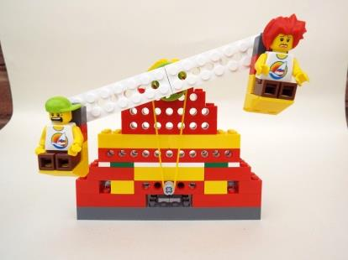

***Fairground ride***

|  |  |  |
| --- | --- | --- |
| **Session breakdown** | **Objectives** | **Activities** |
| *Introduction* | * Introduce Juniorstem and give a brief outline of the session. * Assess prior knowledge and introduce STEM subjects/Robotics * Introduce kits/equipment * Tell children their learning Targets and the skills I will be looking for | * Class discussion |
| *Identifying Lego pieces and working accurately* | * How to use colour, shape and studs to identify pieces * To use studs to work accurately * How to join pieces and strengthen structures * Workshop rules | * Teach and learn |
| *Lego software and algorithms* | * To teach children how to write an algorithm using Lego software blocks   (INPUT/OUTPUT, motor on/off, program keys, direction, power, timer, sounds and display) | * Interactive class teaching with volunteers * Practical challenge: Make your own simple motor machine – write an algorithm to control it |
| *Tidy up* | * Keep work area tidy and replace equipment for future use | * Class tidies up! |
| *Pulleys* | * Teach children how pulleys work | * Teach and learn |
| *Model instructions* | * Teach children how to use the Lego instructions * Review engineering skills | * Teach and learn |
| *Build* | * Use skills taught to build a fairground ride using the instructions * Add your own ideas to the model | * Practical challenge |
| *Program* | * Use programming skills taught to write an algorithm to control the fairground ride, a background and sound. | * Practical challenge |
| *Tidy up and review learning targets* | * To self assess and review learning | * Class discussion |