Changing A: $y=A×2^{x}$

$A=2$: $y=2×2^{x}$

|  |  |  |  |  |  |
| --- | --- | --- | --- | --- | --- |
| x | –2 | –1 | 0 | 1 | 2 |
| y |  |  |  |  |  |

$A=0.5$: $y=0.5×2^{x}$

|  |  |  |  |  |  |
| --- | --- | --- | --- | --- | --- |
| x | –2 | –1 | 0 | 1 | 2 |
| y |  |  |  |  |  |

$A=-1$: $y=(-1)×2^{x}$

|  |  |  |  |  |  |
| --- | --- | --- | --- | --- | --- |
| x | –2 | –1 | 0 | 1 | 2 |
| y |  |  |  |  |  |

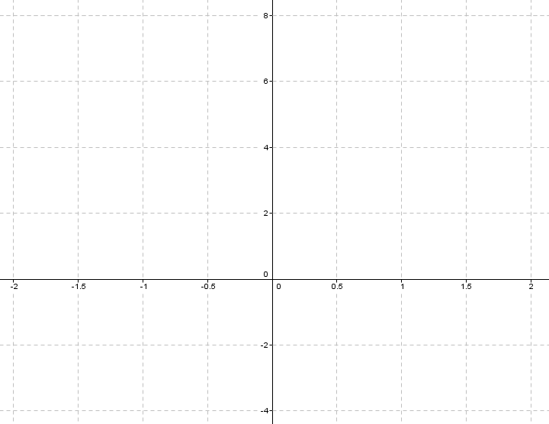

Changing k: $y=2^{kx}$

$k=1.5$: $y=2^{1.5x}$

|  |  |  |  |  |  |
| --- | --- | --- | --- | --- | --- |
| x | –2 | –1 | 0 | 1 | 2 |
| y |  |  |  |  |  |

$k=0.5$: $y=2^{0.5x}$

|  |  |  |  |  |  |
| --- | --- | --- | --- | --- | --- |
| x | –2 | –1 | 0 | 1 | 2 |
| y |  |  |  |  |  |

$k=-0.5$: $y=2^{-0.5x}$

|  |  |  |  |  |  |
| --- | --- | --- | --- | --- | --- |
| x | –2 | –1 | 0 | 1 | 2 |
| y |  |  |  |  |  |

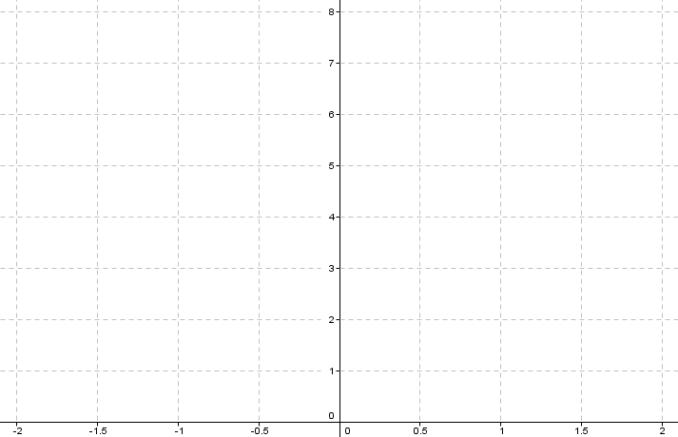

Changing b: $y=b^{x}$

$b=3$: $y=3^{x}$

|  |  |  |  |  |  |
| --- | --- | --- | --- | --- | --- |
| x | -2 | -1 | 0 | 1 | 2 |
| y |  |  |  |  |  |

$b=1.5$: $y={1.5}^{x}$

|  |  |  |  |  |  |
| --- | --- | --- | --- | --- | --- |
| x | –2 | –1 | 0 | 1 | 2 |
| y |  |  |  |  |  |

$b=0.5$: $y={0.5}^{x}$

|  |  |  |  |  |  |
| --- | --- | --- | --- | --- | --- |
| x | –2 | –1 | 0 | 1 | 2 |
| y |  |  |  |  |  |

