Repeated percentage change: compound interest

A cash Individual Savings Account, or ISA, is an account which benefits from higher interest rates due to tax exemptions, although how much you can put into the account each year is limited. Different banks offer different Annual Equivalent Rates (AER). Below are some currently existing ISAs along with an opening balance that will be put into the account and left untouched.

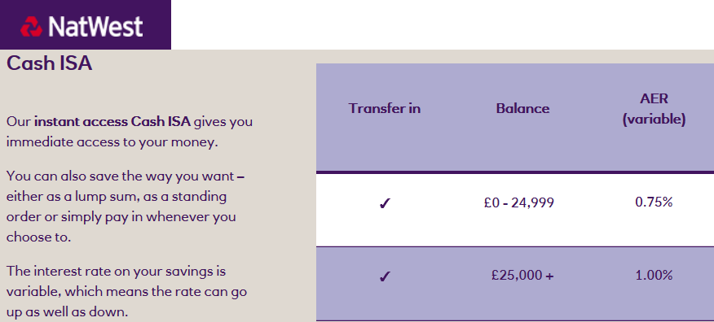

**Natwest**

Opening Balance: £980

Interest: 0.75% AER

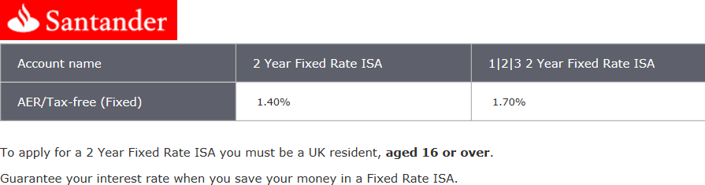

**Santander (123)**

Opening Balance: £920

Interest: 1.7% AER

**Halifax**

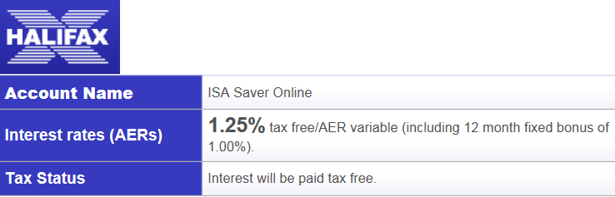

Opening Balance: £940

Interest: 1.25% AER

[](http://www.google.co.uk/url?sa=i&rct=j&q=&esrc=s&source=images&cd=&cad=rja&uact=8&docid=kC8gPal1iR6ReM&tbnid=GcLv9JU9_c-fxM:&ved=0CAcQjRw&url=http://javabird.com/blog/2012/11/07/gst-38-put-savings-first/&ei=eaIuVKnKHdLkarSlgZgI&bvm=bv.76802529,d.d2s&psig=AFQjCNEhxVfNyj-SKQZgztK0v7eZf-eq6g&ust=1412428306449099)

**Under the mattress!**

Opening Balance: £1000

Interest: 0%

**Which account will have the highest balance?**

Complete the following table:

|  |  |  |  |  |
| --- | --- | --- | --- | --- |
| **Year** | **Mattress (0%)** | **Natwest (0.75%)** | **Halifax (1.25%)** | **Santander (1.7%)** |
| Opening | 1000 | 980 | 940 | 920 |
| 1 |  |  |  |  |
| 2 |  |  |  |  |
| 3 |  |  |  |  |
| 4 |  |  |  |  |
| 5 |  |  |  |  |
| 6 |  |  |  |  |
| 7 |  |  |  |  |
| 8 |  |  |  |  |
| 9 |  |  |  |  |
| 10 |  |  |  |  |
| x |  |  |  |  |

On the axis provided, sketch four curves representing the four account balances.

Comment on which account has the higher balance at any given time and the shape of the graph lines.

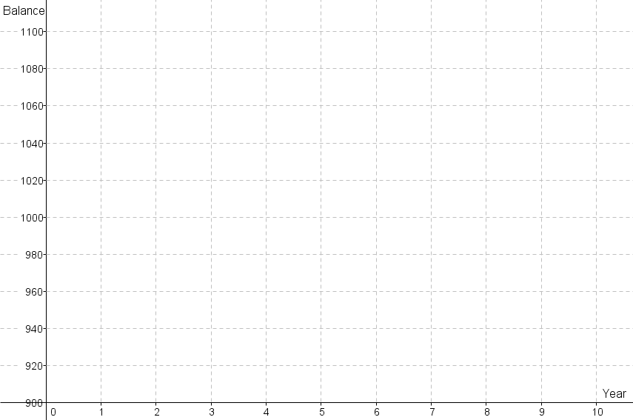

Repeated percentage change: depreciation

Depreciation is the decrease in value of an asset (or valued object). Companies have to apply a percentage decrease to their asset for financial recording purposes (although it isn’t an exact science). Below are four new cars along with a depreciation rate that has been selected to be applied to them.

**VW Golf** Cost: £19,000 Depreciation Rate: 14%

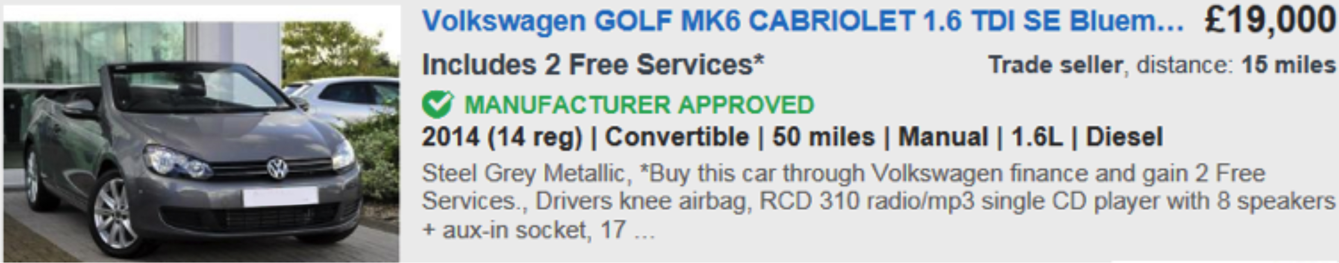

**Nissan Juke**  Cost: £15,000 Depreciation Rate: 9.9%

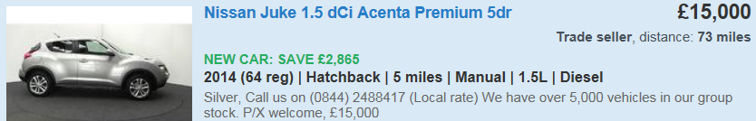

**Renault Megane** Cost: £12,000 Depreciation Rate: 6.5%

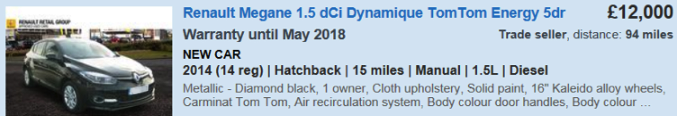

**Hyundai I20**  Cost: £9,500 Depreciation Rate: 5.2%

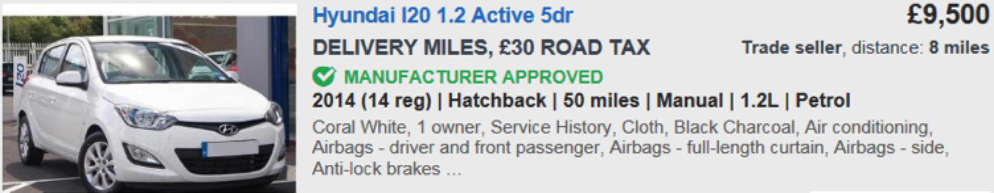

**Which car will have the highest value?**

Complete the following table:

|  |  |  |  |  |
| --- | --- | --- | --- | --- |
| **Year** | **I20 (5.2%)** | **Megane (6.5%)** | **Juke (9.9%)** | **Golf (14%)** |
| Opening | £9,500 | £12,000 | £15,000 | £19,000 |
| 1 |  |  |  |  |
| 2 |  |  |  |  |
| 3 |  |  |  |  |
| 4 |  |  |  |  |
| 5 |  |  |  |  |
| 6 |  |  |  |  |
| 7 |  |  |  |  |
| 8 |  |  |  |  |
| 9 |  |  |  |  |
| 10 |  |  |  |  |
| x |  |  |  |  |

On the axis provided, sketch four curves representing the four car values

Comment on which car has the higher value at any given time and the shape of the graph lines.

