Activity description

Pupils design a table for a group of 5 people for daily use. The table must be extendable to accommodate 8 to 10 people for some occasions.

Suitability

Pupils working in groups or pairs

Time

2-4 hours

AMP resources

Pupil stimulus

Two information sheets

Slideshow

Equipment

Tape measure

Squared paper, isometric paper

Pairs of compasses

Table(s), tableware (plates etc)

Internet access

Key mathematical language

length, width, area, perimeter, maximum, minimum, percentile, median, average, scale drawing, plan, elevation, isometric drawing

Key processes

**Representing** Recognising where mathematics can help with the table design, for example, interpreting data, measuring, using scale drawing.

**Analysing** Looking at the data already available, and using it in combination with their own measurements and calculations to create an appropriate product.

**Interpreting and evaluating** Considering how the design meets the given criteria and whether any modifications are needed.

**Communicating** Producing a clear design and explanatory commentary.

Teacher guidance

The activity can be presented using the slideshow and pupil stimulus. You may choose to use images (video/photographs/magazine articles/posters) which illustrate different approaches and issues affecting good design (such as space per person, height from the ground) though there is the chance that the images may pre-dispose pupils to certain types of design. The activity is well-suited for cross-curricular collaboration with Design & Technology.

Through discussion, pupils can generate statements and questions they see as important for designing a table, such as ‘what works well for adults may not be ideal for children’ or ‘how much room do you need to get your legs under the table?’

Some tables of body measurement data are given on the Information sheets. These are provided as a guideline. Alternatively, you may have pupils collect body measurements for the whole class and use them and/or compare them with the information sheets.

The activity provides an opportunity to introduce or consider the meaning of median and percentiles. Consider exploring the significance of these for the activity; for example, should the table be designed for an ‘average’ person? For a range of persons? And if so, how wide should the range be?

If running the activity as a design competition, agree a set of criteria by which designs will be judged.

During the activity

Remind pupils that they will have to justify their design choices.

Encourage pupils to use their own personal experiences and further research. This can continue outside the classroom.

Give pupils a deadline by which they must be ready to present and justify their solutions. You may choose to organise group presentations. These might be to external ‘experts’, the whole class, or to a subset of the class, leading to a final. The design criteria agreed at the beginning should feature in decisions about which design wins the contract.

If feasible/appropriate, consider providing access to 3-D design software to enable pupils to develop and present their designs.

Google *Sketch Up* <http://sketchup.google.com/> is freely downloadable software that has functionality to develop and display detailed 3-D designs. There is also a virtual warehouse <http://sketchup.google.com/3dwarehouse/> with a search facility (‘extendable table’ brings up some relevant designs).

Education software such as *Yenka* [www.yenka.com/en/Yenka\_3D\_Shapes/](http://www.yenka.com/en/Yenka_3D_Shapes/) provides more basic yet helpful interfaces.

For experimenting with isometric drawing, the US National Council of Teachers of Mathematics has an interactive isometric drawing tool as part of its free *Illuminations* resource <http://illuminations.nctm.org/ActivityDetail.aspx?ID=125>

Probing questions and feedback

AMP activities are well suited to formative assessment, enabling pupils to discuss their understanding and decide how to move forward. See [www.nuffieldfoundation.org/whyAMP](http://www.nuffieldfoundation.org/whyAMP) for related reading.

* How have you decided what data you need to help with the design?
* What are the important features of your table? Why have you designed them? Have you rejected some design ideas? Why?

Extensions

* Take into account the cost of making and marketing the design, with consideration of waste wood, packing/delivery, profit margins, and so on.
* Produce an advertisement for your table.
* Write a critique for the table design of a peer.
* Design a chair to go with the table.
* Build a scale model/ working model of your design.

Progression table

The table below can be used for:

* sharing with pupils the aims of their work
* self- and peer-assessment
* helping pupils review their work and improve on it.

The table supports formative assessment but does not provide a procedure for summative assessment. It also does not address the rich overlap between the processes, nor the interplay of processes and activity-specific content. Please edit the table as necessary.

|  |  |  |  |
| --- | --- | --- | --- |
| **Representing**  *Identifying relevant mathematical aspects and knowledge that might be needed, and formulating suitable approach* | **Analysing**  *Analysing available data, working logically, and calculating accurately to produce a solution* | **Interpreting and evaluating**  *Interpreting the results of calculations and design decisions in developing the final design* | **Communicating and reflecting**  *Communicating and justifying decisions and designs clearly* |
| Simple images are used to explore the situation | Makes some attempt to identify seating positions or dimensions  Pupils A, B | Presents a simple design that satisfies some of the basic criteria  Pupils A, B | Produces a simple sketch of the table with some indication of seating positions or dimensions  Pupil A |
| P_ArrowUses simple forms of representation with some appropriate mathematical aspects, such as dimensions, identified  Pupils A, B | Uses images with some relevant dimensions indicated  Uses basic body measurement data | Uses some of the data to design a table with appropriate dimensions  Relates design to the original problem, e.g. by showing how the table can accommodate different numbers of people  Pupil C | Presents a simple design that meets the basic principles of the task  Includes plan, elevation and dimensions  Pupil B |
| Identifies the mathematical aspects of the task and connects them to their mathematical knowledge to design a table | Evidence of choosing relevant data to calculate dimensions  Uses appropriate and accurate mathematical diagrams, e.g. plans and elevations  Pupil C | Justifies choice of relevant data  Considers how choice of data/dimensions affects design of table  Pupil D | Presents an appropriate design that meets the task criteria with some explanation for the choice of features and dimensions  Shows a clear method of table extension  Pupils C, D |
| Carefully considers the data required to create a sophisticated design, and uses a selection of math-ematical information, methods and tools  Pupil D | Uses clear, detailed and accurate plans and elevations  Uses accurate calculations based upon the analysis of data  Pupil D | Takes full account of the relevant data  Checks the appropriateness of solutions and conclusions  Justifies how these led to design of table | Fully explains choice of design and the selection of all dimensions  Describes issues to be considered when the table is in use |

Sample responses

Pupil A

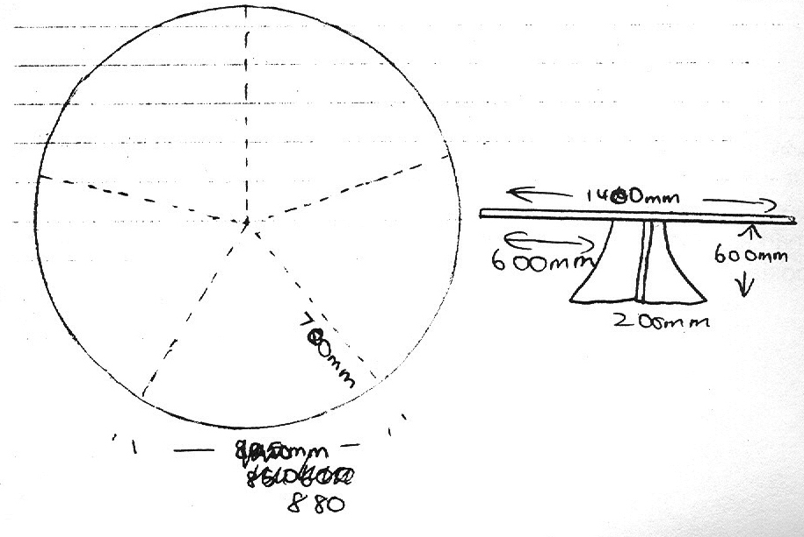Pupil A has created a table that can easily seat 5 people, and shows main dimensions on plan and elevation views.

There is no explanation for the choice of dimensions, and it is not clear how the table could accommodate 8/10 people.

Probing questions

* How did you choose these dimensions?
* How would your table be extended to meet the requirements of the task?

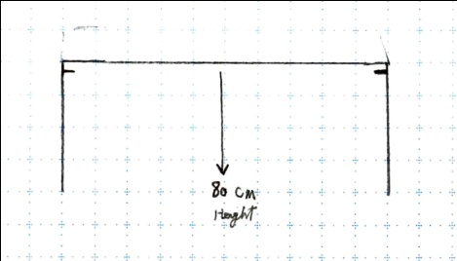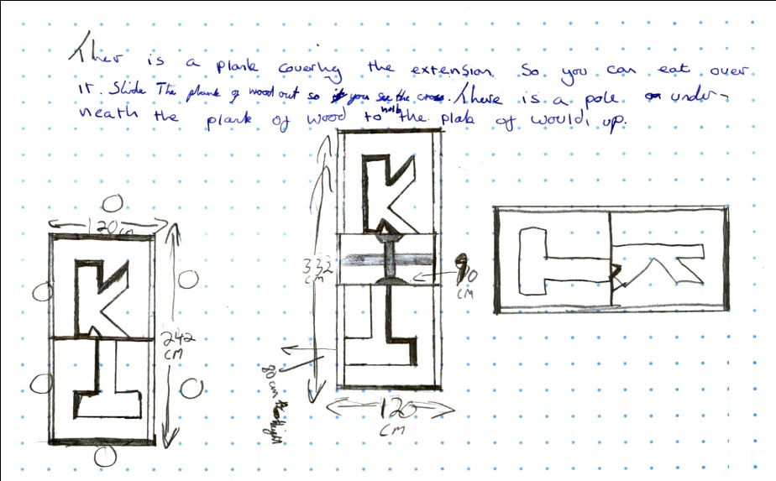Pupil B

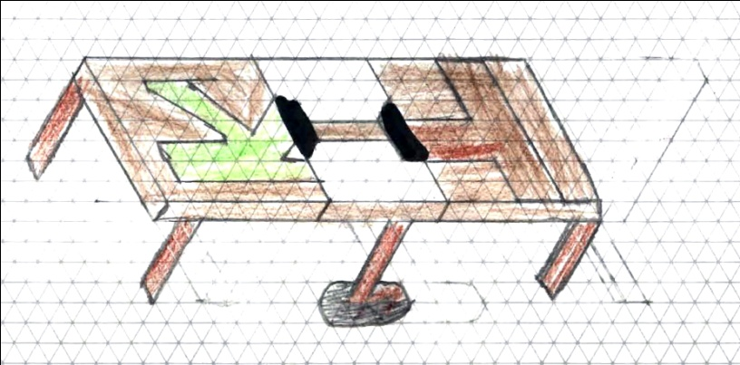

This pupil has used plans and elevations to illustrate a solution, and has attempted an isometric drawing.

There is an attempt to describe the mechanism for extending the table and the dimensions are given, but it is not clear that these have been based on the data given.

Probing questions

* Why did you select this design?
* How did you choose the dimensions?

Pupil C

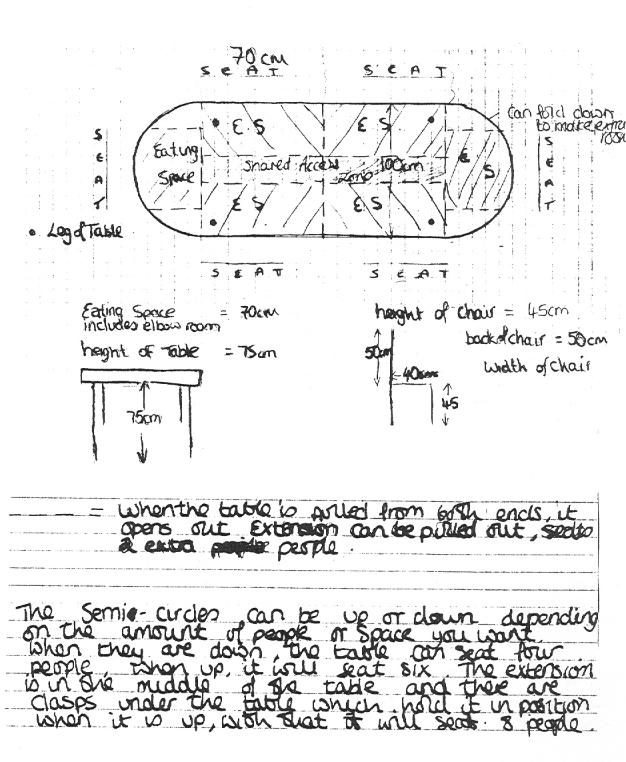

This pupil has created a solution to the task, with a clear explanation as to how the table can sit the minimum and extended numbers (8).

The accurate scale drawing gives the dimensions of the table top and a side elevation gives the height.

There is documented evidence of some data being used to determine the dimensions for the table, which are appropriate.

Probing questions

* How did you decide on the 70cm eating space?
* How did you choose the total length of your table?
* How will you convince the manufacturer that your shape and size are the best?

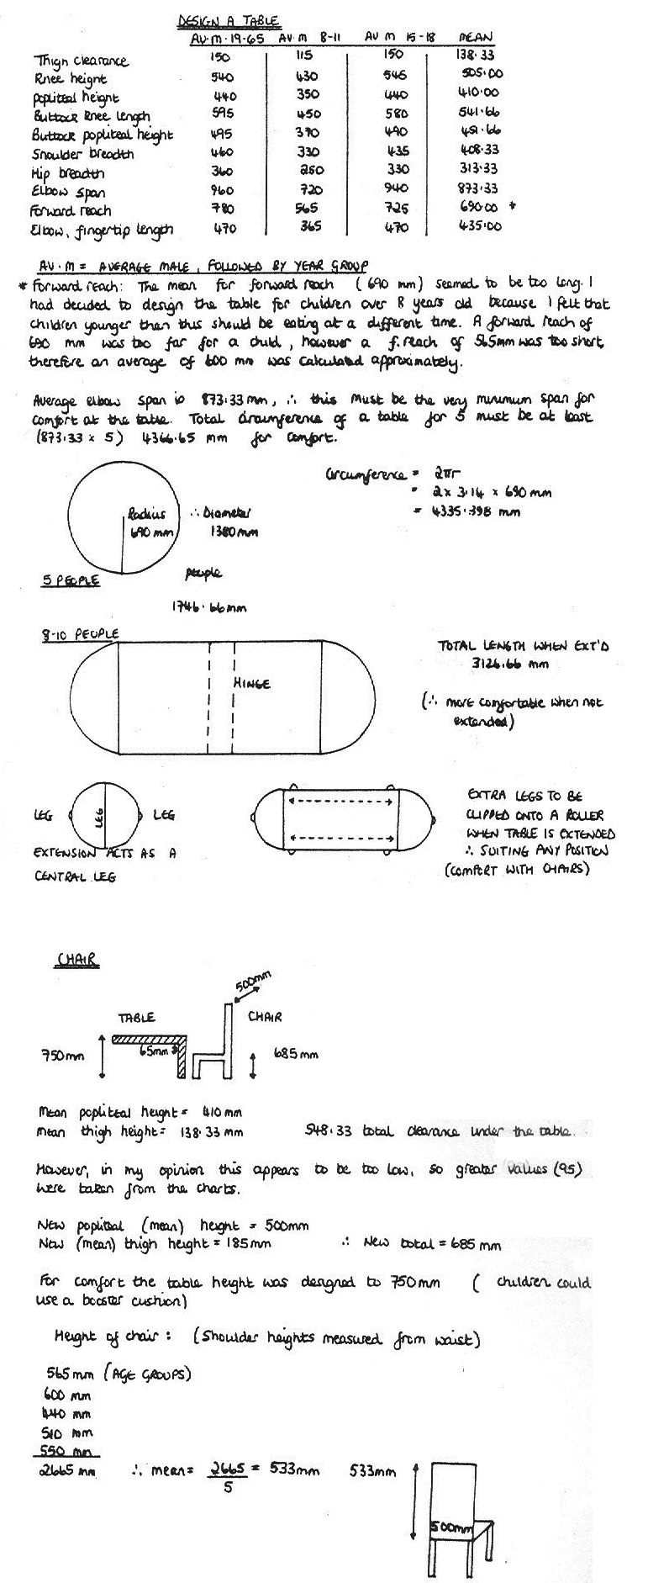Pupil D

*See notes on pupil D’s work on the next page*

Pupil D *(see previous page for this pupil’s work)*

This pupil has designed and drawn an appropriate table based upon the data given, explaining the way it extends.

The dimensions and features of the table have been carefully thought about, although the pupil does not communicate how the tension between elbow span and forward reach has been resolved.

The pupil’s design allows for the legs to be placed in a range of positions, but it is not clear how more than 8 people can be seated around the extended table.

Probing questions

* What are the risks in using average elbow span for minimum spacing around a circular table?
* How did you decide on the figure of 1746.66mm?
* How will the people be seated around the extended table?