Activity description

Pupils decide how to schedule jobs in a fashion workshop. There are six people in the workshop and all jobs must be completed in one day.

Pupils will need to consider whether their schedule is a viable solution to the problem, both in terms of the order in which the jobs can be carried out, and the form of the working days of the employees.

Suitability

Pupils working at all levels; individuals or pairs

Time 1 – 2 hours

AMP resources Pupil stimulus

Equipment

Copies of job sheet for rough work and completed notice

Computer spreadsheet

Key mathematical language Scheduling, logic, decision making

Key processes

**Representing** Identifying factors that affect decisions. Producing a clear plan for the six people who contribute to the completion of all tasks in order, within the constraints of a working day.

**Analysing** Working logically towards a workable job sheet, recognising the impact of constraints and assumptions.

**Interpreting and evaluating** Relating findings to the original problem and adjusting solutions to improve their workability, justifying decisions made.

**Communicating** **and reflecting** Presenting solutions clearly with explanations; considering the assumptions made and the appropriateness and accuracy of the final Job Sheet*.*

Teacher guidance

You may like to set the scene of work in a fashion workshop. You may need to explain what cutting, tacking and machining are. You may need to discuss the need for a clear job sheet for each day’s work, and the notion of people working different hours during the day.

Read through and discuss with the pupils the tasks listed in the student activity, bringing in aspects of the ‘Additional Information’, including decisions about various interpretations of the deliveries.

Explain to the pupils that they will need to make their own decisions to help them plan the jobs. They should write down immediately any decisions they make.

Pupils should use the ‘Notes’ section of the job sheet in the student activity material for notes about each worker, or to show calculations, general notes or decisions they took for their final notice.

Remind pupils that their notice should be easily understandable by all the workers, and that their solution should be workable in reality.

Each pair may need to use job sheet(s) for rough working, and will then need another blank copy on which to produce their final version. Alternatively, they could decide to use a different format if they wish. Remind them to transfer their notes about decisions, constraints and modifications onto the version to be submitted. Pupils working on extension tasks will, of course, need further copies of the job sheet.

During the activity

Look out for unhelpful assumptions ‘hidden’ in the Job Sheets, such as:

* everyone must start work at the same time
* people can work for eight hours without a break
* males do the driving rather than the sewing
* work must be done in one-hour blocks.

By questioning pupils about their rough answers and work in progress, you can encourage them to describe and write down all the assumptions and decisions they have made, with reasons. For example, ‘there are staggered lunch hours so that the workshop is always staffed’.

Encourage pupils to check that their solution is workable before they submit their final job sheet.

Spare job sheets should be readily available.

Discussion of working hours and conditions of work provides some cross-curricular links with PSHE.

Additional information

Every item must be cut before it is tacked, and tacked before it is machined.

The working day can start and finish when pupils choose. People can work for different numbers of hours.

Any person can do any of the tasks.

People can have both short breaks and lunch breaks at different times. It is normal for them to have a short break if working for four hours and for there to be an hour for lunch for full-time workers. The four-hour delivery includes time for a short break.

Pupils may wish to assume that the deliveries are for previously completed garments and could be made at any time (this makes the activity easier) and/or that they are local and do not have to be done in one four-hour block. Decisions on this, and the number of delivery vans available, should be noted by pupils on the job sheet.

If pupils require further information about the nature of the jobs, the following data can be given.

*One hundred track bottoms and one hundred polo shirts are being made, twenty each of sizes XS, S, M, L and XL.*

*There are four different colours of fabric, so five track bottoms and polo shirts in each size and colour are being made.*

*Five layers of fabric can be cut at one time (all the same size and colour).*

Probing questions and feedback

AMP activities are well suited to formative assessment, enabling pupils to discuss their understanding and decide how to move forward. See [www.nuffieldfoundation.org/whyAMP](http://www.nuffieldfoundation.org/whyAMP) for related reading.

* Can you check, for the track bottoms and for the polo shirts, that you have planned all the jobs in the correct order: cutting, tacking, machining?
* Remember that all six people can do any of the jobs. How many hours does each person work? Do they all get reasonable breaks?
* People are paid for the time they are at work. Does your job sheet use their time efficiently?
* How could you adjust your job sheet so that the clothes could be made and delivered all in one day?

Extensions

* Adapt the final job sheet in the light of a notified absence of one person. The effects on each person could be considered, and the person whose absence is easiest, or hardest, to deal with could be found.
* Using the additional information, produce one or more different solutions, for example, using shorter tasks involving garments of only one size and / or colour. Dividing the tasks into smaller units in this way offers more flexibility; for instance, some tacking can take place before all cutting is finished.
* Look at genuine time sheets for various workplaces, including any from pupils’ work experience placements.

Progression table

The table below can be used to:

* share with pupils the aims of their work
* facilitate self- and peer-assessment
* help pupils review their work and improve on it

Please edit it as necessary. The table supports formative assessment but does not provide a procedure for summative assessment. It also does not address the rich overlap between the processes nor the interplay of processes and activity-specific content.

|  |  |  |  |
| --- | --- | --- | --- |
| **Representing**  *Using the job sheet or other format to represent the problem*  *Identifying factors that affect decisions* | **Analysing**  *Extracting relevant information and working within constraints to find a workable solution* | **Interpreting and evaluating**  *Interpreting the effects of decisions on possibilities available and working towards improving solutions* | **Communicating and reflecting**  *Communicating decisions clearly, with reasons where appropriate* |
| Uses the job sheet to plan a solution | Shows minimal understanding through allocating some tasks on the job sheet |  | A filled job sheet is provided  Pupil A |
| P_ArrowExtracts some relevant information about sensible order of tasks  Pupils A, B | Several tasks shown on the job sheet in a sensible order, but may not all have the correct time allocation or may be impractical  Pupils A, B | Evidence that some constraints have been interpreted and taken into account  Pupil B | Communicates some of the decision making in addition to a filled job sheet  Pupil B |
| Recognises the need for tasks to be in correct order, for appropriate times, and suitably shared  Groups C, D | All tasks allocated correctly with some breaks but may have unfilled gaps  Group C | Allocates all tasks in correct order with some explanations for decisions  Groups C, D | Presents a clear and largely correct job sheet, highlighting and clarifying particular features  Groups C, D |
| Gives consideration to issues of work/break balance in the working day, and translates this to meaningful task allocations | Provides a meaningful solution that meets needs for work/break balance | Provides clear rationale for task allocations and states reasons for any assumptions and choices | Presents a clear and coherent solution, including a correct job sheet, explicitly outlining assumptions, decisions and reasons |
| Accounts for contingencies and additional constraints | Provides alternative job sheets to accommodate additional constraints  Group D | Provides explanations for adjustments to original solution | Shows evidence of reflecting on original work and communicates any modifications |

Sample responses

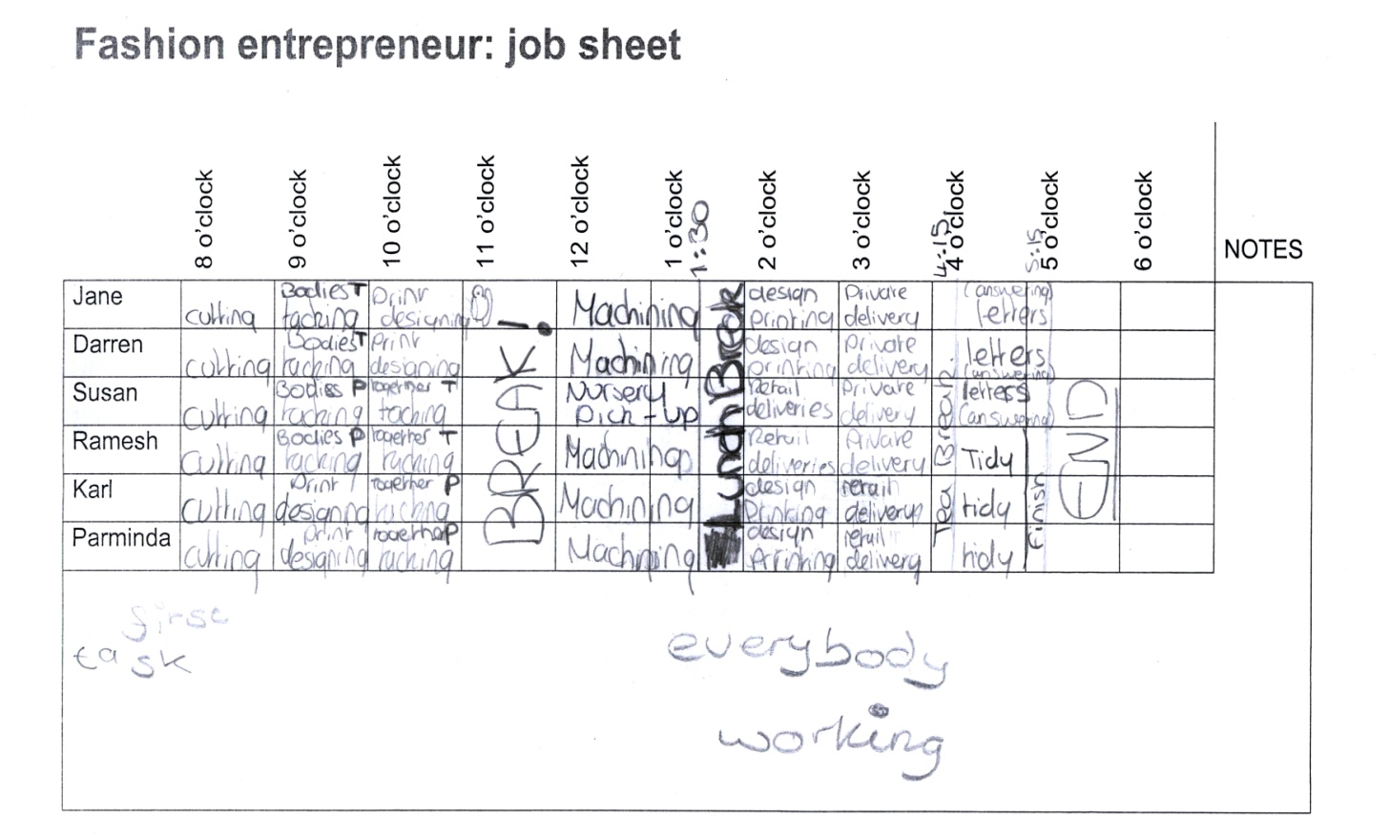Pupil A

Pupil A has used the job sheet to plan a solution which has some tasks in the correct order. The solution has been clearly presented, but the plan includes several additional tasks with no explanation, time allocations that are sometimes incorrect, and with all workers taking breaks at the same time.

Probing questions

* During break times and deliveries the office is left unmanned. Why did you choose to do this? Can you suggest an alternative solution where one or more people are always working?
* You have an afternoon tea break of 15 minutes. How could you improve your job sheet to make the length of morning break and lunch brek more realistic?
* Susan does a nursery pick-up during the day. Other workers are doing their own jobs, print designing, during the day. Why have you chosen to do this?

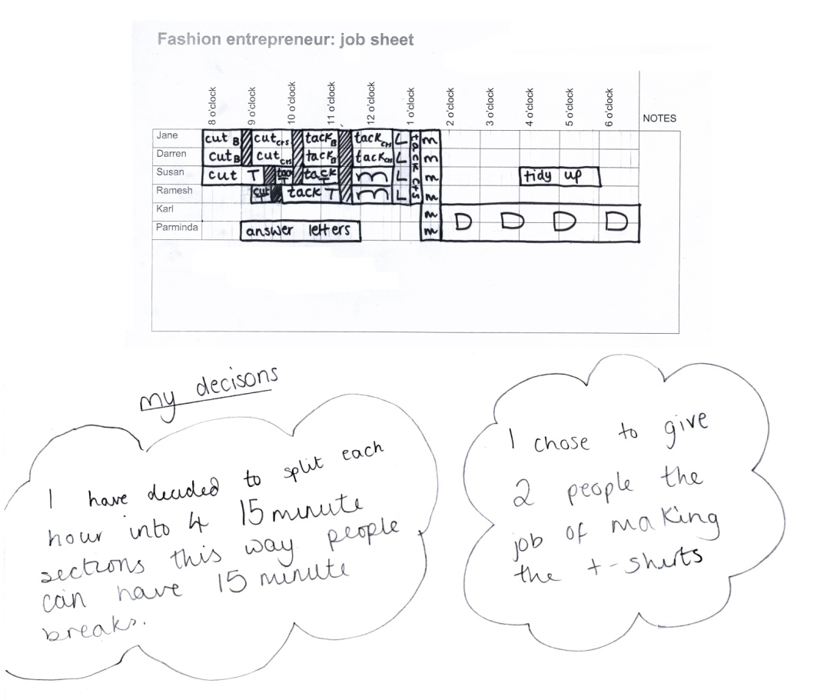Pupil B

Pupil B has considered different start and finishing times. The day has been split into 15-minute slots to allocate tasks and breaks. Tasks are generally in the correct order, but there are several errors in allocation of times for some tasks. Lunch and breaks are indicated, but without a key the job sheet is unclear. There are unexplained gaps in the working day for Susan and Parminda.

Probing questions

* How could you improve your solution so that each employee is productively engaged while they are at work?
* Can you give reasons for all the decisions you made in allocating tasks?

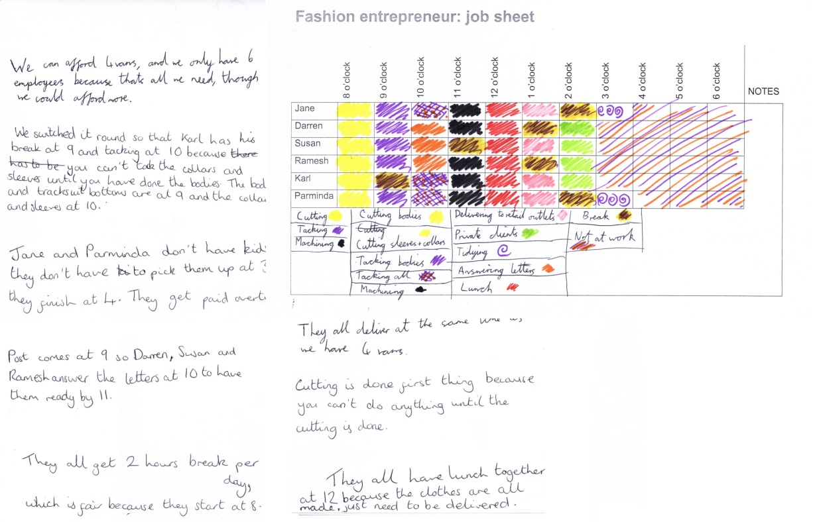Group C

Group C has considered different finishing times, with reasons, but not different starting times, for which the same reasons may apply. However the suggestion that working beyond 3pm is paid at overtime indicates that the working day is fixed as 8am to 3pm. Tasks are in the correct order and everyone has the same amount of time for breaks, but some breaks are just before or just after lunch. The practicality of one-hour breaks following lunch and followed by one hour tidying as the last job of the day is not considered.

Probing questions

* Have you considered workers having different start times as well as different finishing times?
* All breaks and lunch are the same, one hour. You could find out how much time you would be given for break and lunch if you worked in, say, a supermarket from 8am to 3pm, and use this to revise your job sheet.
* Would you want your break directly before or after lunch? Jane and Parminder have a one-hour break before their final one-hour task of tidying up. Can you explain why you’ve chosen these break time slots?
* All your tasks are performed in one-hour time slots. See if you can find another way to organise the timing of the working day.

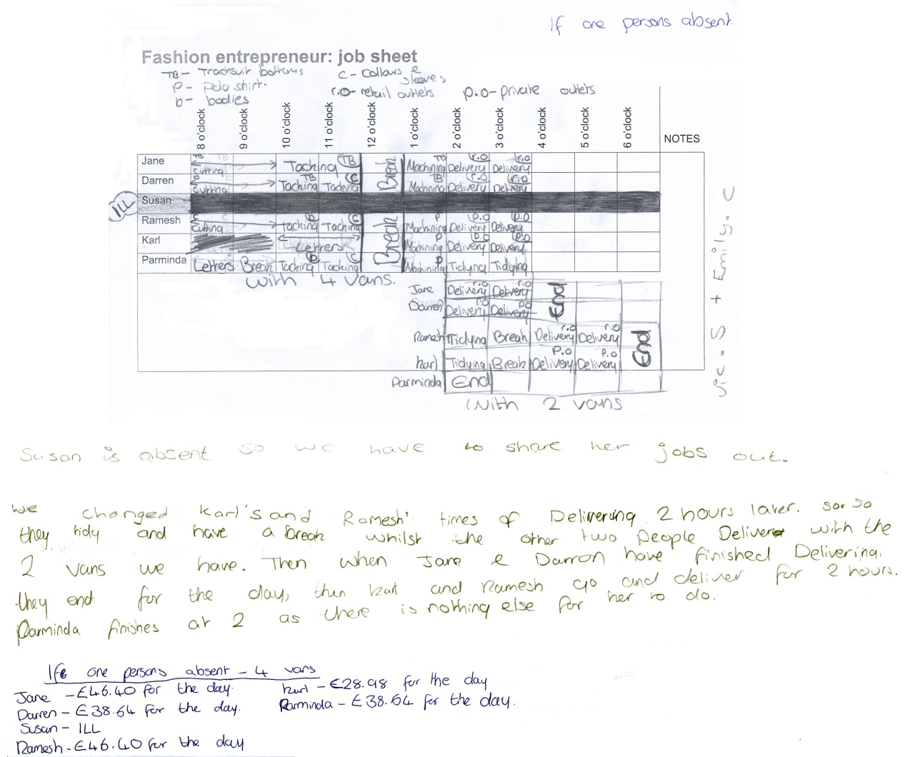Group D

Group D has produced a clear job sheet for one of the extension tasks, the absence of one worker. (The job sheet for the original task is unavailable.)

All tasks have been allocated in the correct order with correct time allocations. However no consideration has been given to anything other than one-hour blocks of time.

Two possible scenarios, the availability of two and of four delivery vans, are given with limited reasons.

Probing questions

* Have you considered allocating tasks in slots of less than one hour?
* Do all the break times need to be one hour long? How long would you get if you worked in a supermarket? What other options would you consider?