TableCraft Inc.
Industrial Rd
London SW24 8OU
UK

Dear Sir/Madam,
At Table Craft Inc. we construct tables of the highest quality. After recent market research we have decided to add a new table to our range. We have recently been informed that your group has great ability in mathematics and would therefore be ideal for the task of producing a design for this project.
The Project:
- We need designs for a cost effective family table
- It must normally be able to seat 5 people eating a family meal
- It must extend so that 8 or 10 people can eat around it on special occasions
- We must have drawings for the plan and elevation of the table including all measurements necessary for us to make the table in our factory
- You must prepare a short report showing the details of your design and explaining its main features. Parts of this will be used in our promotional materials.
We are currently in contact with several other groups to complete this project. Your report and design will be considered against those from other groups in the competition for this contract.
We look forward to seeing your design soon.
Yours sincerely,
Adam Sheraton
Mr. Adam Sheraton
Managing Director
Table Craft Incorporated

Design a table: Information sheet A

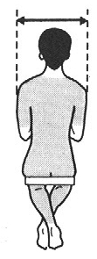  1 Shoulder breadth | 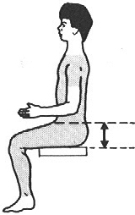  5 Thigh clearance
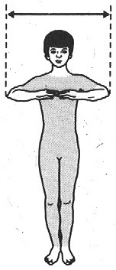  2 Elbow span | 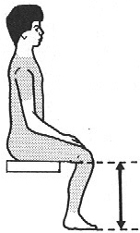  6 Kneeback height
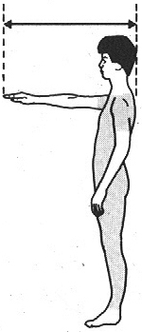  3 Horizontal forward reach | 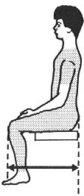  7 Buttock–knee length
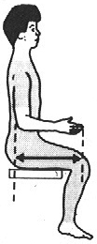  4 Elbow–fingertip  length | 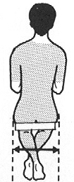  8 Hip breadth

Design a table: Information sheet B
Table 1 Body measurements for adult women
Body dimension | Size in millimetres
 | 5th percentile | 50th percentile (median) | 95th percentile
1 Shoulder breadth | 370 | 415 | 460
2 Elbow span | 815 | 890 | 960
3 Horizontal forward reach | 665 | 725 | 785
4 elbow fingertip length | 405 | 440 | 475
5 Thigh clearance | 105 | 140 | 170
6 Kneeback height | 380 | 415 | 450
7 Buttock knee length | 520 | 570 | 620
8 Hip breadth | 320 | 375 | 430
Table 2 Body measurements for adult men
Body dimension | Size in millimetres
 | 5th percentile | 50th percentile (median) | 95th percentile
1 shoulder breadth | 415 | 460 | 500
2 Elbow span | 880 | 960 | 1040
3 Horizontal forward reach | 715 | 780 | 850
4 Elbow fingertip length | 430 | 470 | 510
5 Thigh clearance | 125 | 150 | 175
6 Kneeback height | 400 | 440 | 480
7 Buttock knee length | 540 | 595 | 645
8 Hip breadth | 315 | 360 | 400

