Networks in Support of Science Teacher Education:

building social capital to increase teacher learning

Elaine Wilson, Faculty of Education, University of Cambridge

Introduction
The picture emerging about teacher education from large scale world-wide studies (Schleicher, 2012; Desimone et al , 2002; Opfer & Pedder, 2010; Timpereley et al, 2007) is that learning, regardless of the stage of a teachers’ career, involves sustained classroom-based development over an extended period of time. Furthermore transformative development only occurs when teachers ‘buy into’ why they need to change practice and when teachers are able to work collaboratively with others to find out how they can make changes together with active support from peers and experts to illustrate what to do to make changes.
This sustained collaborative approach to teacher education is already well established in school university partnership pre-service education courses in the UK where university departments work collaboratively with schools to educate new entrants to the profession. The same model operates in the ‘top performing’ countries of the world and a number of the countries cited in the McKinsey report go further by conceptualising teacher education as a continuous process of lifelong learning from pre service to retirement (Barber & Moushad,2007).
This paper will present a case for extending partnership models of science teacher development in the UK through establishing more formal networks of schools, universities and science learning centres. I will use social capital theory to argue that teacher learning is not simply about cognitive development but that affective and social dimensions of learning are also vital and I will illustrate this by sharing the findings of a recent study of an established science teacher education network centred on the University of Cambridge.

How do teachers learn in classrooms?
Teacher knowledge is both explicit and tacit in form (Eraut, 2002). Explicit, codified academic knowledge is the accumulated propositional knowledge stored in texts, databases, studentship, scholarship, research and cultural practices of teaching. For a secondary science teacher in the UK this is introduced through graduate education and the acquisition of specialised subject knowledge. This sort of explicit knowledge is about intellectual development and progressing through a hierarchy leading to greater levels of abstraction and a deeper understanding of a substantive area of knowledge.
However, this is not the only type of knowledge that an effective teacher uses or requires to do their job. The other form of knowledge is practice-based tacit teacher knowledge. Tacit knowledge of teaching is context-specific and difficult to make explicit, although there are published texts which attempt to distil this into ‘tips for teachers’ style books. Tacit knowledge of teaching is largely acquired informally through participation in authentic classrooms, through guided positive learning experiences. It could be argued then that this is exactly what school based training provides and to some extent this is correct because tacit knowledge of teaching can only be developed in a real classroom. However, accessing tacit teacher knowledge is not straightforward because expert teachers often ‘take for granted’ how and why they do things in classrooms (Eraut, 2004). Expert teachers’ actions have often become so routine that their actions are almost procedural in character (Knight 2002). Introspection on daily practice is not uppermost in the mind of the expert teacher in a busy classroom on a day-to-day basis. Consequently, when called upon, experienced teachers can find it difficult to rationalize and articulate what is actually going on in their classrooms and why they are doing things in a particular way (Wilson & Demetriou, 2007).
A further complication is that new teachers’ judgements at the start of their practical experience are influenced by their own experience as a student, albeit gleaned from the perspective of being a student themselves. Furthermore, many prospective teachers have attended very different types of schools from their practical placement school. Indeed it may be the case then that without direct guidance a novice teacher may not fully appreciate the complexity of the new school situation. Therefore simply observing and being observed is unlikely to help a novice make sense of what is going on in complex classrooms. Making sense of classrooms from a teacher’s perspective is a more sophisticated process, involving understanding how deliberative decision making is carried out, something which is not always apparent to an untrained observer. This deliberative approach (Table One) is based on a deeper understanding of a number of interrelated aspects of the specific classroom and is about knowing why, how and what to do in a classroom to ensure that all students learn. Deliberative knowledge includes; understanding how and when to use appropriate pedagogical approaches; good understanding of the contextual features of specific classrooms, together with detailed knowledge of students and what motivates them to learn.
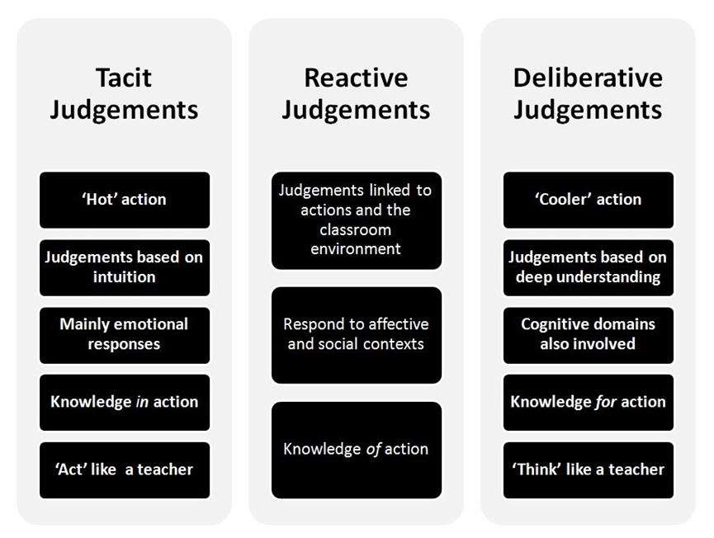
Table One: Stages of reflection from tacit to deliberative judgements

Becoming an expert teacher, then, is a transformative process rather than simply the acquisition of skills. Developing a teacher’s capacity to become an expert teacher involves rather more than acquiring a classroom ‘craft’. Furthermore, becoming critically reflective and able to make deliberative judgements about classroom interactions goes beyond mimicking other teachers behaviour. In other words, becoming a teacher is about ‘growing capacity to make appropriate judgements in changing, and often unique circumstances’ (Beckett & Hager 2000, p. 302).

Teacher learning is coloured by emotions and social interactions
It is widely accepted that the early years of teaching are highly stressful and that becoming a teacher is not just driven by rational thinking but is also influenced to a large degree by human experiences and emotions (Hoekstra et al. 2007; Demetriou, Wilson, & Winterbottom, 2009). It has been suggested that poor retention rates are also linked to lack of self-efficacy in these vulnerable early years (Hakanen et al., 2006; Wilson & Deaney, 2010).
A key determinant in the early success of novice teachers is learning how to establish positive classroom learning environments. Early in the experience novices’ self-efficacy appraisals are closely linked to beliefs about their self-appraisal of competence. How well a novice copes with difficult situations is closely linked to how much support is provided at the early stages.
Teacher learning also involves mind, body and emotions and is embedded in social
and physical situations and practice. Emotions play a crucial role in communication
and engagement between people. This is not a new idea at the turn of the 19th century
John Dewey (1933, 189) wrote of the necessity to address emotions in
Education when he said that : “…There is no education when ideas and knowledge are not translated into emotion, interest, and volition”. More recent research by Hargreaves (2000, 2005) emphasises the importance of fostering close relationships between school leaders, teachers and their colleagues and students, and warns that, without such relationships, teachers are prone to ill health, absences and in early exit from the profession.
The journey to becoming a teacher is not a straightforward linear process and once established, self-efficacy beliefs are difficult to change ( Wilson & Deaney, 2010). Retaining good science teachers is an on-going problem and it is becoming increasingly more difficult for science teachers to find or devote time to keep abreast of developments in their subject our pedagogy (Pedder et al, 2008).
Is there evidence that working collaboratively in University-learning centre- school networks could alleviate some of these difficulties? The next section will present the findings from a study using social network theory of how social capital can be built within a network.

What is Social Capital?
Social capital theory is developed through the interactions between people when they build communities and commit themselves to the roles within a network. It is through cultivating a sense of belonging and the concrete experience of social networks, building relationships of trust, which bring most benefits to a partnership. Putman defines this further:

Whereas physical capital refers to physical objects and human capital refers to the properties of individuals, social capital refers to connections among individuals – social networks and the norms of reciprocity and trustworthiness that arise from them. (Putnam 2000, p. 19)

In other words social capital is a way of defining the intangible resources of a community, such as shared values and trust which participants draw on in their role within a university-school based partnership and is perceived to be a valuable asset to the individuals within the network. This idea that social relations, networks, norms, and values matter in the functioning and development of society has long been researched in the fields of economics, sociology, anthropology, and political science (Bourdieu, 1983; Coleman, 1988, 1990; Lin, 2001, Putnam, , 2000).

Extending teacher education: social capital theory

The contributors to social capital within the Cambridge university-school partnership comprises the 50 schools and staff within the university department who have worked collaboratively to establish the partnership as it stands at the time of writing. The good relationships, positive attitudes of the people and the shared values have been built up over a number of years and these now govern interactions. Trust and mutual respect have been cemented through regular face-to-face meetings, online contact and constant shared reflection and re-evaluation of the roles within the partnership. Such trust is easily undermined and so there is a distinct maintenance ‘expense’ to social capital, usually in the form of time. Rapid major shifts in recruitment patterns and changing roles could potentially alter the dynamics of the partnership.
The next section will focus more closely on one part of the university-school partnership and will analyse the social capital within the secondary science part of the partnership.

The Scope, Forms, and Channels of Social Capital
The social capital within the university-school based partnership can be analysed along three dimensions, using a framework developed by Grootaert and van Bastelaerthe (2002). These dimensions are scope, form (see Figure One) and the channels or networks through which social capital can influence practice within the partnership.
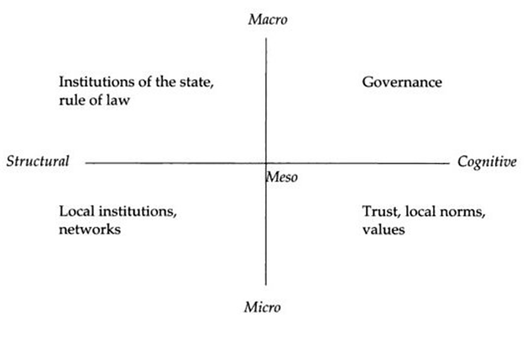
Figure One: Scope and form of social capital (Grootaert and van Bastelaerthe , 2002).

The Scope of Social Capital

Social capital is located at micro, meso and macro levels. At the micro level social capital operates within the individual school and university institutions. Each school has individual, specific norms and values, and within each school there are also science department also with specific norms and vales also operating at a micro level (Putnam, 2000).
The interactions between the school science departments, the university department and the novices who are learning to become teachers operate at a higher meso level are channelled through horizontal links across institutions (Coleman, 1990). Macro level social capital operates at a higher level still, beyond the school and wider university and has vertical associations which are characterized by hierarchical relationships.
The Forms of Social Capital
Social capital exerts influence at all three levels (micro, meso, macro) and takes structural and cognitive forms. Structural social capital facilitates information sharing, collective action and decision making through establishing roles, social networks and other social structures which are supplemented by rules and procedures. Structural forms of social capital are relatively objective, externally observable constructs which can be mapped. On the other hand, cognitive social capital, which refers to shared norms, values, trust, attitudes, and beliefs, is more subjective and intangible and can only be accessed indirectly. Table Two sets out the structural and cognitive forms of social capital located at a micro level in each type of institution.
Institution | Schools | University education department
Structural social capital | Access to authentic classrooms  Interactions with students | Access to recent developments in substantive and research knowledge
Cognitive social capital | Values practice knowledge | Values theoretical knowledge
Table Two: Micro levels of social capital within school and university education departments

Schools have a clear function in promoting the learning of students in the school and so share social capital between teachers working collegially to increase students’ learning. Therefore it is right and proper that teachers focus on developing context specific practice knowledge, to plan lesson sequences and manage groups of learners. As a consequence, teachers value practice knowledge over other sorts of knowledge. The corollary, however, is that having a single focus can mean that teachers do not prioritize the updating and development of this practice knowledge for very sound pragmatic reasons. This can create an insularity of methods within a school and make it more difficult to introduce new ideas to practice.
On the other hand, university departments have access and time to think deeply about pressing educational questions and rightly privilege scholarly activity and the development of substantive research knowledge over practice knowledge (McIntyre, 2005). A major strength of a university - school partnership lies in being able to bridge this gap. Teacher educators who work on PGCE courses have also been classroom teachers and so are perceived to be competent and trustworthy by school-based teachers. This helps to make crucial links between practice and research knowledge. The recent OECD report (Schleicher, 2012) and the extract form the report in Box One reinforces the importance of this bridging process of linking practice with research which is facilitated through successful collaboration between university departments science learning centres and schools.
Box One : The OECD’s comparative review of innovative learning environments concludes that:
• Teachers need a rich repertoire of teaching strategies, the ability to combine approaches, and the knowledge of how
and when to use certain methods and strategies.
• The strategies used should include direct, whole-group teaching, guided discovery, group work, and the
facilitation of self-study and individual discovery. They should also include personalized feedback.
• Teachers need to have a deep understanding of how learning happens, in general, and of individual students’
motivations, emotions and lives outside the classroom, in particular.
• Teachers need to be able to work in highly collaborative ways, working with other teachers, professionals nd para-professionals within the same organization, or with individuals in other organizations, networks of
professional communities and different partnership arrangements, which may include mentoring teachers.
• Teachers need to acquire strong skills in technology and the use of technology as an effective teaching tool, to both optimize the use of digital resources in their teaching and use information-management systems to track student learning.
• Teachers need to develop the capacity to help design, lead, manage and plan learning environments in collaboration with others.
• Last but not least, teachers need to reflect on their practices in order to learn from their experience. (p38)

The next section will use social network analysis to illustrate how science teacher educators and science teachers work together to channel social capital within the network so that school and university based practice is developed in tandem.

What is Social Network Analysis?
Social network analysis is based on an assumption that participants and their actions are interdependent. Relational ties or linkages act as channels for the flow of resources and ideas between the participants in the network. Recent work by Grootaert and van Bastelaerthe (2002) has gone some way to developing methods to analyze networks using multiple methods.

Network maps
The network linkages between university and school were analysed using two types of network map (Fox et al, 2007). The university - school network boundaries were mapped on a whole network map which is shown in Figure Two. The nodes show the density of teachers who have been educated by the Cambridge partnership team and now have teaching posts in science departments within the network. Indeed, 40% of the schools have five or more former Cambridge students who are members of the science department staff. The arrows show the direction of flow of ideas and resources and show that 30% of the schools actively contribute to the faculty based programme. There are also two clusters of schools working together to provide a common programme for novices.
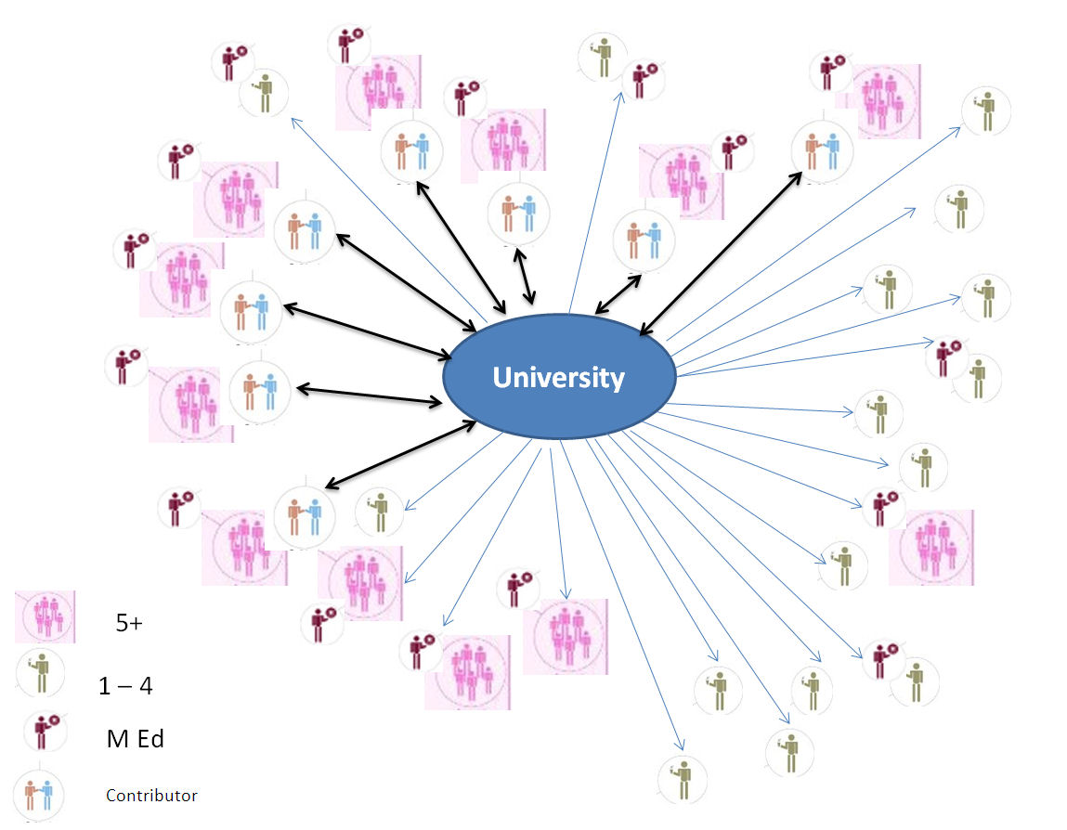

Figure Two : Whole network map

Two further interesting findings emerged from this mapping exercise. First, 65% of the school based mentors who work with novices during their school-based practicum have also been educated on the Cambridge course. This ‘reserve’ of cognitive social capital reinforces the work of the partnership and ensures that common values and principles are shared explicitly between the school and university department. Secondly, 60% of the school science departments have one or more former Cambridge Science M.Ed. students working in the department. This ensures that new context specific research knowledge and practice is being actively developed in partner schools. Furthermore these Masters qualified teachers also assist novice teachers with their school-based research projects. As a consequence there has been a marked shift in attitudes among school-based teachers towards supporting this school-based research element of the course. Over the years, the values within the partnership have altered markedly from dismissing universality based research work to accepting that classroom-based research is an important part of developing classroom practice for all teachers.
The second type of map was drawn by novice teachers at the end of their course. (Figure Three). These maps were drawn from an ego-centred point of view with novices drawing a map of their personal support network.
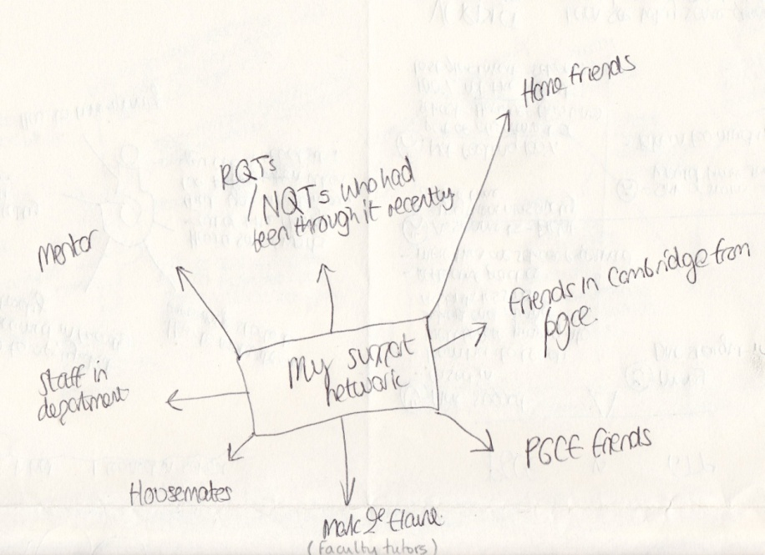
Figure Three: an example of an ego-centred map

The people most frequently cited as providing support were peers on the course, and then school-based teachers and university lecturers. In addition, novice teachers were asked to write about what they believed they learned in both institutions within the network. Table Three sets out the key themes emerging from an analysis of all the maps and Figure Four shows an example of this type of map.
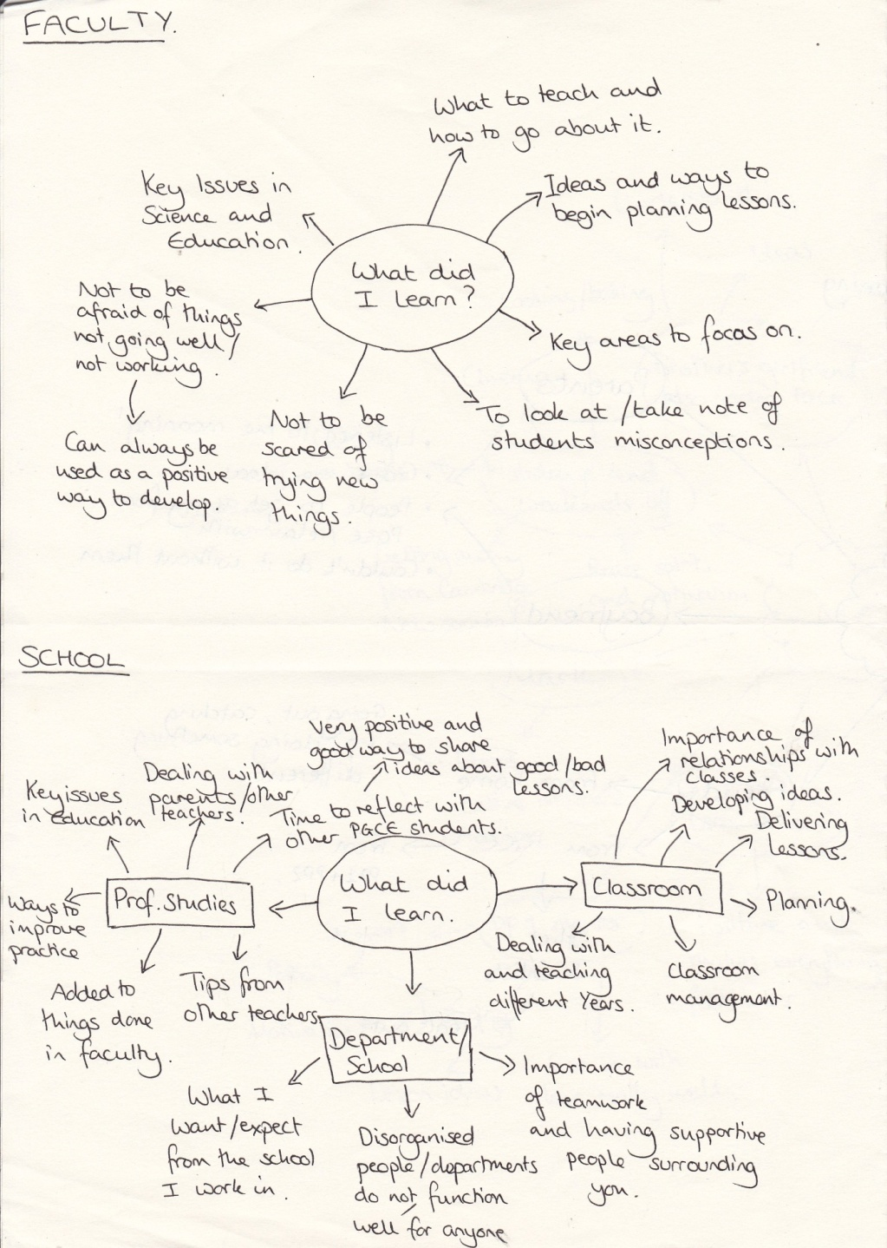
Figure Four: An example of novices’ maps of support provided

Structural social capital | Cognitive social capital
University based  opportunity to work with internationally recognised teacher educators and researchers;  opportunity to develop a deep understanding about how students learn;  access to up to date recent developments in subject knowledge and educational research;  acquire a recognised Masters level qualification as well as qualified teacher status;  School based  provision for novices to gain a deeper understanding of the complexities of teaching in a range of classrooms;  support from expert teachers in applying and preparing for interviews and first teaching posts;  time to think about practice in authentic classrooms; | University based  support to make thoughtful, deliberative judgements, so that teachers can solve problems in the future in response to unique classrooms;  sustained pastoral support during the first few, potentially difficult years, of teaching, beyond Initial teacher education;  School based  access to supportive expert school based mentors who have been trained by the university and share the same values;
School–university partnership
access to knowledge of, and instruction in, effective ways of teaching to ALL learners in ALL classrooms;

to be able to work within a collegial teacher learner community with support networks among peers, expert teachers and subject lecturers;

to have access to contrasting school experiences during Initial Teacher Education (ITE).

Table Three: What novice teachers say they learn and where this takes place.

Table Three illustrates that each type of institution has a unique part to play in the education of teachers, reinforcing a point made earlier that neither institution can provide such a range of learning opportunities in isolation.

How social capital is channelled through the network
There are four key factors which seem to explain how the embedded resources channel through the network. Two factors can be categorised as structural social capital and two which are categorised as cognitive social capital
A. Structural social capital
1. Facilitating the flow of information
The established structures which are in place channel structural social capital so that there is a constant flow of information and ideas moving across the horizontal links between school and the university. In pre service programmes this flow has been predominantly from the university to schools and takes the form of faculty organised face-to-face meetings for sharing information about novices’ progress and to develop participants’ knowledge about mentoring as well as in updating subject knowledge. However, there is now also an increasing flow from schools back into the faculty through teachers contributing to the faculty programme which serves to integrate practice and research knowledge more explicitly.
Through monitoring the use of the course management system it is also possible to record that all participants have accessed documents and research papers in the repository. Furthermore, analysis of the use of email and announcement traffic in the site showed that of the 200 email communications and 112 announcements sent to all participants , 20% were about motivating and supporting novices at key pressure points in the year, 25% involved sharing resources and ideas to supplement pedagogical and subject content knowledge, 25% were to share school-based research information including guidance with research methods, 19% were about passing on details about teaching vacancies in and beyond the network and 10% were inviting all participants to take part in extracurricular science and research events at the faculty.
2. Opening up access
The social linkages set up have also extended access of school-based participants to less accessible resources. Over the years we have invited expert researchers and colleagues formt he science learning centres to address all participants about the most recent educational research areas. Furthermore, getting information about recent research and increasing research expertise has been extended because of the increased numbers of research trained Masters level new teachers in schools. Research knowledge about practice is now generated in the science departments and is disseminated throughout the network. The university also publishes an online peer reviewed journal to share good examples of research work more widely (Journal of Trainee Teacher Educational Research, http://jotter.educ.cam.ac.uk/).
Furthermore, our data show that the trusting relationships established during pre-service education courses carry on into the early years of teaching through access to social networks and through studying for a higher degree.
B. Cognitive social capital
3. Social Ties
There is evidence that the social ties set up through the network seem to exert an influence on the novices who obtain teaching posts within the network (Fox et 2011). The whole network map showed that all schools had at least one former novice working in the science department with 40% of the schools having five or more Cambridge trained science teachers. This may of course be accounted for simply because of geographical proximity to Cambridge. Nonetheless, it does mean that there is a high density of people working within the network who hold similar values and beliefs about science teaching who are able to work with novices and other science teachers within the network.
Another interesting finding is that teachers who have been educated within the Cambridge partnership have maintained contact through friendships beyond the partnership network. For example, there is a PGCE alumni Facebook site which also includes people who trained with us who are working beyond our network.
4. Social interactions
Social relations within the network also reinforce identity and recognition. The active support available from peers, school-based teachers and lecturers helps to increase early career teachers’ sense of self-efficacy. This valuable reassurance and recognition serves to reinforce individual worth and promotes support through being a member of a social group sharing similar interests and resources. This not only provides emotional support but also public acknowledgment of competence.

Conclusion
There are a number of advantages to being part of a university-school partnership. First, university departments are ideally placed to help build social capital with and between school partners. This can take the form of improving and developing teachers’ subject knowledge. Universities can provide access to real experts in the field who can work with science educators, novices and school-based teachers to make recent ideas accessible and available in school classrooms.
Second, collaborative relationships between schools and university departments are underpinned by a shared understanding of how research knowledge and practice knowledge intersect to inform practice about, for example, helping new teachers to engage pupils in learning how to learn. As discussed earlier, effective teachers are constantly called upon to make deliberative judgements about practice and this knowledge is developed through working in collaborative teams in both a school and a university. For example, accessing recent research based knowledge, guided by university staff and then integrating this into current practice though undertaking classroom based action research.
Third, existing university-school pre service partnerships are able to set up opportunities for novices to hone their practice in different schools. At Cambridge novices benefit from two major practicum experiences in at least two very different schools. During the early careers stages, having the opportunity and time to reflect upon practice between placements helps the novices to develop thinking about practice as there is little time to reflect and think on-the-job. Through working collaboratively with groups of schools and university departments early career teachers cultivate a sense of identity which increases self esteem and reducing teacher wastage through early exit. Networks provide a secure, supportive and trusting environment. Extending his wider would go a long way to helping to retain more teachers in classrooms and making more experienced teacher feel more valued too would greatly benefit all schools
In the wider sense, teacher education institutions and science learning centres also serve as key change agents in transforming education and society. Not only do such institutions educate new teachers, update the knowledge and skills of existing teachers, create teacher-education curricula, provide professional development for practising teachers, contribute to textbook production and consult with local schools, they often also provide expert advice to national and international ministries of education. Because of this broad influence on curriculum design and implementation, as well as policy setting within educational institutions, faculty members of teacher education institutions are perfectly poised to promote teacher education in the longer term.

References
Barbar, M. & Mourshed, M. (2007,). How the world’s best performing schools come out on top. McKinsey and Company.
Beckett, D. & Hager, P. (2000). Making judgements as the basis for workplace learning toward an epistemology of practice. International Journal of Lifelong Learning, 19 (4), 300 – 311.
Bourdieu, P. (1983). Forms of capital. In J. C. Richards (Ed.), Handbook of Theory and Research for the Sociology of Education. New York: Greenwood Press.
Coleman, J. C. (1990, 1994). Foundations of Social Theory. Cambridge, Mass.: Harvard University Press.
Demetriou, H., Wilson, E. & Winterbottom, M. (2009). The role of emotion in teaching: Are there differences between male and female newly qualified teachers' approaches to teaching? Educational Studies, 35 (4), 449-473.
Desimone, L., Porter, A., Garet, M., Yoon, K. S., & Birman, B. (2002). Effects of professional
development on teachers’ instruction: Results from a three-year longitudinal study. Educational Evaluation and Policy Analysis, 24(81), 81–112.
Dewey, J. 1933. How we think: A restatement of the relation of reflective thinking to the
educative process (1910), rev. ed. Boston, MA: Heath.
Eraut, M. (2002). Menus for choosy diners, Teachers and Teaching: Theory and Practice, 8, 371–379.
Eraut, M. (2004). Informal learning in the workplace. Studies in Continuing Education, 26, 247–273.
Fox, A., Wilson, E. & Deaney, R. (2011). Beginning Teachers’ Workplace Experiences: Perceptions of and Use of Support. Vocations and Learning, 4 (1), 1-24.
Fox, A., McCormick, R., Procter, R. and Carmichael, R. (2007). The design and use of a mapping tool as a baseline means of identifying an organisation’s active networks. International Journal of Research & Method in Education, 30 (2), 127-147.
Gootaert, C. & von Bastelaer, T (2002). Understanding and measuring social capital. A multi-disciplinary tool for practitioners. Washington: The World Bank.
Hargreaves, A. 2000. Mixed emotions: teachers’ perceptions of their interactions with
students. Teaching and Teacher Education 16: 811–26.
Hargreaves, A. 2005. Educational change takes ages: Life, career and generational factors in teachers’ emotional responses to educational change. Teaching and Teacher Education. 21: 967–83.
Hoekstra, A., Beijard, D. Brekelmans, D & Karthagen, F.(2007). Experienced teachers’ informal learning from classroom teaching. Teachers and teaching; Theory and Practice,13 (2),189 – 206.
Knight, P( 2002) A systemic approach to professional development: learning as practice. Teaching and Teacher Education. 18 (1) 229–241
Lin, N. (2001). Social Capital; A theory of social structure and action. Cambridge. Cambridge University Press.
McIntyre, D. (2005). Bridging the gap between research and practice. Cambridge Journal of Education, 35, 357-382.
Opfer, V.D., Pedder, D. and Lavicza, Z. (2011) The role of teachers’ orientation to learning in professional development and change: A national study of teachers in England. Teaching and Teacher Education, 27(2), 443-453.
Pedder, D., Storey, A., Opfer, V. (2008). Schools and continuing professional development (CPD) in England – State of the Nation research project. Cambridge University, Open University and Training and Development Agency.
Putnam, R. D. (2000). (Ed.) Democracies in Flux: The Evolution of Social Capital in
Contemporary Society. New York: Oxford University Press.
Schleicher, A. (2012). (Ed.) Preparing Teachers and Developing School Leaders for the 21st Century: Lessons from around the World. Paris: OECD Publishing. Retrieved from http://www.oecd.org/dataoecd/4/35/49850576.pdf.
Timperley, H., Wilson, A., Barrar, H. and Fung, I. (2007) Teacher Professional Learning and Development: Best Evidence Synthesis Iteration ( BES).Available from: http://www.educationcounts.govt.nz/__data/assets/pdf_file/0017/16901/TPLandDBESentire.pdf
Wilson, E. & Demetriou, H. (2007). 'New teacher learning: substantive knowledge and contextual factors'. Curriculum Journal, 18 (3), 213 – 229.
Wilson, E. & Deaney, R. (2010). Changing career and changing identity: How do teacher career changers exercise agency in identity construction? Social Psychology of Education,13(2),169 – 183.

