**Key Stage 3 – Cold chemistry**

**Colder and colder…**

**Student worksheet 1**

* Match each temperature card to one picture card.
* Place the temperature and picture cards in the correct places on the temperature line below.

-200 −150 −100 −50 0 +50 +150 **ºC**

|  |  |  |  |  |  |
| --- | --- | --- | --- | --- | --- |
|  |  |  |  |  |  |
|  |  |  |  |  |  |

73 123 173 223 273 323 373 **kelvin (K)**

**Questions**

1. If the temperature is 0 ºC what is the temperature in kelvin?
2. If the temperature is -100 ºC what is the temperature in kelvin?
3. Which is hotter – the temperature of boiling water or the surface of the Moon during the day?
4. Which is cooler – the surface of the Moon at night or the coldest temperature recorded on Earth?

**Student worksheet 2**

**Temperature cards**

|  |  |  |  |  |  |  |
| --- | --- | --- | --- | --- | --- | --- |
| **58 ºC** | **− 89 ºC** | **100 ºC** | **0 ºC** | **38 ºC** | **42 ºC** | **37 ºC** |
| **35 – 41 ºC** | **4 ºC** | **−18 ºC** | **−153 ºC** | **107 ºC** |  |  |

**Picture cards**

|  |  |  |  |  |  |  |
| --- | --- | --- | --- | --- | --- | --- |
| Hottest temperature recorded on Earth (Libya, 1922)  C:\Users\User\AppData\Local\Microsoft\Windows\Temporary Internet Files\Content.IE5\3CR97010\iStock_000004369071XSmall.jpg | C:\Users\User\AppData\Local\Microsoft\Windows\Temporary Internet Files\Content.IE5\IU1WRC1N\iStock_000013671774XSmall.jpgHottest temperature in the UK | C:\Users\User\AppData\Local\Microsoft\Windows\Temporary Internet Files\Content.IE5\IU1WRC1N\iStock_000003990230XSmall.jpgTypical freezer temperature | Melting point of ice  C:\Users\User\AppData\Local\Microsoft\Windows\Temporary Internet Files\Content.IE5\8IL2BN2P\iStock_000020224781XSmall.jpg | C:\Users\User\AppData\Local\Microsoft\Windows\Temporary Internet Files\Content.IE5\3CR97010\iStock_000000764456XSmall.jpgTemperature of the Moon during the day | Body temperature of a chicken  C:\Users\User\AppData\Local\Microsoft\Windows\Temporary Internet Files\Content.IE5\IU1WRC1N\iStock_000009204375XSmall.jpg | C:\Users\User\AppData\Local\Microsoft\Windows\Temporary Internet Files\Content.IE5\3CR97010\iStock_000000764456XSmall.jpgTemperature of the Moon at nig ht |
| Boiling point of water  C:\Users\User\AppData\Local\Microsoft\Windows\Temporary Internet Files\Content.IE5\3CR97010\iStock_000023461160XSmall.jpg | Body temperature of a human  C:\Users\User\AppData\Local\Microsoft\Windows\Temporary Internet Files\Content.IE5\8IL2BN2P\iStock_000000199913XSmall.jpg | C:\Users\User\AppData\Local\Microsoft\Windows\Temporary Internet Files\Content.IE5\8IL2BN2P\iStock_000005142129XSmall.jpgColdest temperature recorded on Earth (Antarctica, 1983) | Body temperature of a camel  C:\Users\User\AppData\Local\Microsoft\Windows\Temporary Internet Files\Content.IE5\NT2VF3W3\iStock_000004438549XSmall.jpg | C:\Users\User\AppData\Local\Microsoft\Windows\Temporary Internet Files\Content.IE5\NT2VF3W3\iStock_000017072302XSmall.jpgTypical fridge temperature |  |  |

**58 ºC**

**−89 ºC**

**100 ºC**

**0 ºC**

**38 ºC**

**42 ºC**

**37 ºC**

**35-41 ºC**

**4 ºC**

**−18 ºC**

**−153 ºC**

**107 ºC**

**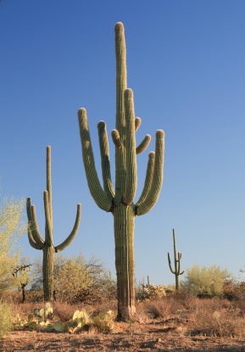Hottest temperature on Earth**

**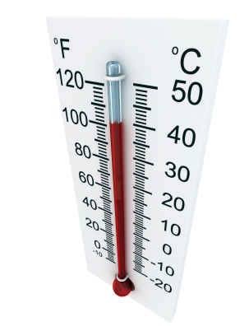Hottest temperature in the UK**

**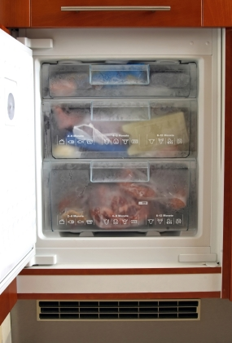Typical freezer temperature**

**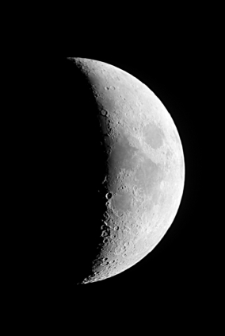Temperature of the Moon in the day**

**Temperature**

**of the Moon at night**

**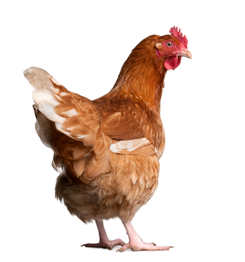Body temperature of a chicken**

**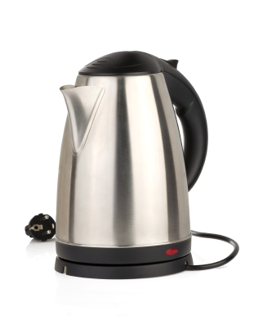Boiling point of water**

**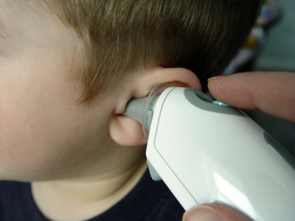Body temperature of a human**

**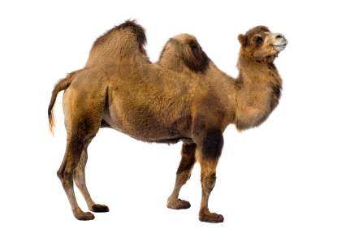Body temperature of a camel**

**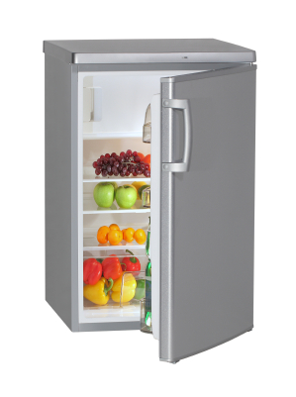Typical fridge temperature**