Key Stage 3 –
Crystal Modelling
Pupil worksheet
X-ray crystallography
What is inside a crystal of salt? How are atoms arranged to make the protein molecules of your heart? What is Mars made of?
How do scientists answer these questions? They use X-ray crystallography. Just as doctors use X-rays to see bones in your body, scientists use X-rays to look into crystals. If an X-ray crystallographer can obtain crystals of a substance, she or he can find out how its atoms are arranged.
Your task
X-ray crystallography is a vital technique. Can you explain it to someone else?
Preparation
- Read the section How X-ray crystallography works.
- Look at models A to J. Some are pictures or ideas. Others are things you can hold or try out.
- Work out which stage of X-ray crystallography each model helps to explain. Some stages have more than one model. Some models help explain more than one stage.
- Choose five or fewer models. Plan how to use the models to explain what X-ray crystallography is, how it works, and why it is important.
Explanation
- Present your explanation to students from another class.
- Be prepared! The students will use the peer evaluation sheet to assess you.
How X-ray crystallography works
Scientists use X-ray crystallography to work out the arrangement of atoms in a substance.
Stage 1
Make a crystal of the substance. The crystal must be very pure and perfect.
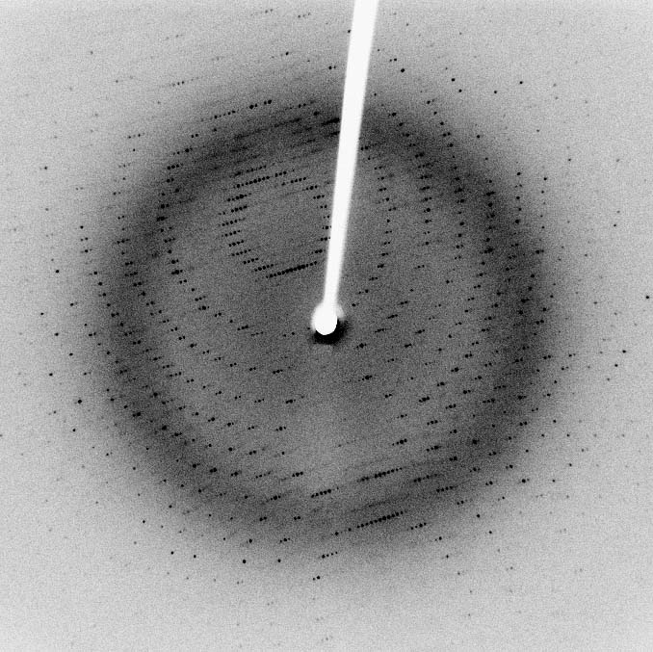
Stage 2
Fire X-rays at the crystal. The X-rays change direction as they go through the crystal. This is diffraction. Diffraction produces a pattern of spots. Some spots are more intense (darker) than others. Every type of crystal makes its own pattern of spots.
Stage 3
Image: Wikimedia commons
Continue to fire X-rays at the crystal whilst rotating the crystal a small amount, say 1º. Repeat until the crystal has turned through at least 180º. This results in up to 180 diffraction pattern images of the crystal.
Stage 4
Use a computer program (and lots of skill) to produce a 3D picture of the crystal structure from the many 2D diffraction pattern images.
Key Stage 3 –
Crystal Modelling
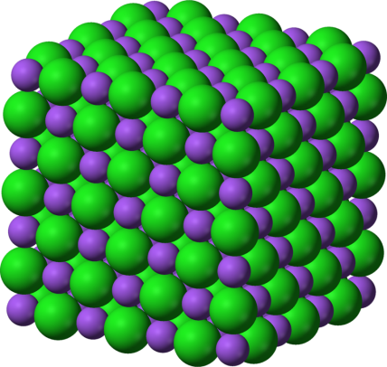
Model A - spheres
You can use spheres to represent atoms in a crystal. This is a model of sodium chloride (salt.)
Key:
purple = sodium
green = chloride
Can you make a model crystal?

Model B - soldiers
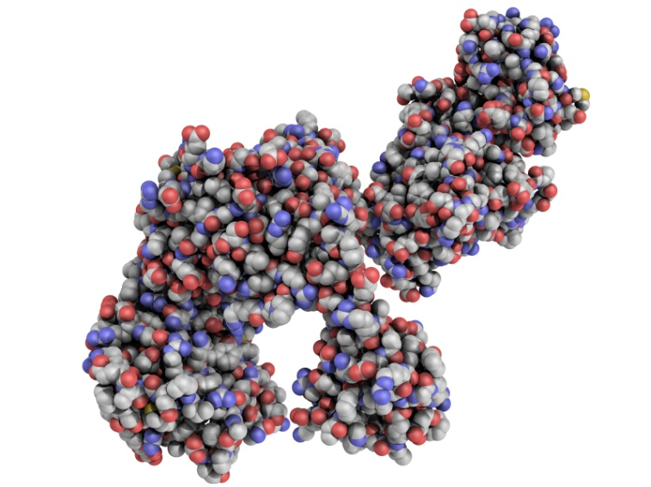
Each line of soldiers represents one row of atoms in a crystal. All the atoms are the same, so this model represents an element.

Key Stage 3 –
Crystal Modelling
Model C - fruit
Each orange represents an atom in a crystal. All the atoms are the same, so this model represents an element.
The oranges are arranged in a regular pattern.

Model D - beads
Each bead represents one amino acid. An amino acid is a group of 10 or more atoms (including carbon, hydrogen, oxygen and nitrogen) that are strongly joined together.
You can make move the string of beads to make different patterns. A protein crystal is like a string of beads that is held in a certain pattern so that it has its own shape.

Key Stage 3 –
Crystal Modelling
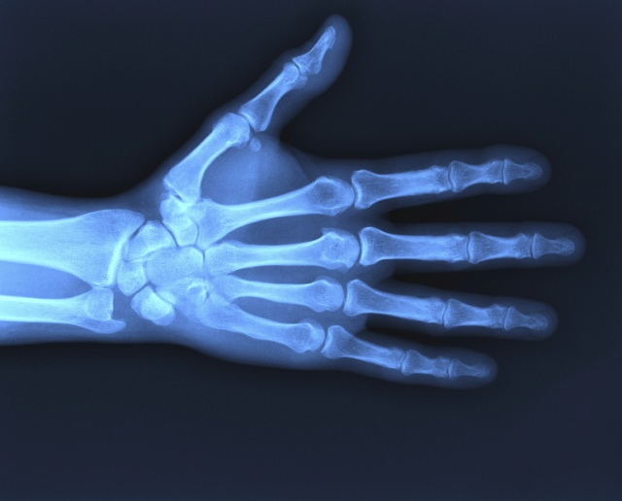
Model E - medical X-ray
Doctors use X-rays to see bones in your body. Crystallographers use X-rays to discover how atoms are arranged in crystals.

Model F – light and cloth
Hold a piece of white cloth in front of a bright light. Stretch in out. The pattern you can see is like an X-ray diffraction pattern.
How does the pattern change if you rotate the cloth? What happens if you stretch the fabric more, or less?
Key Stage 3 –
Crystal Modelling
Model G - what we cannot see
In X-ray crystallography we see things in a different way. It is a bit like trying to identify shapes in a bag with your eyes closed.
Put some items in a bag. Ask someone else to find a certain item without looking.

Model H - what is an X-ray?
An X-ray is a wave. It transfers energy from place to place, just like waves in the sea.
X-rays carry energy at the speed of light.

Key Stage 3 –
Crystal Modelling
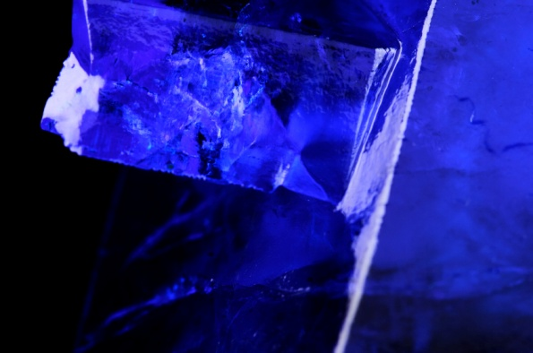
Model I - crystal
Look at the crystal. What observations can you make about its shape?
What might your observations suggest about the arrangement of its atoms?

Model J - 2D to 3D
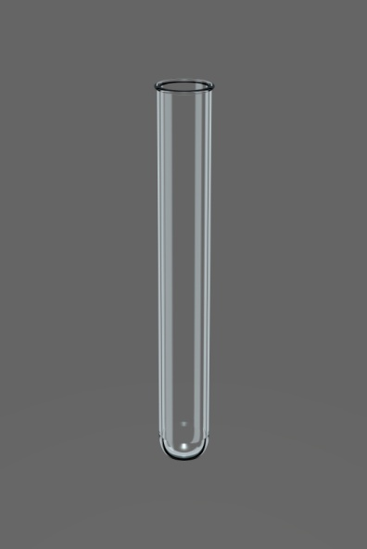
A computer program uses maths to convert many 2D images to one 3D image.

Key Stage 3 –
Crystal Modelling
Why is X-ray crystallography important?
Scientists use X-ray crystallography to find out how atoms are arranged in crystals. If you can obtain crystals of a substance, you can find out how its atoms are arranged.
Scientists have used X-ray crystallography to:
- Measure atoms;
- Discover the arrangement of atoms in substances such as sodium chloride (salt) and copper sulfate.;
- Work out structures of vitamins, proteins, insulin, and DNA;
- Find out how atoms are arranged in metals and minerals;
- Create new medicines ;
- Design new materials, and explain their properties.

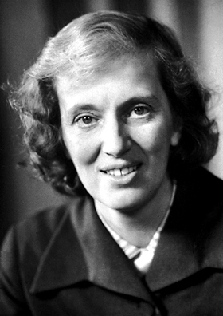
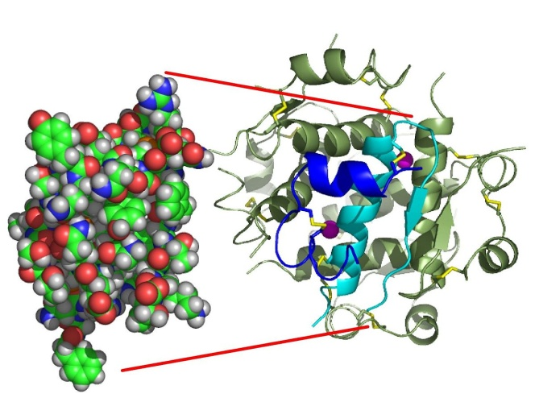
In fact, X-ray crystallography has determined the structure of over half a million substances!
Dorothy Hodgkin used X-ray crystallography to work out the structure of insulin.

Key Stage 3 –
Crystal Modelling
Peer assessment
The group will explain what X-ray crystallography is, how it works and why it is important. They will use models to help them explain clearly.
Question | How clearly did they answer this question?  1 = not clear  3 = very clear
What is X-ray crystallography?
How does X-ray crystallography work?
Why is X-ray crystallography important?

- How did the models help you understand X-ray crystallography?
- Suggest one improvement.

Key Stage 3 –
Crystal Modelling
Peer assessment
The group will explain what X-ray crystallography is, how it works, and why it is important. They will use models to help them explain clearly.
Question | How clearly did they answer this question?  1 = not clear  3 = very clear
What is X-ray crystallography?
How does X-ray crystallography work?
Why is X-ray crystallography important?

- How did the models help you understand X-ray crystallography?
- Suggest one improvement.

Key Stage 3 –
Crystal Modelling
Modelling help sheet
Question | What we will say
What is X-ray crystallography?
Why is X-ray crystallography important?
How does X-ray crystallography work? | Models that help to explain this stage | What we will say
Stage 1

Stage 2

Stage 3

Stage 4

Stage 5

