Key Stage 3 –
Crystal Modelling
Notes for teachers
At a glance
In this activity, students learn about X-ray crystallography. As well as considering its importance (scientists have used the technique to elucidate the structures of over half a million substances) students use models to learn about – and explain to students in another class – how X-ray crystallography works.
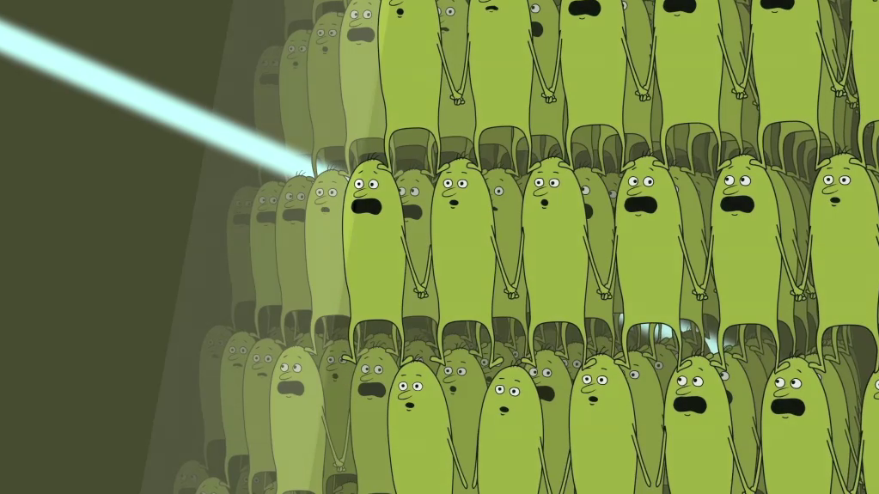
Learning Outcomes
- Students understand the importance of X-ray crystallography in elucidating structures.
- Students use models to explain the stages of X-ray crystallography.
Each group of three or four students will need
- 1 copy of the pupil worksheet
- 1 copy of each sheet describing models A to I (ideally laminated)
- 1 copy of the sheet Why is X-ray crystallography important?
- 1 copy of the peer assessment sheet
- 1 copy of the help sheet (optional)

- Access to each of the following models, perhaps arranged as a circus:
  - A space-filling model of the structure of sodium chloride
  - A string of beads or ‘poppits’
  - A lamp in a dark place
  - A piece of white cloth, about the size of a handkerchief, and ideally closely woven
  - A cloth bag containing items of different shape, for example spheres and cubes
  - Big crystals of various salts, such as copper sulfate
Possible Lesson Activities
- Starter activity
  - Show the animation “A Case of Crystal Clarity” to the class.
  - Repeat the viewing, focusing on the section from 00:39 to 01:53, which shows how X-ray crystallography works.
  - Show the International Year of Crystallography video to outline why crystals, and X-ray crystallography, are important (web link 1).

- Main activity
  - Divide the class into groups of three or four and outline the activity as described on the pupil worksheet.
  - Allow students time to read How X-ray crystallography works on the pupil worksheet.
  - Student groups then move around the circus to look at the models. Emphasise that some of the models are physical models, but others are pictures, or things they can imagine.
  - Groups then select up to five models to help them explain the five stages described on How X-ray crystallography works. They plan how to explain the technique to students in another class who have not encountered it before. They should also plan what to say about the importance of the technique, using the sheet entitled Why is X-ray crystallography important to help them. A help sheet is available. Students might also like to see the peer assessment sheet so that they know the assessment criteria.
  - Students present their explanations – with models – to students in another class. The students from the other class complete the peer assessment sheets.
- Plenary
- Consider the efficacy of the models in helping to explain the different stages of X-ray crystallography. What are the advantages and drawbacks of each?
- Show the animation again. Ask students if they understand it better now.
Web links
Web link 1: www.iycr2014.org/about/video
International year of crystallography video: What can crystallography do for you?
Web link 2: www.innovateus.net/science/what-x-ray-crystallography
Useful teacher background information

