Key Stage 3 –
DNA detectives
Pupil worksheet
The recipe of life
You are you because of your DNA. This molecule, which is found in every nucleus of your cells, contains instructions on how to make every protein in your body, from the colour in your eyes to the shape of your hair strands. This unique mix of proteins that your body’s cells are able to make following the 'recipe' in DNA is what makes you like no other person on Earth (unless you have an identical twin!).
Identical twins have the same DNA

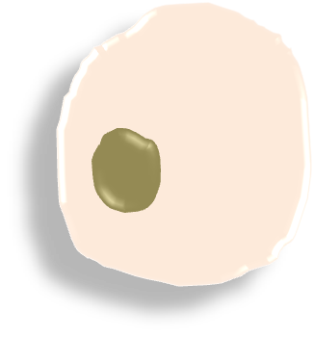
Mystery molecule
DNA was discovered in 1869 by a scientist called Friedrich Miescher who isolated it from pus on used bandages (yuk!). But he didn't know how its atoms were arranged or even what its function was.
It wasn't until the 1920s that scientists realised that DNA had some role in carrying genetic information. The next challenge was to work out its structure to unlock the secrets of how it did this extraordinary job.
DNA is found in the nucleus of the cell

Your task
You are going to investigate how scientists managed to work out the structure of DNA.
What to do
- Work as a pair.

- Collect the sheet 'Scientist A' and 'Bases' from your teacher. Read what the scientist discovered and follow the instructions.

- Now collect the Scientist B sheet and follow the instructions. Repeat for Scientists C and D.

- Congratulations! You have worked out the structure of DNA. Show your expertise by answering the questions below.
Questions
- DNA is a chiral molecule. State what this means.

- Describe why the work of many different scientists was important in the discovery of the structure of DNA.

- Which scientist(s) do you think deserved the Nobel Prize for working it out? (you can't include yourself!) Explain your answer.

Key Stage 3 –
DNA detectives
Clue cards
The blue atom is joined to atoms of two other colours | The blue atom is joined to atoms of two other colours
The black atom is joined to four different atoms | The black atom is joined to four different atoms
The red atom is joined to a white atom | The red atom is joined to a white atom
The blue atom is joined to two white atoms | The blue atom is joined to two white atoms
The green atom is only joined to one other atom | The green atom is only joined to one other atom
White atoms can only be found joined to blue, black and red atoms | White atoms can only be found joined to blue, black and red atoms

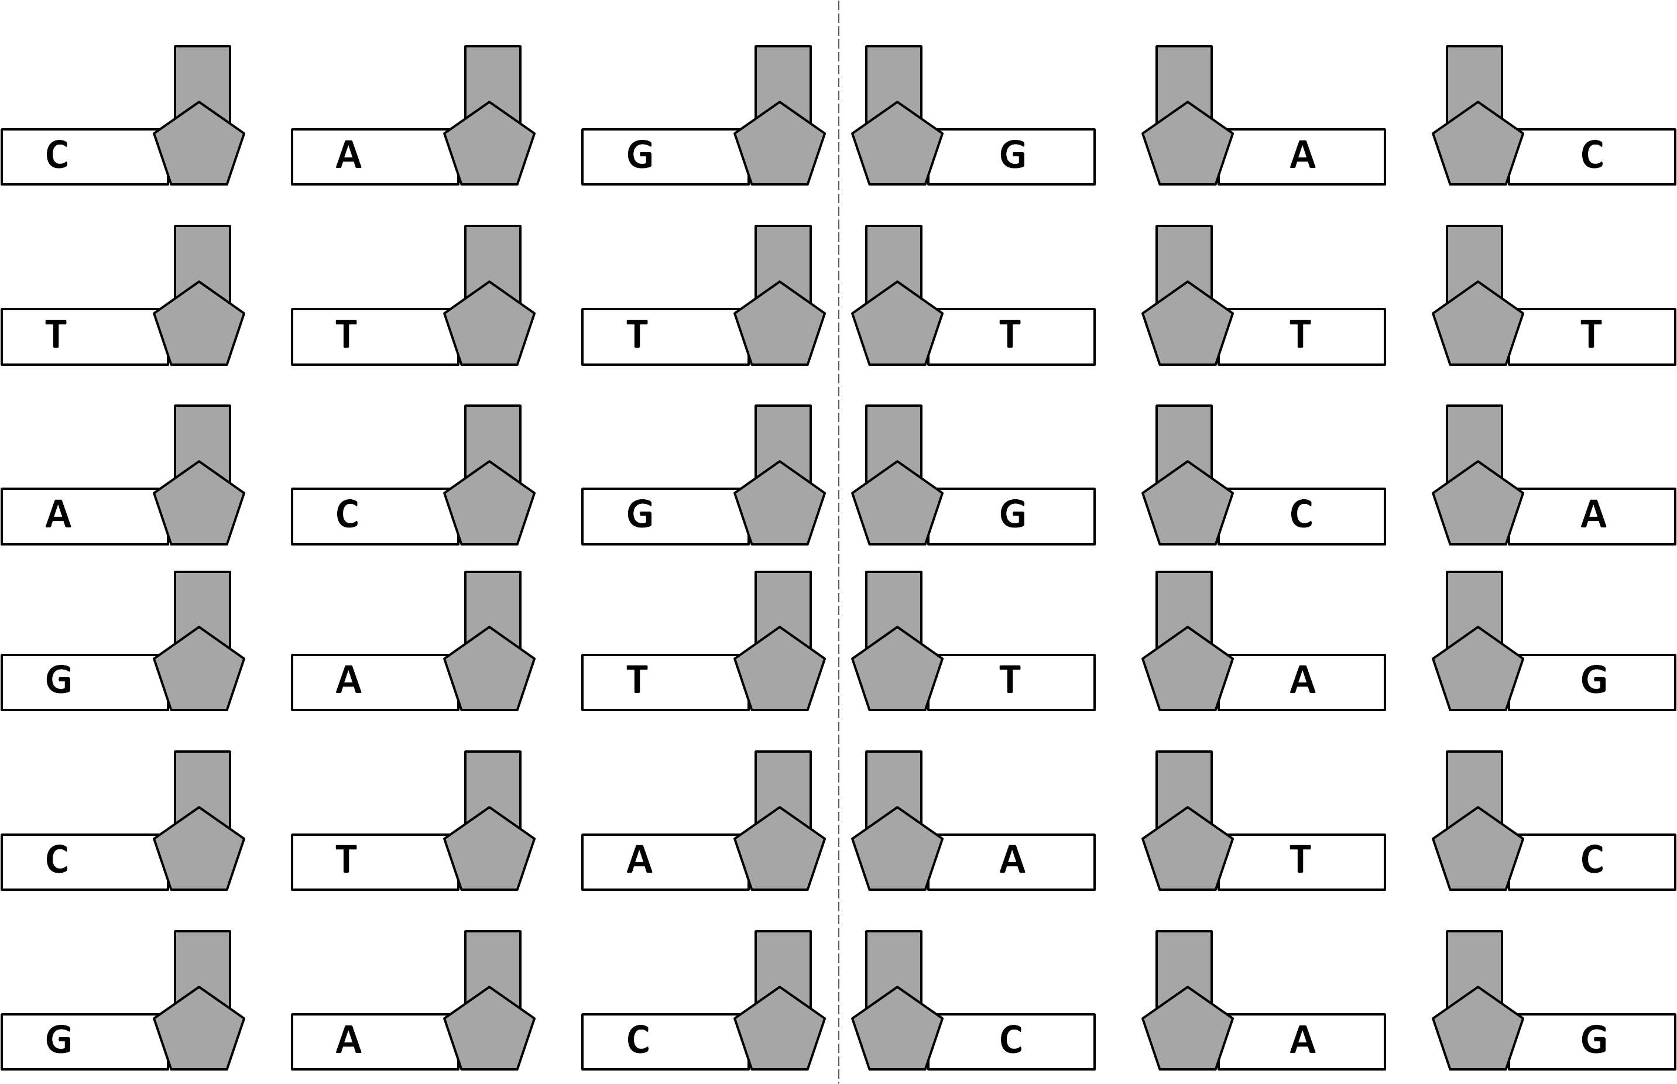
Key Stage 3 – DNA detectives
Bases

Key Stage 3 –
DNA detectives
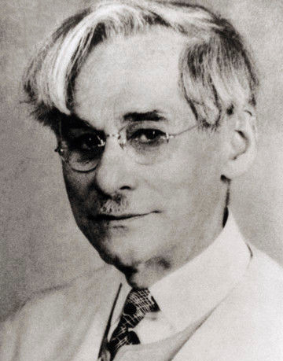
Scientist A
1910

Phoebus Levene

Discovery
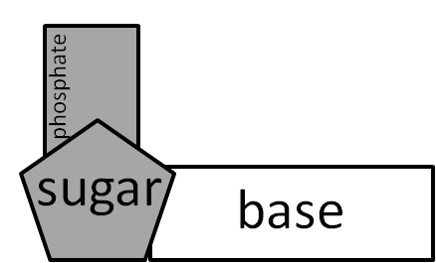
DNA is a large molecule made up of smaller units called nucleotides joined together.

There are four different bases: A, C, G and T.

Your task
- Fold the Bases sheet in half along the dotted line so each base has a back to it and glue together.
- Cut them out.
- Colour in the bases. Use a different colour for each type of base.
- Use Levene's evidence to arrange the bases to come up with a hypothesis for the structure of DNA.

Key Stage 3 –
DNA detectives
Scientist B
1952

Erwin Chargaff
 | Relative proportions (%) of bases in DNA
Organism | A | T | C | G
Human | 30.9 | 29.4 | 19.8 | 19.9
Chicken | 28.8 | 29.2 | 21.5 | 20.5
Grasshopper | 29.3 | 29.3 | 20.7 | 20.5
Wheat | 27.3 | 27.1 | 22.8 | 22.8
Yeast | 31.3 | 32.9 | 17.1 | 17.1

Discovery
He was the first scientist to accurately measure the amounts of the different bases in DNA.
He wrote two rules about DNA bases.

Your task
- Study the results from his experiments.
- Come up with your own rules about the bases in DNA
- Do you want to modify your hypothesis about the structure of DNA based on these rules?
Credit: Cold Spring Harbor Archives
Key Stage 3 –
DNA detectives
Scientists C

Watson and Crick

Discovery
Hydrogen bonds
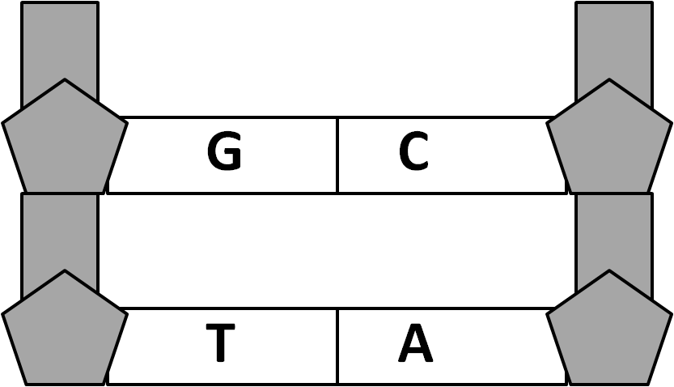
After talking to Erwin Chargaff they came up with the hypothesis that the bases in DNA were paired up: A to T and G to C.
They explained how strong bonds called hydrogen bonds existed between the bases.

Your task
Pair up your bases to form a 'ladder' of DNA and stick it together.

Credit: Watson and Crick: Public Library of Science journal

Key Stage 3 –
DNA detectives
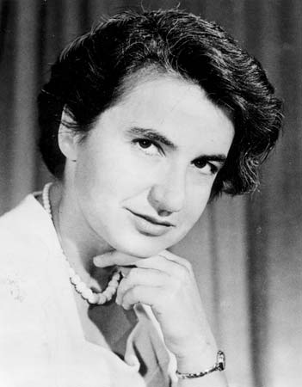
Scientist D
1952
1952

Rosalind Franklin

Discovery
She took pictures of DNA using X-ray crystallography.
The most famous picture she took was called 'photo 51'.
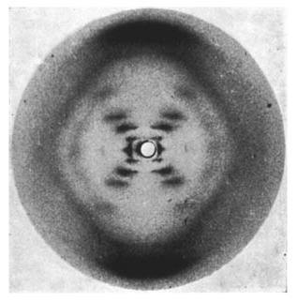

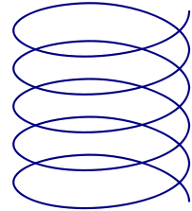
She measured the angles of the image and concluded that DNA must have a helix (coiled) shape.

Your task
Hold the bottom of your 'ladder' and turn the twist the top to form it into a helix shape.
DNA is described as having a double helix shape because it has two strands.

Credit: Photo 51 x-ray diffraction image: WP:NFCC#4

