Key Stage 3 - DNA detectives

Notes for teachers
At a glance
In this lesson students experience first-hand how collaboration between scientists helps make scientific discoveries.
In their first task they try and build a simple molecule using clues and see how important it is to share information to build up a theory. They then watch the video Give us a hand that introduces them to the concept of chirality in molecules such as DNA. Finally, they combine this knowledge to build a paper model of DNA. Students will do this by formulating and improving their own hypotheses based on the real evidence collected by scientists in the past.
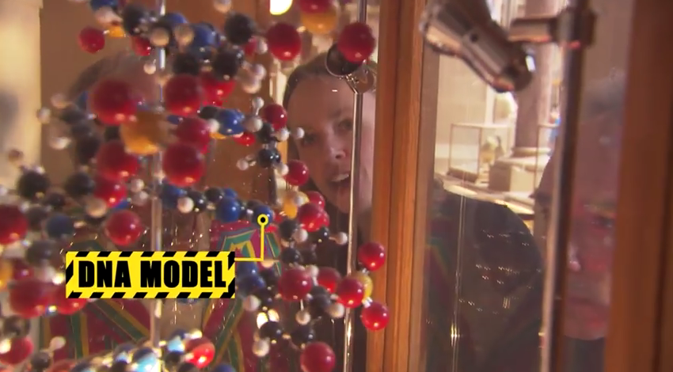
Learning Outcomes
- Students describe how molecules are formed when atoms bond together
- Students recall that chiral molecules are those that have a different structure from their mirror image
- Students explain why it took work from many scientists to develop an understanding of the structure of DNA
Each pair of students will need
- 1 copy of the pupil worksheet
- 1 clue card cut from page 2 of the pupil worksheet
- scissors
- sticky tape
- glue
- colouring pens/pencils
- molymods: 5 hydrogens (white), 1 nitrogen (blue), 1 carbon (black), 1 oxygen (red) and 7 long bonds

Possible Lesson Activities
- Starter activity
  - Before the lesson, use molymods to build the molecule as shown below.

  - Give each pair of students the molymods. Explain that the balls represent atoms and the connectors are bonds. Show how you can join atoms to form molecules.
  - Tell the class that you are thinking of a particular molecule and their task is to build it (don't show it to them!). Give them 30 seconds to build a molecule.
  - Discuss that they need more information before they can accurately build your molecule. Give each pair one clue card. This should enable them to modify their molecule but they still will not be able to build an accurate representation.
  - Discuss with them what they would like to do - they may want to share clue cards with other groups. Allow pairs to do this and give them a few more minutes to use as many clues as they need to build the model.
  - Show the class your model. Pass it around the pairs so they can see if they managed to build it. Note: as this is a chiral molecule, some pairs will have built an enantiomer but do not reveal this at this stage.

- Class activity: Introduction of chirality
- Show the students the video Give us a hand up to 3:37 (before the DNA model is introduced)
- Ask them to look carefully at their models - did they all build the same as yours? If not, why not? Discuss briefly that some molecules are not the same as their mirror images - these are chiral.

- Paired activity: Working out the structure of DNA
- Introduce DNA as another chiral molecule. Give each pair a copy of page 1 of the pupil worksheet and ask them to read through the information on DNA.
- Discuss why scientists could not immediately determine its structure - it is too small to be seen. They needed to work it out, draw parallels with this and the starter activity.
- Let each pair collect a copy of the bases sheet (page 3) and Scientist A sheet (cut out from page 4 of the pupil worksheet). They fold the sheet in half, glue the two sides then cut them out. If you have time students can colour in the bases. Allow them to rearrange the bases to come up with a hypothesis on how the bases are arranged in DNA. It is important that they use the evidence that Levene had at the time - some students may already be familiar with the double helix structure of DNA but explain that he didn't have any evidence for this! Levene's hypothesis was that the bases were arranged in a long string and that the order did not matter.
- Pairs then collect a copy of Scientist B (cut from page 4). They use this information to come up with two rules and modify their hypothesis if they wish. Chargraff's first rule was that in the DNA of all species there is approximately equal amounts of A and T; and G and C. His second rule was that these proportions were different in each species.
- Provide pairs with a copy of Scientists C (cut from page 5). Watson and Crick came up with the theory of base-pairs following a conversation with Chargraff where he revealed his findings. Allow students to match up their paper bases to form a DNA ladder.
- Finally, pairs use a copy of Scientist D (cut from page 5) to find out that the DNA has a helix shape. They twist their paper model to form the double helix.
- Discuss with them if it matters which way they twist it. The answer is yes! DNA is a right-handed chiral molecule. They should hold the bottom and twist the top in an anti-clockwise direction.
- Show the class the rest of the video which discusses DNA and its chirality.
- Students then answer the questions on the sheet to summarise what they have learnt.

- Plenary
- Discuss the answers with the students:
Answers
- DNA is a chiral molecule because it isn’t identical to its mirror image.
- The structure of DNA was determined using the work of many different scientists. Their discovery was recorded (usually in a scientific journal) which could be read by other scientists, who used this and improved on their work. The advent of new technology, like x-ray crystallography meant that new experiments could be carried out.
- This is hotly debated! The actual Nobel Prize went to Watson, Crick and Wilkins. Wilkins was Franklin's professor and it was he who shared the famous photo 51 with Watson and Crick. In 1953 they published an article in the scientific journal Nature where they used their base-pair theory (which was based on Chargraff's work) and mathematical modelling to determine the structure of DNA.
- Finish with a discussion on how this discovery has impacted on the science of genetics. Now we know that the base order determines the structure of the proteins produced. We can use this information to carry out genetic tests and genetically engineer organisms. In the future we may be able to change the human genome to eradicate inherited conditions.

Web links
http://www.oxfordsparks.net/video/case-crystal-clarity
Rosalind Franklin used x-ray crystallography to help determine the structure of DNA. For more about this technique watch the Oxford Sparks Video A case of crystal clarity.
http://www.nature.com/nature/dna50/watsoncrick.pdf
Watson and Cricks famous paper on the structure of DNA.
https://www.youtube.com/watch?v=35FwmiPE9tI&sns
Rosalind Franklin vs. Watson & Crick - Science History Rap Battle. Entertaining account of the work of Watson, Crick, Wilkins and Franklin.
https://www.youtube.com/watch?v=gG7uCskUOrA
An animation which shows how DNA codes for proteins.
http://www.theguardian.com/science/blog/2013/apr/25/dna-double-helix-jelly-babies-liquorice
Some further ideas for a lesson on the structure of DNA, including how to build an edible DNA model.

