Key Stage 3 -
Hypertrophic cardiomyopathy
Cardiac chaos
Your task

Anycity United’s star player collapsed in Saturday’s match. First aiders kept his heart going until the ambulance arrived. The player is now recovering in hospital. Doctors think he has hypertrophic cardiomyopathy, HCM.

The club cannot reply to all the questions and messages from fans. Write a web page for the club to explain HCM. Include:
- Words and pictures showing how a normal heart works. Include information about its cells and tissues.
- An explanation of why and how the heart of an HCM sufferer is different.
- Frequently Asked Questions and answers.
Use these sources of information:

- The heart animation.
- The podcast of the doctor’s press conference speech, following tests on the player.
- The HCM patients’ leaflet.

Extension
Describe how scientists have developed explanations to explain HCM symptoms.
Key Stage 3 -
Hypertrophic cardiomyopathy
Cardiac chaos
Your task
Anycity United’s star player collapsed in Saturday’s match. First aiders kept his heart going until the ambulance arrived. The player is now recovering in hospital. Doctors think he has hypertrophic cardiomyopathy, HCM.

The club cannot reply to all the questions and messages from fans. Write a web page for the club to explain HCM. Include:
- Words and pictures showing how a normal heart works. Include information about its cells and tissues.
- An explanation of why and how the heart of an HCM sufferer is different.
- Frequently Asked Questions and answers.
Use these sources of information:

- The heart animation.
- The podcast of the doctor’s press conference speech, following tests on the player.
- The HCM patients’ leaflet.

Extension
Describe how scientists have developed explanations to explain HCM symptoms.

Hypertrophic cardiomyopathy – leaflet for patients [1]
The normal heart

Your heart is an amazing organ. It beats 100 000 times every day, pumping blood. It must never stop. Your heart is part of the circulatory system, which transports materials all over your body.

Your heart is made up of three types of tissue. Each tissue does its own job.
- A thick layer of muscle tissue contracts and squeezes blood out of the heart.
- A thin layer of a different type of tissue lines the inside of the heart.
- A double layer of another tissue protects the outside of the heart.
Tissues are made up of cells. All the cells in a tissue are the same. They are specialised to do their jobs.

Heart muscle tissue is made up of heart muscle cells. The table shows why they are so good at their job.
Feature of cell | Why heart muscle cells have this feature
Long and thin | So they can slide past each other as the muscle contracts and relaxes.
Many mitochondria | A mitochondrion is a part of a cell. It converts the energy in glucose into energy a cell can use. A heart muscle cell needs many mitochondria because its energy supply must never run out.
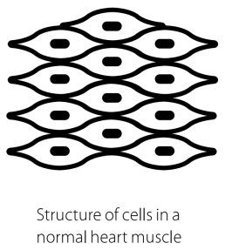
In normal heart muscle tissue, the cells are arranged like this.

Hypertrophic cardiomyopathy (HCM)
Inside the heart

If you have HCM, your heart muscle cells are not arranged in straight lines. They are arranged in disorganised layers. This cell arrangement makes the heart muscle thick and stiff.

In the most common type of HCM, the muscle between the two sides of the heart – the septum – is extra thick.

Explaining HCM symptoms
Scientists wanted to know why the disorganised cell arrangement causes problems, such as sudden cardiac arrest. They collected lots of evidence. But no one could explain it all.

Eventually, Oxford scientists suggested an explanation. The heart of an HCM patient works inefficiently. It needs extra energy to produce the force needed to pump enough blood around the body. If the energy supply runs out, the heart beats quickly and chaotically. It may stop altogether.

The Oxford scientists collected more evidence from HCM patients. The evidence supports their explanation. This makes them more confident that their explanation is correct.

What causes HCM?
Every cell has a nucleus. Inside the nucleus are genes. Genes give instructions to cells. You inherit your genes from your parents.

Some genes may have mistakes in them. Certain mistakes cause HCM. These mistakes are passed from parents to children. The child of one parent with HCM has a 50% chance of having the condition.

Treating HCM
HCM cannot be cured, but medicines help to control its symptoms. Oxford scientists are developing treatments based on their new explanation of HCM.

Hypertrophic cardiomyopathy – leaflet for patients [2]
The normal heart

Your heart is an amazing organ. It pumps blood around your body. It beats
100 000 times every day.

Most of your heart is made of heart muscle tissue.

Heart muscle tissue is made of heart muscle cells. The cells are specialised to do their job. The table shows how.
Feature of cell | Why heart muscle cells have this feature
Long and thin | So they can slide past each other easily.
Many mitochondria | A mitochondrion converts food energy into useful energy. A heart muscle cell has many mitochondria. Its energy supply must never run out.

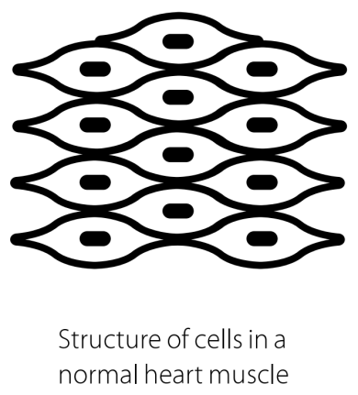

In normal heart muscle tissue, the cells are arranged like this.
Hypertrophic cardiomyopathy (HCM)
Inside the heart
The diagram on the left shows how the heart muscle cells are arranged in a person with HCM. The heart muscle is thick and stiff.
In a person with HCM, the muscle between the two sides of the heart is too thick.

Explaining HCM symptoms
Scientists wanted to know why the untidy cell arrangement causes problems. They collected lots of evidence. But no one could explain it all.

Then Oxford scientists suggested an explanation. An HCM patient needs extra energy to pump blood. If the energy supply runs out, the heart may beat too quickly, or stop.

What causes HCM?
Every cell has a nucleus. Inside the nucleus are genes. Genes give instructions to cells. You inherit genes from your parents.

Some genes have mistakes. Certain mistakes cause HCM. These mistakes pass from parents to children.

Treating HCM
There is no cure for HCM, but medicines help to control it. Oxford scientists are developing new treatments for HCM.

Hypertrophic cardiomyopathy (HCM)
Help sheet
How a healthy heart works
[Describe what a healthy heart does, and how]

Why heart muscle cells are good at their job
[Use information from the table]

How heart muscle cells are arranged in healthy heart tissue
[Choose a diagram to put here]

How the heart of an HCM sufferer is different from a healthy heart
[Choose a diagram to put here]

Frequently asked questions

Q1 What are the symptoms of HCM?

Answer

Q2 [Make up another question]

Answer

Q3 [Make up another question]

Answer

