Key Stage 3 - Hypertrophic cardiomyopathy
Cardiac chaos
Notes for teachers
At a glance
In this lesson, students learn about the specialised cells of the heart and the tissues they form. They find out what can happen to the function of the heart if, as the result of an inherited condition, the cells are not arranged properly. The lesson begins with a video clip about the condition. Students then use patient leaflets and a podcast to find out more about the condition, and design a web page to explain it to fans of a footballer who collapsed during a match.
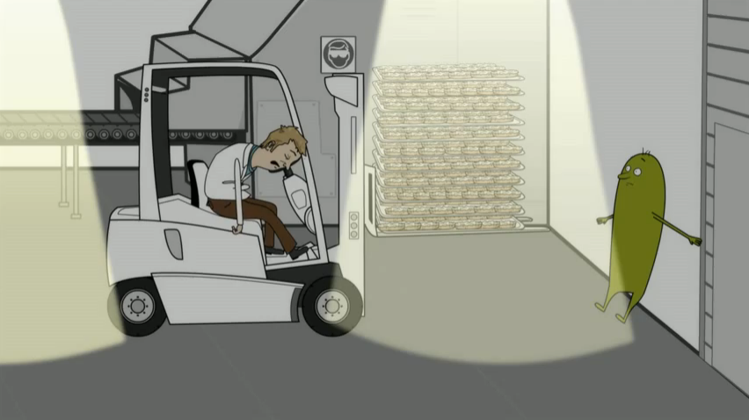
Learning Outcomes
- Students understand that heart muscle cells are specialised, and that if they join together to form tissues in a disorganised way in the heart, they cannot do their job properly.
- Students understand that scientists are gathering evidence and developing explanations to understand the reasons for the symptoms of hypertrophic cardiomyopathy, and ultimately to develop treatments for the condition.

Possible Lesson Activities
- Starter activity
  - Show the animation ‘Another case of heart trouble’ as far as 0:28. Ask students to speculate as to why the driver – a fit, healthy young man – might have suddenly collapsed. Do not give any answers at this stage.
  - Continue viewing the animation to 1:33. Emphasise that the driver has hypertrophic cardiomyopathy (HCM). Scientists now know that the symptoms of this genetic disease are the result of the patient’s heart using energy inefficiently.
  - Show the rest of the animation. Focus on the internal defibrillator, and ensure students realise that the disease is caused by a faulty gene. There is no need to go into genetic details, or the role of ATP.
- Main activity
  - Give student pairs the task sheet, and make sure they all understand the task – to develop a web page, electronically or on paper – explaining HCM to fans of a fictional football club whose star player recently collapsed as a result of the disease.
  - Listen to the podcast from the fictional doctor in charge of the case. This describes the symptoms of HCM, as well as some diagnostic tests. Repeat the podcast, pausing to allow students to take notes.
  - Give out the extract from the leaflet for HCM patients. Two versions are available – [1] is suitable for middle and higher attaining students; [2] is suitable for lower attaining students. Ask students to use the information on this sheet, as well as their notes from the podcast, to do the task on the task sheet. An extension task is included on the task sheet. The help sheet provides a suggested template for the web page. Students can make up their own frequently asked questions (FAQs) and provide answers for these.
- Plenary
  - Students display their web pages – either on screen or on paper – around the classroom. Others read them carefully, and peer evaluate. You might like to ask students to provide written feedback for a few web pages.
  - Emphasise the How Science Works aspect of the task. Oxford scientists, led by Professor Hugh Watkins, examined evidence – often conflicting – from many scientists. They thought creatively about this evidence, and developed a new explanation – that the symptoms for HCM are the result of the heart using energy inefficiently. They gathered further evidence, and noted that it supports their explanation. This makes them more confident that their explanation is correct. They are developing new treatments based on this explanation. (See the text under the heading Explaining HCM symptoms on the leaflet for HCM patients.)

Further suggestions
- Link the activities to a practical heart dissection.
See www.nuffieldfoundation.org/practical-biology/looking-heart
- Observe prepared slides of animal heart tissue through a microscope.

Podcast script

Welcome to Anycity Hospital. I am pleased to report that United’s player, Simon, is making progress. He is now able to talk to family and friends. He has given me permission to talk about his condition – in some detail – at this press conference. He wants others to learn from his experience.

Simon admits suffering occasional chest pains. He once had a blackout after training – he put it down to exhaustion, and didn’t tell anyone. He also seemed to get more breathless than others in the team. You may also remember his aunt. She was a promising athlete, but died suddenly during a race twenty years ago, aged just 23.

We’ve done some tests on Simon. His pulse is jerky, suggesting his heart muscle is working harder than normal.

We also did an echocardiogram test. The test uses ultrasound waves to look at the structure of the heart. The picture shows that Simon’s septum – the muscle dividing the two sides of his heart – is thicker than normal.

We did an MRI test, too. This uses magnetic fields and radio waves to create images of the heart. The MRI confirmed that Simon has a thick heart septum. It also showed that his heart is pumping harder than normal.

The results of all these tests suggest that Simon may have hypertrophic cardiomyopathy (HCM). We are now working on treatment options. If Simon has HCM, he may need to stop playing football. People with the condition are advised not to exercise vigorously.

