Key Stage 3 - Jet
Cool blades
Pupil worksheet
Jet engine
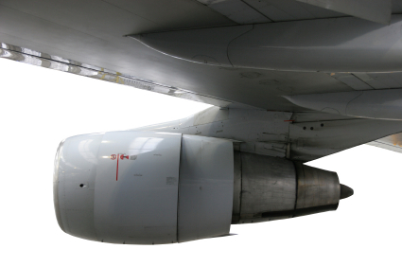
A jet engine pushes a huge mass flow of gas backwards. An equal but opposite force, called thrust, pushes the aeroplane forwards.

thrust

A jet engine includes a turbine. The turbine extracts energy from the hot gases that flow over it. It converts this energy to useful work.

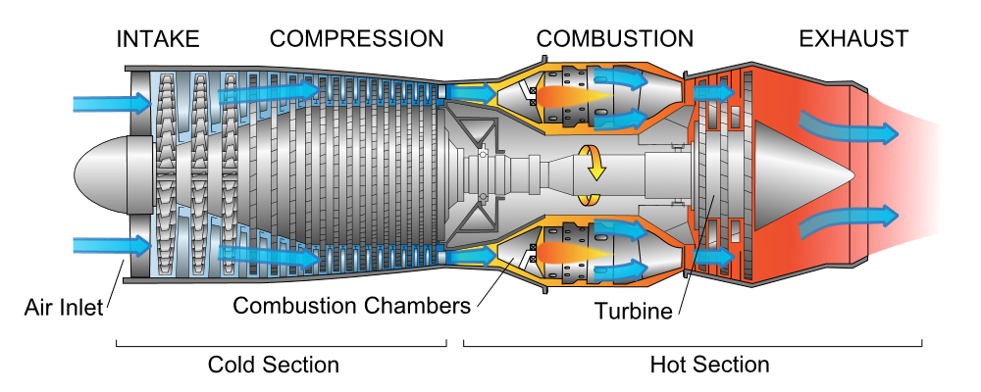
Image: Jeff Dahl, Wikimedia Commons
Turbine blades get very hot. Their temperature can reach 1000 ºC. Moving air cools the hot blades. The air enters a system of holes inside each blade. Air seeps out of the holes. This results in a film of cooler air around the blades.
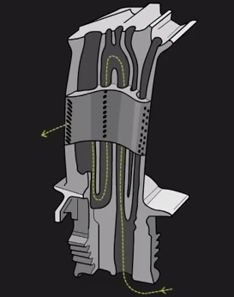
exhaust gases
Engineers test different turbine blade designs. They want to find the best way of using air to cool them quickly.
How do engineers collect data to compare their designs? They need to measure turbine blade temperatures, but normal thermometers do not work at such high temperatures. For this reason, scientists often experiment at lower temperatures so that they can make more detailed measurements.
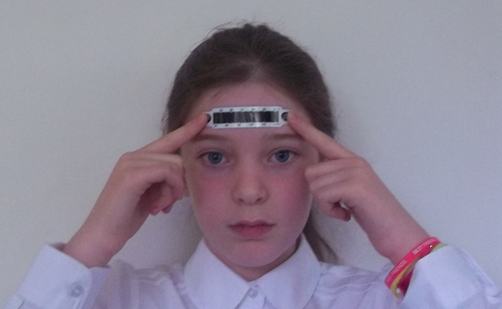
Oxford engineers have pioneered the use of liquid crystal thermometers to measure temperatures in these experiments. They work like a forehead thermometer, but measure temperatures over a much greater range.

Key Stage 3 - Jet
Cool blades
Group challenge
Investigation
Design and carry out an investigation to answer the question How much faster does an object cool when surrounded by moving air? If possible, use a liquid crystal thermometer to measure temperature.
Hints
- Your object could be a beaker of water, or a block of warm metal.
- Look at the range of your thermometer. If it is a liquid crystal forehead thermometer, its range may be only 34 ºC to 40 ºC. You will only be able to measure temperatures within this range.
Safety
- Wear eye protection
- Take care when handling hot objects

Further research
Choose one or two of the questions below, or make up your own. Use text books or the Internet to research answers to these questions.
- Is heat transferred from the turbine blade by conduction, convection or radiation, or by a combination of these processes? Use diagrams to illustrate your answer.

- What are the differences between liquid crystal thermometers used to measure body temperature and liquid crystal thermometers used to measure turbine temperature?

- What are the roles of the compressor, combustor and turbine in a jet engine? Search the Internet for ‘Rolls Royce journey through a jet engine’ to find out. Your teacher has the web site address.
- What are the similarities and differences between a jet engine turbine cooling system and a car engine cooling system? Search the Internet for ‘How stuff works car cooling systems’ to find out.

Communicating your findings
Tell another group what you have found out about turbine cooling and jet engines.
Follow these steps:
- Choose your communication tool – poster, presentation, drama, video storyboard or written account.
- Decide what you want to tell the other group.
- Work out what needs to be done, and divide the tasks between the members of your group.
If you wish, choose pictures from the Image Bank PowerPoint to illustrate your work.
Use the Peer Assessment sheet to help you make sure you include everything.

Key Stage 3 - Jet
Cool blades
Peer assessment
Look at – or listen to – the work produced by another group. Then complete this form.
Question | How clearly did they answer this question?  1 = not clear  3 = very clear
How much faster does an object cool when surrounded by moving air?
Research question 1
……………………………………………………………………………….
……………………………………………………………………………….
Research question 1
……………………………………………………………………………….
……………………………………………………………………………….

- What were the two best things about the other group’s work?
☺
☺
- Suggest one improvement.

Key Stage 3 - Jet
Cool blades
Peer assessment
Look at – or listen to – the work produced by another group. Then complete this form.
Question | How clearly did they answer this question?  1 = not clear  3 = very clear
How much faster does an object cool when surrounded by moving air?
Research question 1
……………………………………………………………………………….
……………………………………………………………………………….
Research question 1
……………………………………………………………………………….
……………………………………………………………………………….

- What were the two best things about the other group’s work?
☺
☺
- Suggest one improvement.
- Key Stage 3 - Jet
Cool blades
- Help sheet
Investigation question

Investigation diagram

Investigation results

Time (minutes) | Temperature (ºC)
 | Without moving air | With moving air

Investigation conclusion

Research question | Answer
First question

Second question

