Key Stage 3 - Particle Forensics
Footprints of the Higgs Boson
Pupil worksheet
Part 1: What footprints do particles make?
These are the paths made by particles as they pass through the various layers of detectors in the CMS experiment at the LHC.
Electron  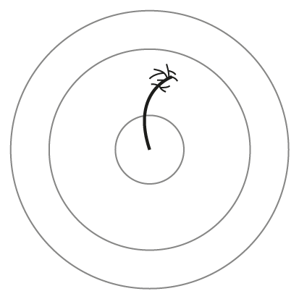 | Muon  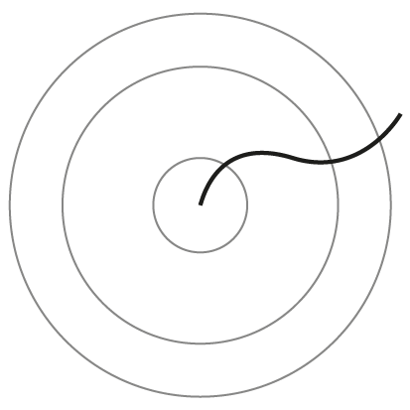 | Neutrino
Antielectron | Antimuon | Antineutrino
Pupil worksheet
Part 2: What do the particles formed on collision of the protons break down into?
Using Part 1 for reference, draw in below the paths of the particles formed on when collision products break down.
Type of particle formed on collision | What it breaks down into | Drawing
- W Boson | Electron + antineutrino
- W Boson | Muon + antineutrino
- Z Boson | Electron + antielectron
- Z boson | Muon + antimuon
- Black hole | Lots of particles
- Higgs Boson | 2x electron + 2x antielectron
- Higgs Boson | 2x muon + 2x antimuon
- Higgs Boson | electron + antielectron + muon + antimuon

Pupil worksheet
Part 3: Collision images from different particles
Collision image | What particles do you think were present after the protons collided?  Why?
