Key Stage 3 – MRI
Brain briefing
Notes for teachers
At a glance
In this activity, student groups become multidisciplinary teams of hospital staff working on new leaflets or videos to help patients prepare for MRI brain scans. Through the activity, students enrich their understanding of the brain as an organ, and apply their knowledge of magnetic fields and the magnetic effects of a current. Every team includes a radiologist, a radiographer, a physicist, a researcher and a hospital communications worker, so the activity is also an opportunity for students to broaden their knowledge of careers in science.
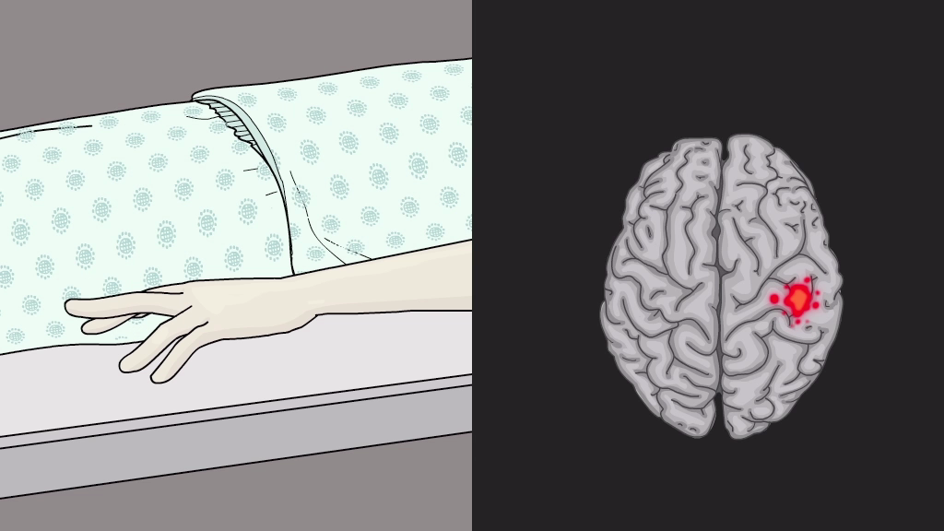
Learning Outcome
- Students develop their understanding of the brain as an organ.
Each group of five students will need
- 1 copy of the pupil worksheet
- 1 copy of the peer assessment sheet
- 1 copy each of roles 1, 2, 3, 4, and 5
- MRI leaflet help sheet (optional)
- Access to an digital version of the PowerPoint presentation, which is a collection of images.
Possible Lesson Activities
- Starter activity
  - Show the animation ‘A spin around the brain’ to the class.
  - Repeat the viewing, focusing on the section from 0:44 to 1:25 which explains how MRI works. Students are unlikely to have come across protons before, so you might like to introduce them as tiny positive particles inside atoms.
  - Finally, focus on the section from 1:26 to 1:46, which shows the areas of the brain associated with different activities such as listening to music and watching a film.
- Main activity
  - Divide students into groups of five. Tell them they will take the role of hospital workers developing a new leaflet or video to help patients prepare for an MRI scan.
  - Allocate roles within groups: role 1 is suited to a student who can chair the group and ensure the task is completed; role 2 is suited to a lower attaining student; role 4 is best taken by a higher attaining student.
  - Give each group one copy of the worksheet, one copy of the peer assessment sheet and one copy of each briefing sheet for roles 1 to 5. Tell students that the peer assessment sheet outlines the success criteria for the task.
  - Allow time for each student to read their one briefing sheet and to complete the tasks on this sheet. The tasks check understanding and prepare students for the next part of the activity. If one student completes their tasks more quickly than others in the group, they can help others in the group with their tasks.
  - Then ask groups to move on to the meeting section described on the task sheet. In the meeting, each student – in role – describes what they would like to include in the leaflet or video. As a team, students then plan their leaflet or video. At this stage, you might like to give some groups the help sheet to support their planning.
  - Next, students write their own sections of their team leaflet or video storyboard using information from the briefing sheets. If you wish, students could refer to the web sites listed on the animation web page, but this is not vital.
  - If you wish, allow students to use ICT to produce their leaflets. The PowerPoint presentation accompanying this activity is a collection of images that students could include.
- Plenary
- This involves peer assessment of the leaflet or video storyboard.
- Ask groups to swap their finished products and to use the peer assessment sheet to guide them in assessing the work of the other group.
- Allow time for groups to study the assessment sheet for their own work.
- If you wish, show the animation again.

