Key Stage 3 –
Perfect planet?
Pupil worksheet
Life beyond Earth
Conditions on Earth are perfect for life. Might other planets support living things too?
As far as we know, there is no life on the other planets of our solar system. But does life exist on planets that orbit other stars, the so-called exoplanets? Scientists, and people like you, are working hard to find out.
Finding an exoplanet that might support life is not easy:
- First detect a planet against the dazzling backdrop of its parent star.
- Then, at a distance of many light years, find out what the planet is like and make a prediction: could life survive in these conditions?
Your task
Which exoplanets might support life? Your task is to find out.
Prepare
- Read the sections Conditions for life and Habitable zone.
- Study your Exoplanet information and complete a Planet profile.
Predict
- Display your Planet profile for others to see.
- Look at other groups’ Planet profiles. Predict whether each exoplanet is habitable (supports life). Record your predictions on Habitable or not?
Conditions for life
Water
Almost all forms of life on Earth need water, and the water must be in its liquid state. Water is a compound of two elements, hydrogen and oxygen. Its chemical formula is H₂O.
Let’s assume that water is also vital for life beyond Earth. This means that a habitable exoplanet needs water, or at least the elements to make it from.
Type of surface
A habitable exoplanet must be rocky so that water can remain on its surface.
Temperature
The temperature on the surface of the planet must be just right – too hot, and water exists as vapour; too cold, and any water will be in the form of ice.
Several factors affect the surface temperature of an exoplanet, including:
- The temperature of its star.
- Its distance from this star.
- Whether or not the planet has an atmosphere. An atmosphere insulates a planet. This helps to avoid extremes of temperature.
Habitable zone
Scientists look for life-supporting exoplanets around a star in its habitable zone, also called the Goldilocks zone. This is the range of distances from the star which could include planets on which any water might be liquid.

Key Stage 3 –
Perfect planet?
Planet profile
Name of exoplanet

Name of star

Type of planet
(rocky, gas giant or…)

Is it possible that the surface temperature of the planet is such that water could be in its liquid state?

Give reasons for your decision.
Any other comments

Key Stage 3 –
Perfect planet?
Planet profile
Name of exoplanet

Name of star

Type of planet
(rocky, gas giant or…)

Is it possible that the surface temperature of the planet is such that water could be in its liquid state?

Give reasons for your decision.
Any other comments

Key Stage 3 – Perfect planet?

Habitable or not?
Name of exoplanet | Prediction  (tick one box only for each exoplanet) |  |  | Reason for prediction
 | Life is likely | Life is possible | Life is impossible
Alpha centauri – Bb
Gliese-581g
Gliese-667Cc
Gliese-832b
Gliese-832c
HD 40307g
HD 85512b
Kepler-22b
Kepler-186f
MOA-192B
PH1 (Kepler-64b)
PSR B1620-26b ‘Methuselah’

Key Stage 3 –
Perfect planet?
Exoplanet information: Alpha Centauri-Bb
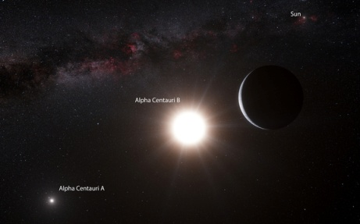
In October 2012 European scientists announced the discovery of Alpha Centauri-Bb. This is the nearest exoplanet found so far, and is just 4.2 light-years from our Sun.

The planet orbits a Sun-like star, Alpha Centuri-B. The orbit takes three Earth days.

The planet orbits its star at a distance of just 6 million kilometers, which is much less than the distance between Mercury and the Sun. The surface temperature of the planet is estimated at about 1300 ºC. For comparison, the surface temperature of Venus, the hottest planet in our Solar System, is 460 ºC.
Scientists predict that the surface of the planet is made up of lava.
The existence of Alpha Centauri Bb is controversial. In 2013 a separate group of scientists claimed that discoverers of the exoplanet had not interpreted the data correctly, and that the planet does not exist.
More information from:
www.nasa.gov/ames/kepler/nasas-kepler-discovers-first-earth-size-planet-in-the-habitable-zone-of-another-star/
Image: Artists impression of Alpha Centauri Bb.
Credit: ESO/L. Calçada/N. Risinger
Key Stage 3 –
Perfect planet?
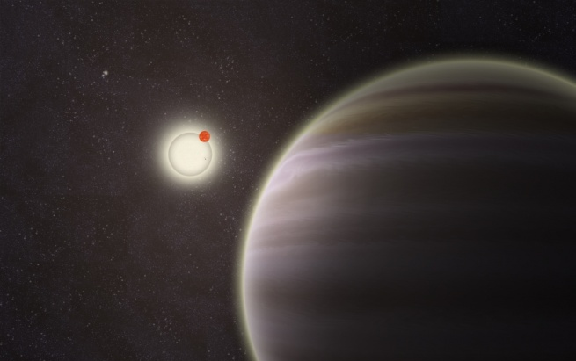
Exoplanet information: PH-1 (also called Kepler-64b)
Two amateur astronomers announced the discovery of PH-1 in 2012. The astronomers used data gathered by the Kepler space telescope and made public by the PlanetHunter.org project run by Dr Chris Lintott from Oxford University.
The planet is 5000 light-years from Earth. It is the first reported planet to orbit a double star system which is in turn orbited by a second pair of stars.
The mass of PH-1 is between 20 and 55 times greater than the mass of Earth. Its radius is six times that of Earth. It has many similarities to the planet Neptune, and is thought to be a gas giant.
More information from:
www.nasa.gov/content/kepler-64b-four-star-planet/
Image: Artist’s impression of the planet shown in the foreground.
Credit: Haven Giguere, Yale
Key Stage 3 –
Perfect planet?
Exoplanet information: Kepler-186f
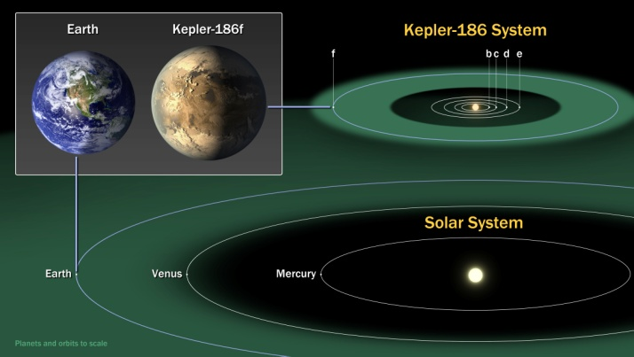
In April 2014 scientists were excited to discover the first Earth-size planet orbiting a star in the habitable zone. The planet is one of five orbiting a red dwarf star in the constellation Cygnus. It is about 500 light-years from Earth.

The star is about half the mass and size of our Sun. This – and the distance of the planet from its star – means that the planet receives only one third the energy from its star that Earth gets from the Sun. The planet is at the outer edge of the habitable zone.

Scientists do not know what type of atmosphere the planet has, and so cannot predict its temperature. Scientists are also not sure what Kepler-186f is made from. However, there is some evidence that its surface is rocky.

More information from:
www.nasa.gov/ames/kepler/nasas-kepler-discovers-first-earth-size-planet-in-the-habitable-zone-of-another-star/
Image: The habitable zone of Kepler-186f compared to that of the Sun.
Credit: NASA Ames/SETI Institute/JPL-Caltech
Key Stage 3 –
Perfect planet?
Exoplanet information: Gliese-581g
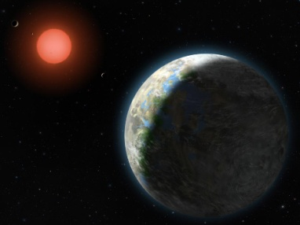
Planet hunters announced the discovery of Gliese-581g in 2010. The find was the result of more than ten years of observations using one of the world’s biggest telescopes. Its parent star, Gliese-581, is a red giant. It is in the constellation Libra, and is about 20 light-years from Earth.
The star emits only one hundredth the amount of light energy of our Sun. This means that its habitable zone is closer to the star than the habitable zone of the Sun. Gliese-581g is in this habitable zone.
The planet orbits its star every 37 days. It always shows the same face to its star, so one side is always in daylight and the other is always dark.
The mass of Gliese-581g is three or four times greater than the mass of Earth. Its diameter is between 1.2 and 1.4 times greater than the diameter of Earth. This means that it is likely to be a rocky planet rather than a gas giant. Scientists do not know what type of atmosphere the planet has.
The existence of Gliese-581g is controversial. In 2014 new research suggested that it does not actually exist, and that the evidence thought to demonstrate its existence in fact shows something else.
More information from: www.nasa.gov/topics/universe/features/gliese_581_feature.html
Image: Artist’s impression of Gliese-581g with its parent star.
Credit: Lynette Cook, NASA
Key Stage 3 –
Perfect planet?
Exoplanet information: Gliese-667Cc
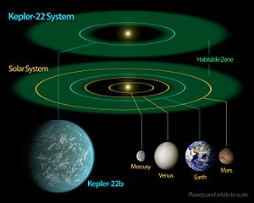
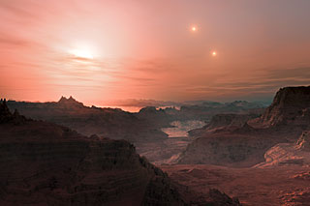
A group of astronomers at the European Southern Observatory in Chile were thrilled to discover Gliese-667Cc in 2011.
Gliese-667Cc is 22 light years from Earth. It orbits a red dwarf star whose mass is one third that of our Sun. The star is part of a triple star system.
The surface temperature of the star is approximately 667 ºC. This is cooler than the Sun. Its habitable zone is between 16.4 and 34.3 million kilometers from the star. Gliese-667Cc is about 17.9 million kilometers from its star. For comparison, the Earth is about 150 million kilometers from the Sun. Gliese-667Cc receives a similar amount of energy at its surface as the Earth receives from the Sun.
The planet orbits its star once every 28 days. Scientists think that Gliese-667Cc always shows the same face to its star, so one side is always in daylight and the other is always dark.
The planet is about 4.5 times bigger than Earth, and has a mass about 3.4 times that of Earth. It is likely to be a rocky planet. Scientists do not know what type of atmosphere it has.
More information from:
www.planetsedu.com/habitable-planet/gliese-667-cc/
Image: Artist’s impression showing a sunset from the planet.
Credit: ESO/L. Calçada
Key Stage 3 –
Perfect planet?
Exoplanet information: Kepler-22b
In 2011 scientists announced Kepler-22b. The exoplanet was discovered by analysing evidence from the Space-based Kepler telescope.
Kepler-22b is 600 light years from Earth. It orbits a star that is similar to the Sun. One complete orbit takes 290 days. Scientists think that the orbit might be elliptical.
Kepler-22b is 15% closer to its star than Earth is to the Sun, but the star is slightly cooler than the Sun.
If the atmosphere of Kepler-22b were similar to the atmosphere of Earth, then its surface temperature would be about 22 ºC. If the planet has no atmosphere then its average surface temperature would be approximately −11 ºC.
Kepler-22b is 2.4 times the size of Earth, and its mass is about 6 times greater than that of Earth. Scientists do not yet know what type of surface the planet has, although evidence suggests that it might have a liquid or gaseous outer shell.
More information from:
www.nasa.gov/mission_pages/kepler/news/kepscicon-briefing.html
Image: Diagram of Kepler-22b within its system, compared to the Solar system. Credit: NASA/Ames/JPL-Caltech
Key Stage 3 –
Perfect planet?
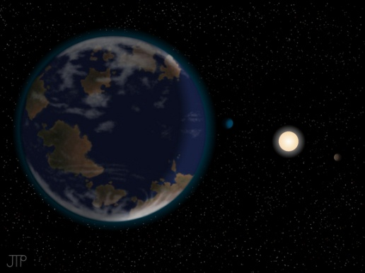
Exoplanet information: HD 40307g
In 2012 a team of scientists from British and German universities discovered HD-40307g. The exoplanet is 42 light-years away from Earth.
HD-40307g orbits its star at a distance of 90 million kilometers, compared to Earth’s orbit of 150 million kilometers. The planet is in the habitable zone of its star.
The planet has a mass that is about 7 times greater than Earth. Scientists do not know what the surface of the planet is like. It could be like a large, rocky Earth or a small, warm Neptune without a rocky surface. Scientists do not know whether the planet has an atmosphere.
The planet orbits its star once every 198 Earth days. There is evidence that the planet is rotating on its own axis as its orbits its star. This means the planet has day and night, just like Earth.
More information from:
http://scitechdaily.com/new-earth-like-planet-hd-40307g-may-be-capable-of-supporting-life/
Image: Artist’s impression of HD40307g and its star.
Credit: J Pinfield for the RoPACS network at the University of Hertfordshire.
Key Stage 3 –
Perfect planet?
Exoplanet information: HD 85512b
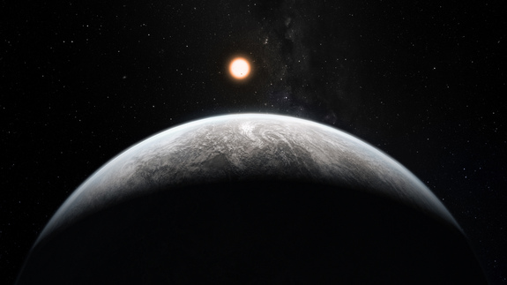
Swiss-based scientists announced the discovery of exoplanet HD-85512b in 2011. They discovered the planet by analysing data from a specially-designed telescope in Chile.
The planet is about 35 light-years from Earth. It orbits a Sun-like star with a mass of about two thirds the mass of our Sun. The planet is 39 million kilometers from its star, compared to a distance of 150 million kilometers from the Earth to the Sun. HD 85512bis at the outer edge of its star’s habitable zone, so it is possible that there is liquid water on the surface of the planet
The mass of HD 85512b is 3.6 times the mass of Earth. Its radius is around 1.5 times that of Earth. Scientists are not sure what the surface of the planet is like.
Scientists have so far not reported whether or not the planet has an atmosphere, and – if so – what it is like. For this reason its surface temperature is not known.
More information from:
www.solarsystemquick.com/universe/hd85512b.htm
Image: Artist’s impression of HD-85512b and its star.
Credit: ESO/M. Kornmesser
Key Stage 3 –
Perfect planet?
Exoplanet information: Gliese-832c
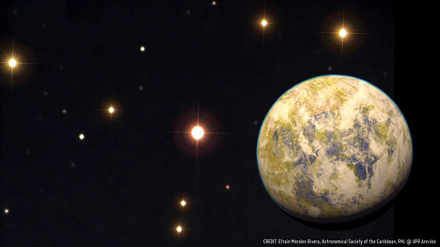
An Australia-based team recently discovered Gliese-832c just 16 light-years from our Sun.
The planet orbits its star in just 36 days. The star is a red dwarf, so is smaller and cooler than our Sun. The planet is closer to its star than Earth is to the Sun, so both planets receive a similar amount of energy. The planet orbits near the inner edge of the habitable zone. It is likely to have extreme seasonal variations in temperature.
The mass of the planet is five times greater than the mass of Earth. Scientists think that it may have a rocky surface.
Scientists predict that the average temperature at the surface of Gliese-832c could be −20 ºC. However, if it has a high density atmosphere then it would be much hotter, with conditions more like those on Venus.
More information from:
www.sci-news.com/astronomy/science-gliese832c-potentially-habitable-super-earth-02029.html
Image: Artist’s impression of Gliese-832c with its parent star in the centre.
Credit: Efrain Morales Rivera / Astronomical Society of the Caribbean / PHL / UPR Arecibo
Key Stage 3 –
Perfect planet?
Exoplanet information: Gliese-832b
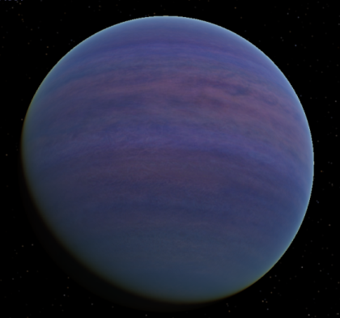
Gliese-832b was discovered in 2008. It is just 16 light-years from our Sun. It orbits a red dwarf star which is smaller and cooler than our Sun.
The planet is about three times further from its star than Earth is from the Sun. This means that its surface temperature is very much colder than that on Earth. It is not in the habitable zone of it star.
The planet orbits its star in 3416 days, with a near-circular orbit.
Gliese-832b has a mass much greater than that of the Earth, and is also much bigger. Scientists have labelled it as a giant planet, rather like Jupiter.
More information from:
http://en.wikipedia.org/wiki/Gliese_832_b

Key Stage 3 –
Perfect planet?
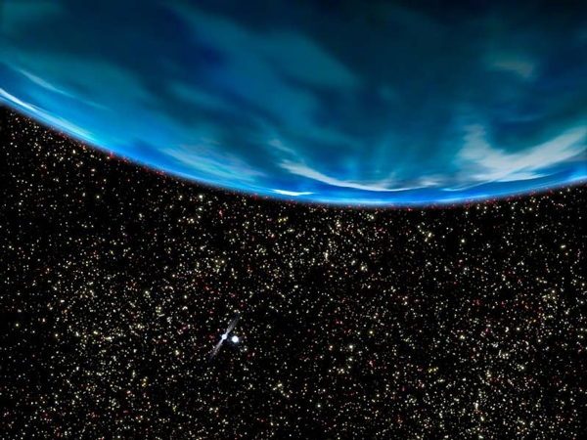
Exoplanet information: PSR B1620-26b ‘Methuselah’
Methuselah was discovered in 1994. Scientists think it was formed 13 billion years ago, less than a billion years after the big bang. It is one of the oldest planets in the Universe. It is 5600 light-years from Earth
The planet orbits two stars – a white dwarf and a pulsar. The stars are part of the constellation Scorpius.
The planet is close to several other stars, and scientists think that it is likely to have been blasted by many explosions in the past 13 billion years.
The mass of the planet is 2.5 times greater than that of Jupiter. It is probably a gas giant.
Methuselah orbits its star at a distance 23 times greater than that between the Earth and the Sun. This is about the distance of Uranus from the Sun.
More information from:
www.scientificamerican.com/slideshow/top-10-exoplanets/
Image: Artist’s impression.
Credit: NASA/ G Bacon
Key Stage 3 –
Perfect planet?
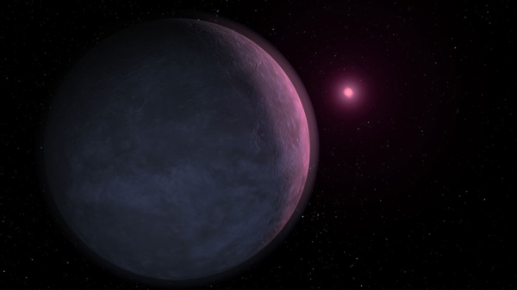
Exoplanet information: MOA-192B
MOA-192B was discovered in 2007. It orbits a brown dwarf star approximately 3000 light-years away in the constellation of Sagittarius.
The mass of the star is between 5% and 6% of the mass of the Sun. It glows only dimly.
The planet orbits its star at a distance of just over half the distance between Earth and the Sun. This means that it is likely to be an ice giant planet, rather like Neptune. Some scientists have speculated that the planet could have a thick atmosphere.
The mass of the planet is equivalent to about 3.3 Earths. It is one of the smallest exoplanets ever discovered.
More information from:
www.scientificamerican.com/slideshow/top-10-exoplanets/
Image: Artist’s impression.
Credit: NASA

