Key Stage 3 – Perfect planet?

Notes for teachers
At a glance
This activity for gifted and talented students introduces some of the fascinating worlds outside our own solar system. Students begin by learning about the conditions which might make a planet habitable. They then study data about exoplanets, and evaluate evidence to predict which might harbour life.
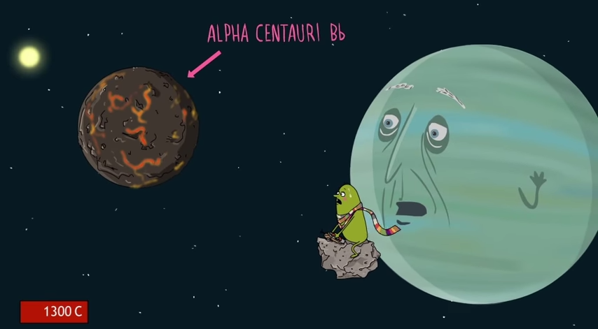
Learning Outcomes
- Students outline the conditions that make an exoplanet habitable.
- Students evaluate evidence to predict which exoplanets might harbour life.

Each group of two or three students will need
- 1 copy of the pupil worksheet
- 1 copy of the Planet profile to complete
- 1 copy of the sheet Habitable or not? to complete
- One Exoplanet information sheet. There are twelve of these, each about a different exoplanet. Each group needs a different one. They are best printed in colour and laminated.
Possible Lesson Activities
- Starter activity
  - Show the animation ‘Rogue planet’ to the class.
  - Repeat the viewing, focusing on the section on exoplanets from 1:32 to 2:16.

- Main activity
  - Divide the class into twelve groups, and outline the activity as described on the pupil worksheet.
  - Allow students time to read Conditions for life and Habitable zone on the pupil worksheet, then check their understanding. Make the link between the term Goldilocks zone and the children’s story of the same name.
  - Give each group one copy of the Planet profile proforma to complete as well as one Exoplanet information sheet. There are twelve Exoplanet information sheets; each group needs a different one.
  - Allow time for each group to complete its Planet profile, then display these around the room. Please note that, for some planets some of the information required to complete the Planet profile is not available. This means that some groups will not be able to complete all the boxes on their Planet profile.
  - Give each student or small group a copy of Habitable or not? Ask them to move around the room to read the Planet profile sheets, completing the Habitable or not? sheet as they circulate.
- Plenary
- Lead a discussion to reach a consensus about which planets could be habitable. The planets that are definitely not habitable are Alpha Centauri-Bb, Kepler-64b, Gliese-832b, PSR B1620-26b and MOA-192B. Any of the others might have conditions that would support Earth-like life, but of course we cannot be sure.
- Suggest that students explore PlanetHunters.org at home. Maybe they will discover their own exoplanet.
Web links
Web link 1: www.planethunters.org
Citizen science project in which volunteers analyse data to search for exoplanets.
Further web links are given at the bottom of each Exoplanet information sheet. If there is time, students can use these to find out further information about their exoplanet.

