Key Stage 3 –
Exoplanet calculator
Pupil worksheet
Life beyond our Solar System
Is life beyond our own planet? How can we find distant worlds that might support living things?
Sophisticated instruments search our galaxy for signs of exoplanets, the planets that orbit stars other than our Sun. Scientists, and people like you, analyse data to predict which planets are perfect for life.
Conditions for life
Step 2
Use data from the Solar System to plot a graph of orbital time versus distance from star.
Let us assume that exoplanet life needs liquid water. If the surface temperature of an exoplanet is too high, water exists as vapour. If the temperature is too low, water exists as ice. For water to exist as liquid, the exoplanet temperature must be just right.
Step 3
Use graphs to estimate distances from exoplanets to their stars.
How can we predict the temperature of an exoplanet? Temperature depends on three variables – the temperature of its star, its distance from this star, and whether or not it has an insulating atmosphere.
Scientists expect to find life-supporting exoplanets in the habitable zone around a star, also called the Goldilocks zone. This is the range of distances from the star which could include planets on which water could be liquid.
Step 4
Use data from step 3, and star temperature data, to decide if the exoplanets are in their stars’ habitable zones.

Your task – Exoplanet calculator
You will use data from the Kepler space telescope to draw graphs and do calculations to work out which of four exoplanets are in the habitable zones of their stars.
Here is an outline of the stages you will follow.
Step 1
Analyse graphs from the Kepler space telescope to work out exoplanet orbital times.

Key Stage 3 –
Planet calculator
Step 1: exoplanet orbital times
Scientists use the Kepler space telescope to observe stars. The telescope monitors the brightness of 100,000 stars.

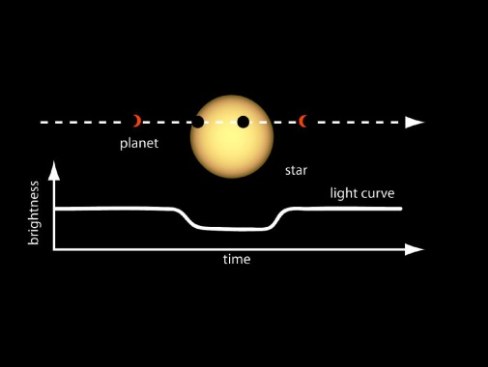
Sometimes the telescope detects a dip in the brightness of light from a star. This could be because the star has a planet. When the planet passes in front of, or transits, the star it blocks some light from that star.
Credit: NASA
If the brightness dips regularly scientists can be more confident that the star has a planet. The planet blocks light from the star every time its orbit takes it between the star and telescope.

The graphs on this page are light curves from Kepler. Each downward spike shows a dip in brightness. Each dip in brightness represents one transit of the planet in front of the star. The time between transits is the orbital time of the planet.

What to do

- Work out the orbital times for the four planets whose light curves are given. Give your answers in days, to one decimal point, for example 8.1 days.
Write your answers in the boxes.
Orbital time for mystery exoplanet = _______ days
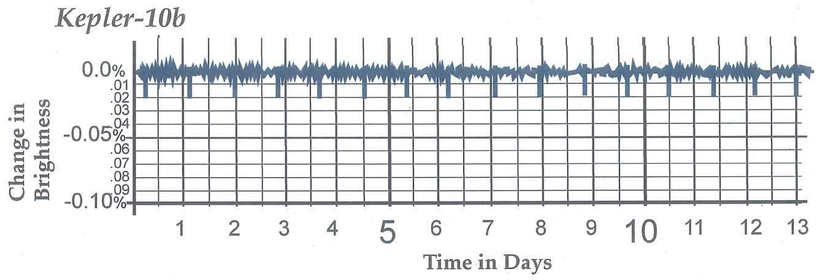
Orbital time for Kepler-10b = _______ days

This graph shows the orbital times of two planets:
- The green, longer lines are for Kepler-9b
- The brown, shorter lines are for Kepler-9c

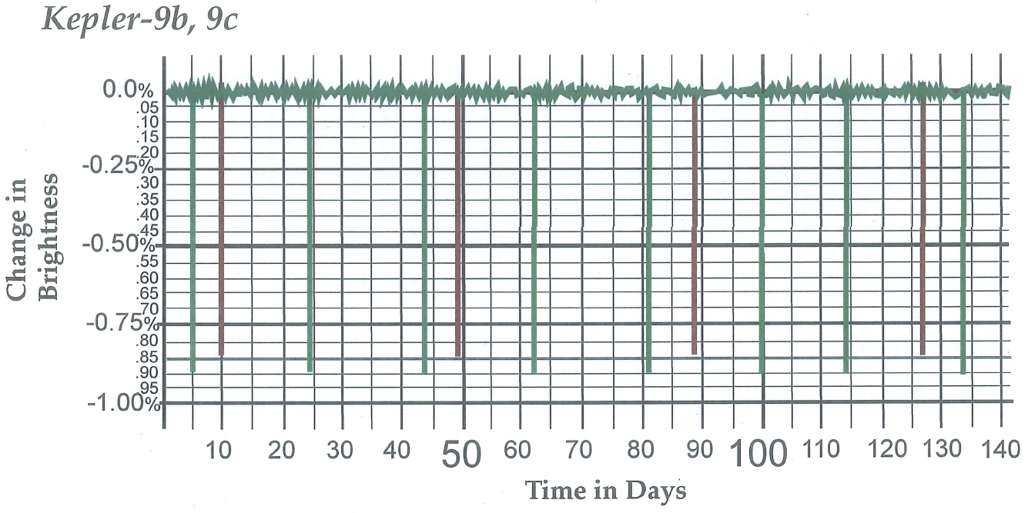
Orbital times: Kepler-9b = _______ days; Kepler-9c = _______ days

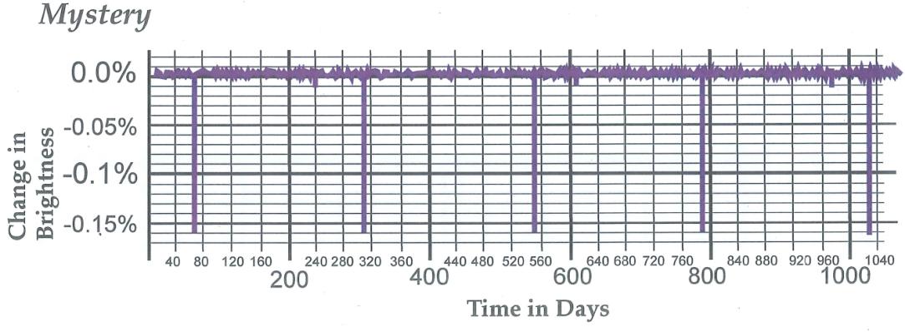

Key Stage 3 –
Planet calculator
Steps 2 and 3: exoplanet distances from stars
Kepler discovered a relationship between the orbital time of a planet and the distance from its star.
What to do
- For the first four planets of our own Solar System, plot a graph of orbital time
(y-axis) versus distance (x-axis). Use the data in the table.
Planet | Distance from Sun (Astronomical Units) | Orbital time  (Earth years)
Mercury | 0.39 | 0.24
Venus | 0.72 | 0.62
Earth | 1.00 | 1.00
Mars | 1.52 | 1.88

- Extrapolate your graph to (0,0).
- Stick your graph in the box on the right. You might need to fold it.
- For each exoplanet, choose one graph on this page to estimate the distance of the exoplanet to its star. Write your answers in the table.
Exoplanet | Orbital time  (Earth days)  (Copy your values from Step 1) | Estimated distance from the exoplanet to its star  (Astronomical Units)  (Use the graphs)
Kepler-10b
Kepler-9b
Kepler-9c
Mystery planet

Stick your graph here

Graph of orbital time versus distance from star
(for orbital times shorter than two years)

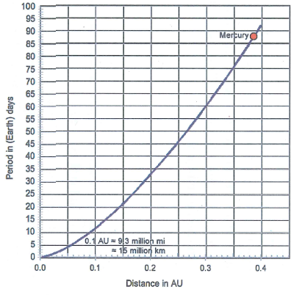
Graph of orbital time versus distance from star
(for orbital times shorter than 100 days)
Key Stage 3 –
Planet calculator
Step 4: star temperatures and habitable zones
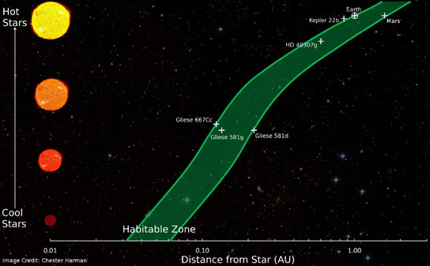
You have estimated the distances of exoplanets from their stars. But are the exoplanets in the habitable zones of the stars?

What to do
- The table gives the temperatures of four stars, including Kepler-9 and Kepler-10. Exoplanet Kepler-10b orbits star Kepler-10. Kepler-9b and Kepler-9c orbit star Kepler-9.
Star | Approximate temperature (ºC)
Kepler-9 | 6000
Kepler-10 | 6000
Gliese-581 | 3800
Sun | 6000

- Estimate where to plot the three exoplanets on the diagram on the right. Clue: look at the position of Earth on the diagram, and the temperature of the stars in the table. Your teacher will show you how to use the x-axis scale.
- Write down whether each of the planets Kepler-9b, Kepler-9c and Kepler-10b is in the habitable zone of its star, or not. Are those that are not in the habitable zone too hot or too cold for water to exist as liquid?
- The mystery exoplanet orbits a star with a temperature of 6000 ºC. Is it likely to be in the habitable zone of its planet?
This diagram shows the habitable zone distances around different types of stars. Some exoplanets that could be habitable are also shown.
- Suggest other factors that might affect whether an exoplanet can support life, apart from whether or not it is in the habitable zone of its star.

