Key Stage 3 – Planet calculator

Notes for teachers
At a glance
This extension activity for gifted and talented scientists with a good grasp of mathematics and well-developed literacy skills introduces them to some of the fascinating worlds outside our own solar system. Students use data from the Kepler space telescope to draw graphs and make calculations to work out which of four exoplanets are in the habitable zones of their stars. The activity stands alone, but is best tackled following the other Oxford Sparks Key Stage 3 activity on exoplanets, Perfect Planet.
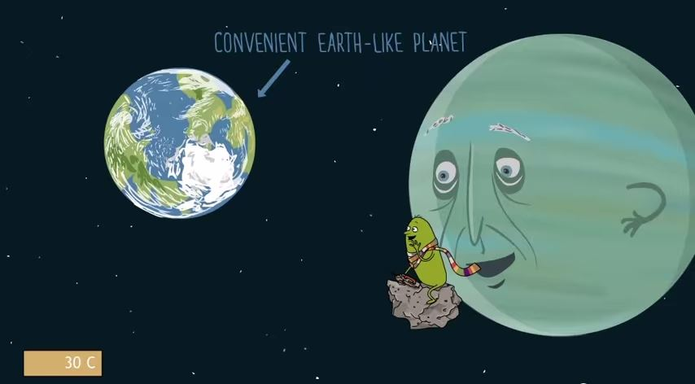
Learning Outcomes
- Students plot exoplanet data on graphs.
- Students analyse data and use graphs to predict which exoplanets might be able to support life.
Each group of two or three students will need
- 1 copy of the pupil worksheet
- 1 copy of each of the sheets Step 1; Steps 2 and 3; Step 4
- Graph paper, or access to a spreadsheet program and a printer
- Glue and scissors
Possible Lesson Activities
- Starter activity
  - Show the animation ‘Rogue planet’ to the class.
  - Repeat the viewing, focusing on the section on exoplanets from 1:32 to 2:16.

- Main activity
  - If students have not previously encountered exoplanets, talk through the sections Life beyond our Solar System and Conditions for life on the Pupil Worksheet. Then outline the four steps of the task, as shown on the Pupil Worksheet.
  - Allow students to work through steps 1 to 4 independently or in pairs, giving support when necessary. It is strongly advisable to work through the questions yourself before the lesson. The diagram in step 4 does not include star temperatures. In plotting their exoplanets on this diagram, students should compare the temperatures of Kepler-9 and Kepler-10 to the temperature of the Sun (they are all approximately the same) and add their exoplanets to the diagram accordingly.
  - Answers for all steps:
    - Step 1 – Orbital time for Kepler-10b ≈ 2 days; orbital time for Kepler-9b ≈ 19 days; orbital time for Kepler-9c ≈ 38 days; orbital time for mystery exoplanet ≈ 240 days.
    - Steps 2 and 3 – Estimates of distances from stars: Kepler-10b ≈ 0.025 AU; Kepler-9b ≈ 0.14 AU; Kepler-9c ≈ 0.22 AU; mystery exoplanet ≈ 0.8 AU
    - Step 4 – Kepler-10c, Kepler-9b and Kepler-9c are not in the habitable zones of their stars; they are too hot for water to exist as liquid. The mystery exoplanet is just within the habitable zone of its star.
- Plenary
- Lead a discussion to explore the other factors which might determine whether the mystery planet is habitable.
- Suggest that students explore PlanetHunters.org at home. Maybe they will discover their own exoplanet.
Web links
Web link 1: www.planethunters.org
Citizen science project in which volunteers analyse data to search for exoplanets.
Web link 2: http://spacemath.gsfc.nasa.gov/
This site from NASA has a huge number of engaging maths problems linked to Space exploration.

