Key Stage 3 -
Quality Crystal
Pupil worksheet
X-ray crystallography
How are atoms arranged in arsenic? How are particles positioned in platinum? What gives copper sulfate crystals their shape?
Before 1914 scientists could not answer these questions. Then they worked out how to use X-rays to look inside crystals. If they could obtain crystals of a substance, they could use X-rays, maths, and a great deal of skill to find out how its atoms were arranged. This is X-ray crystallography.
X-ray crystallography is a powerful and important technique. Since 1914 X-ray crystallographers have discovered the atom arrangement, or structure, of more than half a million substances.
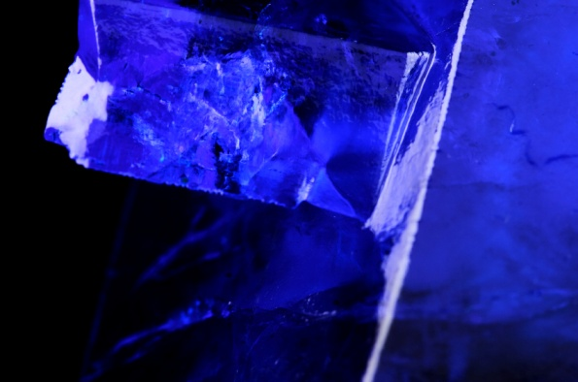
Your task
Some substances exist naturally as crystals, for example sodium chloride (salt). Substances such as proteins do not. Making crystals of big biological molecules is difficult and may take many weeks.
In this activity you will learn some crystal-growing techniques. How can you make incredible crystals? What factors will affect your success?

Key Stage 3 -
Quality Crystal
Pupil worksheet
X-ray crystallography
How are atoms arranged in arsenic? How are particles positioned in platinum? What gives copper sulfate crystals their shape?
Before 1914 scientists could not answer these questions. Then they worked out how to use X-rays to look inside crystals. If they could obtain crystals of a substance, they could use X-rays, maths, and a great deal of skill to find out how its atoms were arranged. This is X-ray crystallography.
X-ray crystallography is a powerful and important technique. Since 1914 X-ray crystallographers have discovered the atom arrangement, or structure, of more than half a million substances.
Your task
Some substances exist naturally as crystals, for example sodium chloride (salt). Substances such as proteins do not. Making crystals of big biological molecules is difficult and may take many weeks.
In this activity you will learn some crystal-growing techniques. How can you make incredible crystals? What factors will affect your success?

Key Stage 3 -
Quality Crystal
Making crystals
Choose one of these substances:
- Copper sulfate
- Potassium aluminium sulfate(alum)
- Potassium hexacyanoferrate(III)
Now follow the instructions below to make the best crystals you can.
Making a saturated solution
First make a saturated solution. This is a solution in which no more solid can dissolve.
- Use the table to find the solubility of your substance at 50 ºC or 60 ºC. This is the maximum mass that can dissolve in 100 g of water. Weigh out this mass.
- Use a measuring cylinder to measure out 100 cm³ of pure water.
- Pour the water into a beaker. Place it on a tripod and gauze over a Bunsen burner. Heat the water to 50 ºC or 60 ºC. Turn off the Bunsen burner.
- Add your weighed out substance to the beaker of hot water. Stir.
- Allow your solution to cool to room temperature.
- With a spatula, add a few tiny crystals of your substance to the solution.
- Cover the top of the beaker with a piece of card. Leave for two or three days.
- Pour off the solution into another beaker, leaving behind any solid. Cover with a piece of card. This is your saturated solution.

Making a seed crystal
- Pour a little of your solution into a watch glass. Leave the rest of your solution in the beaker, covered with a piece of card.
- Leave the solution in the watch glass for a few days. Small crystals will form.
- Once all the water has evaporated from the watch glass, use a magnifying glass to look at the crystals that have formed. Choose the biggest crystal with the best shape. Remove it with tweezers. This is your seed crystal.
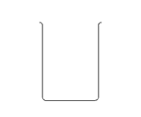
Making a big crystal
pencil
- Use a slip knot to tie your seed crystal to a 20 cm length of thread. This is not easy!
thread
- Suspend the crystal in your beaker of saturated solution, as shown.
seed crystal
- Cover the beaker.
saturated solution
- Leave the beaker for a few days, ideally in a place where the temperature will not change, for example in a cupboard.
- Write down your observations as often as possible.
Solubility data
Substance | Solubility (g of substance / 100 g of water)
 | 20 ºC | 50 ºC | 60 ºC
copper sulfate (hydrated) | 32 | − | 62
potassium aluminium sulfate | 14 | 37 | −
potassium hexacyanoferrate(III) | 46 | − | 70

Key Stage 3 -
Quality Crystal
Record sheet
Crystal progress
Write down your observations as your crystal forms. If you can, take photos, too.
Date | Observations

Crystal quality
Think about what might affect the quality of your crystal. Write these factors in the table. Describe how you think this factor affects crystal quality.
Factor | How we think this factor might affect crystal quality

The best crystal

Look at the crystals that other people made. Discuss what they did, and the factors that they think affect crystal quality.

In the box below, write down what you can do to make the best possible crystals.

