Key Stage 3
School day delay?
Pupil worksheet
Your body clock
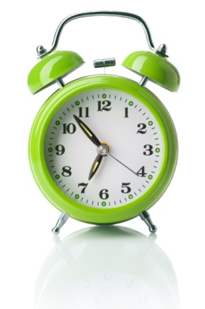
Your body knows when it is time to go to sleep and when it is time to wake up. This natural body clock is a circadian rhythm - a biological process that follows a roughly 24 hour cycle.
It is important to make sure you get enough sleep. A lack of sleep causes you to be tired during the day which means that you find it difficult to concentrate and do well in tasks, such as learning at school. What you may not know is that a lack of sleep is also linked to illnesses such as depression, diabetes and obesity.
Night owls and morning larks
Even though we all have them, people's circadian rhythms can be slightly different; some prefer to stay up later at night and then wake up later in the morning. Others go to bed earlier and rise early in the morning.
There is scientific evidence that the circadian rhythms in adolescents (age 10-18) are slightly different from younger children and adults.
Adolescents are much more likely to be night owls, not being tired until later at night. In order to get enough sleep, they naturally wake up later in the day. However, having to get up early for school disrupts their circadian rhythm, so they do not get enough sleep.
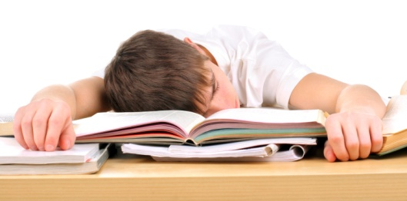

One idea is to start the school day later. This could help to improve their health and happiness, as well as exam results.
Your task
You are going to debate whether you think GCSE students in your school should have lessons from 13:30 to 19:00.
- Work in a pair. Look at the information on pages 2-3. Write down at least two arguments for the change and two against. Your arguments should be supported by evidence. Think about how reliable the source is.
- Think of any other arguments for and against the change to lesson times.
- You will then be put into teams for a class debate. One team will argue for changing the school day, and one team will argue against.
- After the debate, write down what your personal opinion is, with reasons.
Key Stage 3
School day delay?

Source A: A study in the USA using 1,724 students aged 10 to 19. After being asked how many hours of sleep they had a night, they then took some maths and reading tests.
For 16-year-olds about 7 hours of sleep per night is associated with the highest average test scores.
Sleeping less than 6 hours or more than 11 hours resulted in lower test scores.

Source B: Student at Hampton Court school in Surrey where lessons begin later in the day
'I find it easier to concentrate in lessons whereas before I would sometimes be falling asleep over the first few hours of the morning. Here it's so much easier to concentrate and just to focus on the work I have to do.'

Source C: A scientific study carried out in 1997
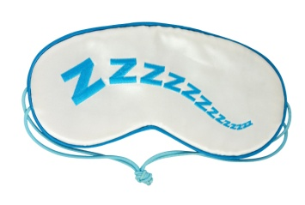
The circadian rhythm can be reset if students keep to a specific sleep schedule and wear eyeshades to exclude light during evening hours.

Source D: Dr Sarah Blunden - Sleep Researcher and Psychologist
'During adolescence there is a delay in the time when melatonin (one of our sleep hormones which makes us sleepy) is released from our brains to our bodies.
Therefore adolescents are not tired until later in the evening. So their bodies are not ready to fall asleep until later - so they do things to stop being bored (TV, phone).
They find it hard to get up in the morning because they fell asleep later and have not had enough sleep.'

Key Stage 3
School day delay?

Source E: Emma Harsin - Student age 15
'If students aren't doing well in school because of their lack of sleep, they should get more on their own time. After school, most kids have jobs, homework and after-school activities. I don't feel that school should start later just because some kids don't get enough sleep. I wouldn't mind sleeping in more, but if that means staying at school later, I would rather get up early.'

Source F: Aaron, 16. A student who has sleep counselling and learnt about how to follow a schedule to fall asleep earlier
'I get to sleep much easier and I'm up bright and early in the morning. I feel much better, my energy is off the chart and I feel much happier. I'm doing better at school and my homework is always handed in on time now.'

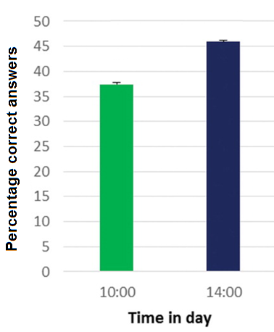
Source G: Scientific study where 200 students aged 13–14 were given a word pairs test at different times of the day

