Key Stage 3 – School day delay?
Notes for teachers
At a glance
A change in circadian rhythms in adolescents means that asking them to wake early in the morning for school results in them being tired and less able to concentrate in lessons.
In this activity, based on the Teensleep study being conducted by The University of Oxford, students decide whether the school day should be delayed for GCSE students. They gather arguments for and against the action before presenting them in a class debate.
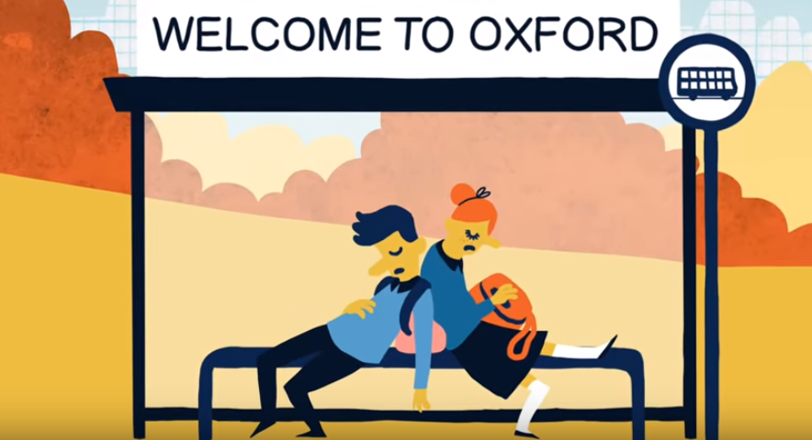
Learning Outcomes
- Students can describe what a circadian rhythm is
- Students recognise the sleep-wake cycle as a circadian rhythm
- Students write arguments for or against an action and present them in a debate
Each student will need
- 1 copy of the pupil worksheet

Possible Lesson Activities
- Starter activity
  - Ask a range of students to tell the class what time they would fall asleep and wake up if they were allowed to go to bed and wake up at whatever time they wanted. Write down these times so the rest of the class can see them and compare to their own times. Discuss how similar (or not) these times are.
  - Show the class the animation 'What makes you tick?' and discuss how our sleep-wake cycle is an example of a circadian rhythm, a biological process that follows a roughly 24 hour cycle.
  - Ask students how waking up earlier than they wish makes them feel in the morning. Introduce the idea that in some schools they have decided to start the school day later to prevent this.

- Main activity: Gathering arguments
  - Supply students with the pupil worksheet. Ask them to read through the information on page 1.
  - Ask the class to raise their hands to show who would vote for a later start (and end) of the school day for GCSE students only.
  - Ask students to work in pairs and read through the instructions for the task. They should read through the information on pages 2-3 of the pupil worksheet. This contains information from a range of different sources. They should use them to gather arguments for and against a delayed school day which they will use later in a class debate.
  - They should also discuss in their pairs any other arguments they can think of e.g. problems with school transportation. They write down at least two arguments for and two against along with the source of the information.
  - You may wish to discuss with the class how good arguments are based on reliable sources and identify some examples of these (scientific studies that have been published in journals, information from experts).

- Main activity: Class debate
  - Ask one student from each pair to argue for the delayed school day and one against.
  - Run a debate on whether GCSE students in the school should have a different school day (13:30-19:00) from everyone else.
There are many different ways of carrying out a debate. Here are some suggestions:
A whole class debate
Before starting, discuss with the class rules. Students on each side should put up their hand if they want to mention an argument that they collected. They should wait until you choose them to talk. When someone is talking everyone should listen. They should present their argument and reasoning (the evidence that backs up their argument). Students can also come up with rebuttals for arguments.
Speed-debating
All the 'fors' line up along one side bench, and the 'againsts' line up facing them. They have one minute to debate at normal conversational volume. Then move all the 'fors' along two places so they get to debate with someone else. Then move them along again and tell them to now support the opposite side of the argument.
Silent debate
Unroll a long length of paper down some central desks (approx 5 m long) and invite students to write their opinions onto it in silence, commenting on the views and comments of others.

- Plenary
- Recap the main points made in the debate.
- Ask students to work alone to write down their personal opinion on whether the delayed school day should go ahead along with their reasons.

Weblinks
http://www.ndcn.ox.ac.uk/research/sleep-circadian-neuroscience-institute/research-projects-4/teensleep
Information about the Teensleep study including videos about why sleep is important and how the study will be carried out. Please visit the website if your school is interested in being involved in the study.
http://www.bbc.co.uk/news/education-34763366
News story about Hampton Court school in Surrey whose sixth form begin lessons at 13:30 and finish at 19:00.

