Key Stage 3
The dark side of blue light
Pupil worksheet
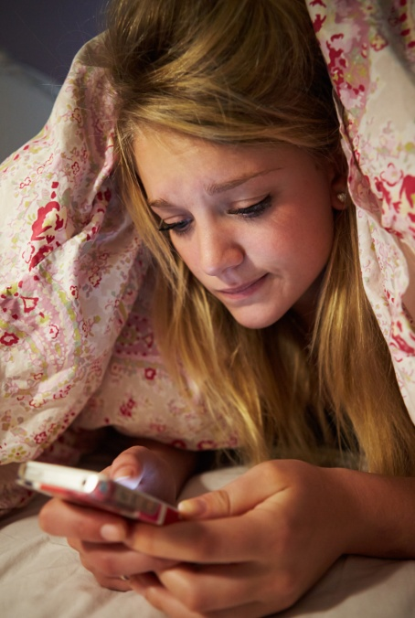
Put down the phone!
Do you find it difficult to drop off to sleep at night? If the answer is 'Yes', then consider this - do you normally spend time on your mobile phone just before bed?
Having one last quick check for messages or trying to complete the next level on your favourite game is very tempting before lights out, but there is scientific evidence that the light from mobile devices is stopping us from falling asleep.

How do we know when to sleep?
Light enters the eye and is focused onto the retina at the back. The retina contains special cells that detect light and send this information along the optic nerve to the brain. Some of these cells, called rods and cones, form images which is what you see.
Another type, called the photo-sensitive retinal ganglion cells (pRGCs for short) help regulate your body clock.
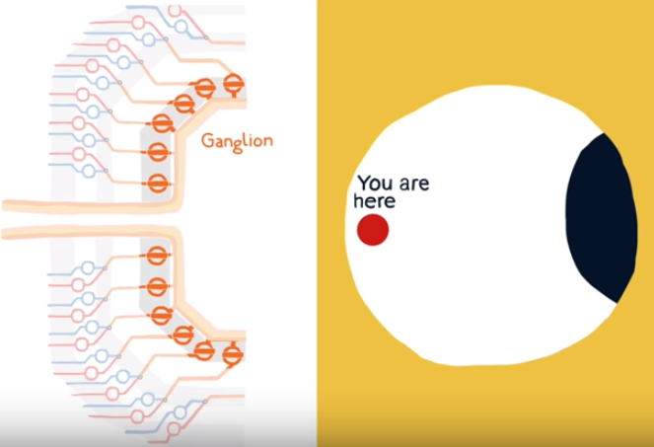

As the level of light gradually decreases at the start of the night we produce increasing levels of a hormone called melatonin, which makes us feel sleepy.
pRGCs are most sensitive to blue light so the light from mobile devices could confuse the body clock and prevent the production of melatonin. Using them before bed will mean that falling asleep takes longer, making us feel tired and unable to concentrate the next morning. A lack of sleep is also linked to more serious conditions such as diabetes, depression and obesity. So, it really is important that we all get a good night's sleep.
Your task
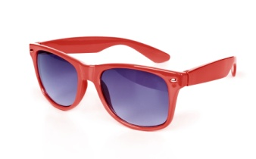
You are going to design special glasses that people could wear at night to help them fall asleep more quickly. The glasses should stop the blue light from mobile devices from entering the eye.
Work in a pair and follow the method on the next page.
Key Stage 3
The dark side of blue light

Investigating filters

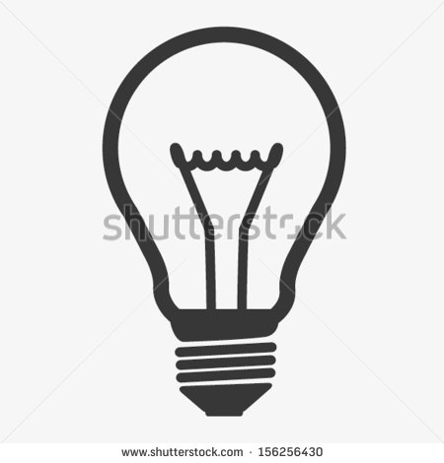
white light

The bulb in a ray box emits white light. White light is a mixture of all the colours in the spectrum:

You are going to investigate what colour lenses are best for glasses to stop the blue light from mobile devices entering your eyes.

You will need:
- A ray box
- Different colour filters (pieces of acetate: green, purple, red, blue)
- White screen (can be just a piece of white card)

Method:

- Place a filter in front of the bulb. Observe the colour of the light on the screen. What colour light went through the filter? What colours were absorbed by the filter?
- Repeat for the other filters.
- Place two filters in front of the ray box as shown in the diagram.

filter 1 filter 2 screen
- Fill in the table below to show the colour on the screen when you use different combinations of filters. See if you can predict what you will see before you try it.
 |  | Filter 1
 |  | green | purple | red | blue
Filter 2 | green
 | purple
 | red
 | blue

Conclusion
Which colour would you recommend for the lenses in glasses to block out the blue light from mobile devices?
Explain why you chose this colour, using what you have learnt about how filters work.

