Key Stage 3 – The dark side of blue light
Notes for teachers
At a glance
There is scientific evidence that the blue light emitted from mobile devices and computer screens disrupts sleep by delaying the body clock.
In this activity students carry out an investigation using filters to find out what colour lenses would be most useful in glasses that prevent blue light from entering the eyes.
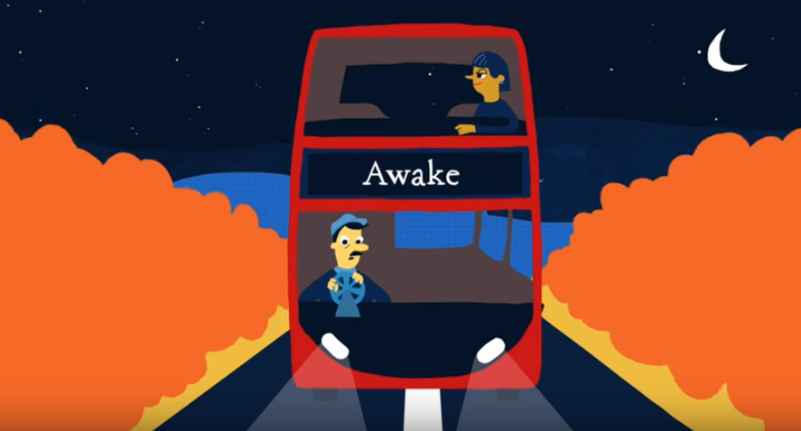
Learning Outcomes
- Students can describe how sleep is affected by light entering the eyes
- Students carry out an investigation into filters and record results
- Students write a scientific conclusion
Each student will need
- Copy of the pupil worksheet

Each pair will need
- A ray box
- Coloured filters (pieces of acetate in green, blue, purple and red)
- White screen/piece of white card

Possible Lesson Activities
- Starter activity
  - Show the class the animation 'What makes you tick?'. Whilst they are watching, ask them to write down why sleep is important for our health. Discuss their answers.
  - Ask students to put up their hand if they find it difficult to fall asleep at night. Ask them to put down their hands down if they never use a mobile phone (or other electronic device such as a tablet/laptop) in bed at night.
  - You will probably still have some hands up. Introduce them to the fact that there is scientific evidence that using a mobile phone before bed interrupts the sleep-wake cycle and makes it harder to fall asleep.
  - Give each student a copy of the pupil worksheet and ask them to read through and write down in their own words why. At this point you may wish to give some classes a copy of a newspaper article outlining the research (suitable examples are shown in the weblinks below).

- Main activity: Investigating filters
  - Tell the class that if you could prevent the blue light from mobile devices entering our eyes this could help up fall asleep at night. They are going to investigate what colour lenses in a pair of glasses would provide this protection.
  - Ask students to work in pairs and give each the equipment for the experiment. They work through the method, investigating what happens to the colour of white light when one filter, then two are added in front of it.
  - After students have completed the method and obtained their results briefly check that they understand how filters work; they allow the transmission of some colours of light and absorb others. Discuss what colours each filter will transmit and absorb.

- Plenary
- Ask students to work alone to write their conclusion - to state which colour filter they would recommend for the glasses and explain how would they work.
- As an optional extra you could ask students to create advertisements for the glasses and present them to the rest of the class.
Weblinks
http://www.bbc.co.uk/news/health-34744859
A short BBC news story which links to a scientific study into the effects of blue light on sleep.

http://www.dailymail.co.uk/sciencetech/article-3262634/Want-good-night-s-sleep-Change-phone-s-blue-light-RED-Apps-claim-able-improve-rest.html
News story from the Daily Mail, which contains a video about glasses which block blue light. It also highlights apps which can be installed on mobile devices to reduce blue light emission.

https://www.washingtonpost.com/national/health-science/blue-light-from-electronics-disturbs-sleep-especially-for-teenagers/2014/08/29/3edd2726-27a7-11e4-958c-268a320a60ce_story.html
A slightly longer news story which contains a scientific explanation for the effects of blue light on sleep disruption.

