Key Stage 3 - Volcano
Fracking
Pupil worksheet
Fracking
Fracking is short for hydraulic fracturing. It is a technique that extracts gas and oil from shale rock. It involves drilling deep into underground rock and then injecting water and sand into the rock at high pressure to release oil and gas.
Your task
A fracking company wants to extract gas from shale rock in your area. The local council is meeting next week to decide whether or not to allow fracking to take place. Your group will help to make the decision.
Preparation
- Do practical tasks A and B to learn about shale rock, and how it stores gas.
- Read the briefing sheets. Answer the questions to check your understanding.
- Plan what to say to help the council make its decision. Use the briefing sheets and the information about your group role to help you.
- Think of a question to ask one of the other groups in the council meeting.
Council meeting
- Present your talk to the council.
- Ask the question you have planned, and answer any questions other groups ask you.

After the meeting
Come out of your role. Write your own summary of the dilemmas facing the council, and recommend whether or not they should allow fracking to take place.
Group roles
- Fracking company – Has drilled through the rock in the local area, and found deposits of shale. Is asking the council for permission to use fracking to extract gas from the shale.

- Environment organisation – Has considered possible impacts of fracking on the local area. Is asking the council not to allow fracking.
- University geologists – Have studied the local rock in detail, as well as the benefits and problems of fracking. Have been asked by the council to advise on fracking.

- Local councillors (OPTIONAL) – Represent local people, and want to do what is best for the area. Want to get re-elected at the next election. Must decide whether or not to allow fracking in the local area.

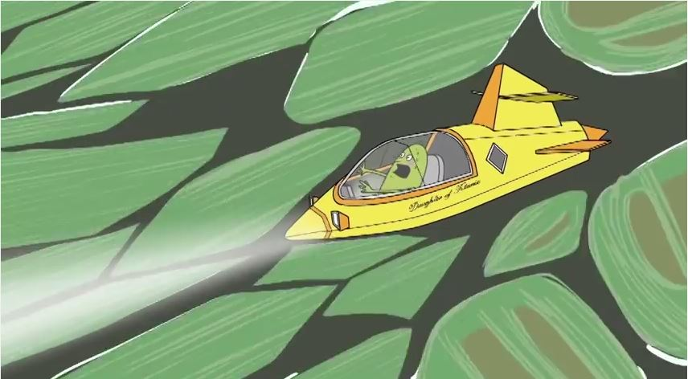

Key Stage 3 - Volcano
Fracking
Practical activity A - Porosity
There are spaces between the grains of a sedimentary rock. The spaces can be filled by substances in the gas or liquid states, such as air or water. The porosity of a rock is the space between the grains, compared with the total volume of the rock.
Porosity of model rocks
- Make a model sedimentary rock by packing marbles into a beaker. Draw a line to mark the level of the top of the marbles.
- Now add water to the marbles in the beaker up to the marked line. Measure the volume of water added. This is W₁.
- Remove the marbles and fill the beaker with water up to the marked line. Measure the volume of water. This is W₂.
- Calculate the porosity of the rock: porosity = (W₁ ÷ W₂) × 100 %
- Repeat the steps above for dry sand.
Porosity of real rocks
Slowly drip water onto several rock samples, and observe how quickly the water soaks in. The rock that soaks up the water most quickly is most porous.
Questions
- A sample of sandstone has a porosity of 30%. A sample of shale has a porosity of 10%. Which rock sample can hold the greater volume of gas in its pores?
- A dry rock sample has a volume of 50 cm³. It is placed in water for a week. The sample soaks up 10 cm³ of water. Calculate the porosity of the rock.
[Adapted from www.earthlearningidea.com]
Key Stage 3 - Volcano
Fracking
Practical activity B - Permeability
Some rocks allow water to flow through them. Some rocks do not. The permeability of a rock is its ability to allow substances in the liquid and gas states to pass through it.
Permeability of rock samples
- Collect some rock samples of similar size.
- Place the rock samples in a beaker of water at the same time. Watch carefully. Which rocks bubble? Where do most of the bubbles come from?
Explaining your observations
The rocks that bubble have spaces between their grains. Air and water can flow through these spaces, so the rocks are permeable.
Bubbles rise from the top of permeable rocks when you place them in water. This is because the air ‘hidden’ in the pore spaces in the rock is less dense than water. The air rises through the interconnected pores. At the same time, water flows into the bottom of the permeable samples.
Good connections between pore spaces, so high permeability
Questions
- Explain the difference between the words porosity and permeability.
- Suggest what might make a rock porous, but not not permeable.
One grain, or sediment

[Adapted from www.earthlearningidea.com]
Large pore spaces, so high porosity
Key Stage 3 - Volcano
Fracking
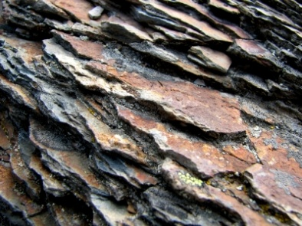
Briefing sheet C - Shale
Shale is a sedimentary rock. It is dark coloured. Shale is hard, so it is difficult to scratch. It is brittle, which means it breaks easily if you drop it.

Shale is formed from tiny clay minerals, which are long and thin. As these become compressed by the weight of sediment above, they become aligned at right angles to the maximum pressure. The resulting layers are usually horizontal. Shale splits easily along these layers.

There are pore spaces between the clay minerals, so shale is porous. However, because the minerals are lined up in layers, water and gas cannot pass through. This means that shale is impermeable.
Comparing shale to sandstone

 | Shale | Sandstone
Diameter of typical grain (mm) | less than 0.0625 | 0.0625 to 2.0000
Porosity (%) | 6 – 15 | 10 – 35
Permeability | impermeable | most types are permeable

Questions
- List four properties of shale.
- Use the data in the table to decide which rock can hold more gas between its pores: shale or sandstone. Explain why it is difficult to get gas out of the pores of shale.
Key Stage 3 - Volcano
Fracking
Briefing sheet D - Fracking
Fracking involves drilling deep into the Earth until the drill bit reaches a layer of shale, with methane gas in its pores. At the shale, the drill turns horizontally.
A mixture of water and sand is pumped into the rock at high pressure. The water forces tiny cracks in the rock to open more widely. Sand holds the cracks open. Gas is released from the pores in the shale. It travels up to the surface.
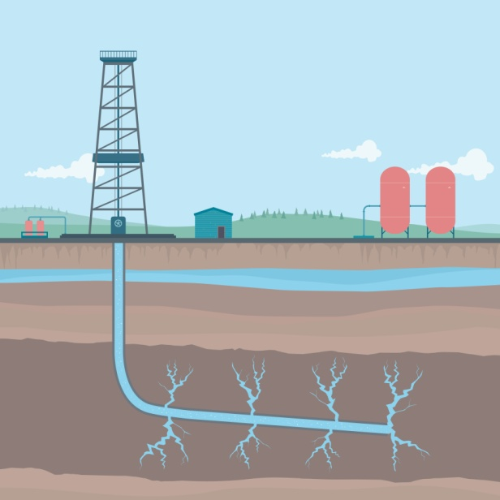
Cracks in shale
Shale
Water table
Water, sand and other chemicals are injected into the well
Gas flows out
Questions
- Use the information above to describe how fracking is used to extract methane gas from shale.
- Explain why fracking uses lots of water.
Key Stage 3 - Volcano
Fracking
Briefing sheet D – Advantages of fracking
Methane: a vital fuel
NO! NO!
Methane gas is an important fuel:
- It burns in central heating boilers to heat homes
- It burns in power stations to generate electricity
Fracking: a new source of methane
Fracking makes it possible to extract methane gas from new places. The pie chart shows US methane sources.
The tables show estimated amounts of shale gas that could be extracted in different countries. There are huge uncertainties in the estimates.

Country | Estimates of shale gas (trillion cubic feet) |  | Country | Estimates of shale gas (trillion cubic feet)
Argentina | 774 |  | China | 1275
Australia | 396 |  | South Africa | 485
Canada | 388 |  | UK | 20

Question
Draw a bar chart to present the data in the tables.
Key Stage 3 - Volcano
Fracking
Briefing sheet E – Disadvantages of fracking

Water, lorries and noise
No to fracking
Fracking uses huge amounts of water. The water must be transported to the fracking site. A new fracking site causes many extra lorry journeys.

Fracking sites are noisy and ugly.

Not for ever… and not on the cheap
Deposits of shale gas run out quickly, meaning that more and more sites would need to be drilled to keep up supplies. It is not easy to find new sites for drilling in the UK. Even in the USA 75% of potential new sites turn out to be dry.

To meet legally-binding targets for carbon dioxide emissions, the UK must stop using methane fuel by 2030. Is it wise to continue to spend money on fracking?

It is unlikely that fracking will reduce energy prices in the UK, since the UK is connected to world gas markets which set the price.

Distraction

Some campaigners say that fracking is stopping energy firms and the government from investing in renewable energy sources, such as solar power, wind power and tidal power.

Question

- List six disadvantages of fracking.

Key Stage 3 - Volcano
Fracking
Briefing sheet F – Where to drill
The diagram shows the rocks in a cross section through the through the Earth’s crust in the council area.
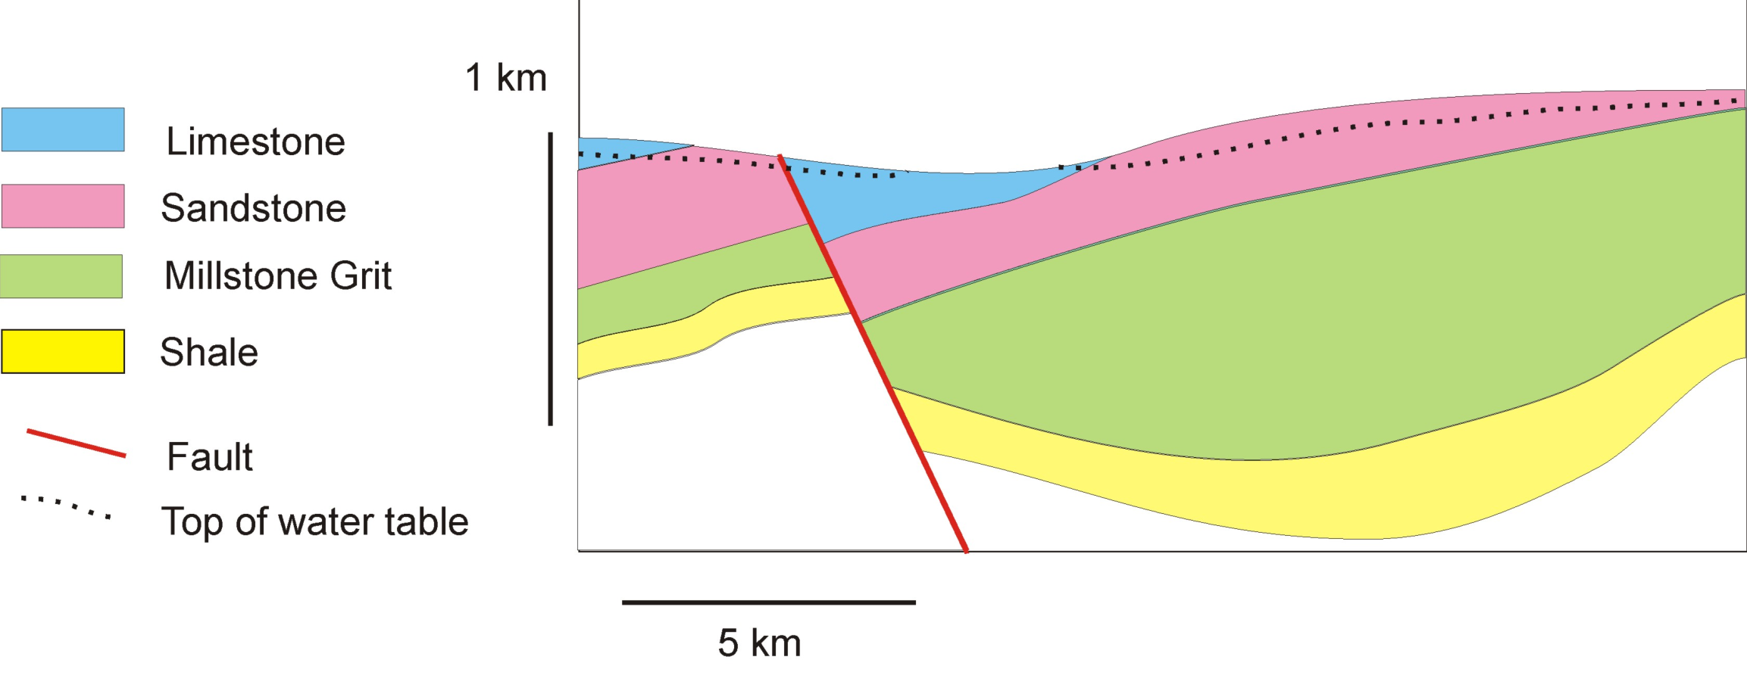
Question
- Study the diagram. Decide where to drill for shale gas, and why. The town is built on limestone, to the left of the cross section shown above.
Key Stage 3 - Volcano
Fracking
Fracking help sheet
Our group name

Do we support fracking, or not?

What we will tell the council

We will ask a question to this group:

This is our question:

