Key Stage 3 – Volcano
Fracking
Notes for teachers
At a glance
In this activity, students explore the ins and outs of hydraulic fracturing, the technique used to extract methane gas from shale rock. The activity includes opportunities to apply ideas about sedimentary rocks, and to experience at first hand the concepts of porosity and permeability. Students learn how fracking works, and about its advantages and disadvantages. They present their findings at a local council meeting to help councillors decide whether or not to allow fracking to go ahead in the local area.
The activities as described below are likely to take two lessons to complete.
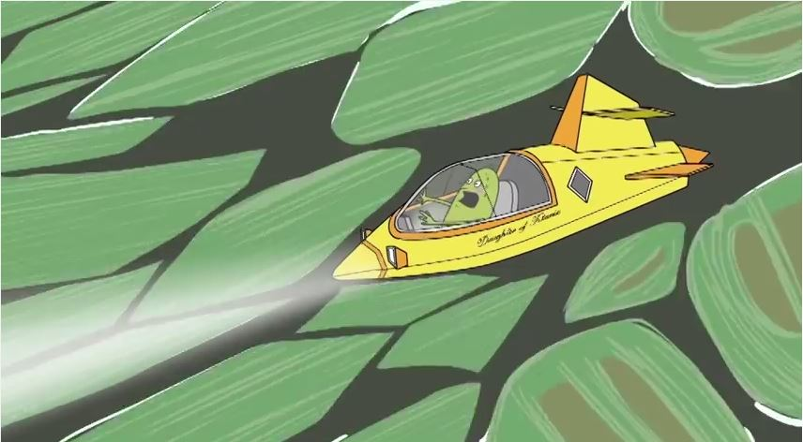
Learning Outcomes
- Students explain the difference between porosity and permeability.
- Students understand how methane gas is extracted from shale by hydraulic fracturing, and can describe some advantages and disadvantages of this technique.

Each group of three or four students will need
- 1 copy of the pupil worksheet
- 1 copy of practical sheets A and B
- 1 copy of briefing sheets C, D, E, and F
- 1 copy of the help sheet (optional)
- Access to the Internet (optional)
- Large beaker (at least 250 cm³)
- Marbles or other roughly spherical objects to half fill the beaker
- Tap water
- Measuring cylinder (at least 100 cm³)
- Method of drawing a mark on the beaker
- Samples of sedimentary rocks of similar size (about 10 cm³), for example limestone, sandstone, shale
Possible Lesson Activities
- Starter activity
  - Show the animation ‘Underwater volcano disaster’ to the class.
  - Repeat the viewing, focusing on the section from 1:03 to 1:26, which shows Ossie moving through fissures in the rock.
  - Introduce the topic of the lesson – fracking. Tell students that, as well as studying volcanoes, such as that in the animation, geologists also study sedimentary rocks. One purpose of so doing is to find fuels such as methane gas. A relatively new technique of extracting methane is hydraulic fracturing, or fracking, which can be used to obtain the gas from the tiny spaces between the grains in a sedimentary rock called shale.
  - Show the BBC video to outline how fracking works (web link 1).

- Main activity
  - Outline the activity, as described on the pupil worksheet. Allocate each group of four students one of the three group roles listed. In a class of thirty, each group role will be played by two or three separate groups.
  - Student groups follow the guidance on Practical activity A and Practical activity B page of the pupil worksheet to explore the porosity and permeability of sedimentary rocks. The activities have been adapted from the Earth Learning Idea web site (see web links 2 and 3 for more comprehensive details of the activities).
  - Groups then read briefing sheets C to F, and discuss or write answers to the questions.
  - Each group then selects relevant information from the briefing sheets and plans their talk for the local council, in line with their group role outlined on the pupil worksheet. Suitable web sites for further information are given below – web links 1 and 6 are particularly useful at this stage. A help sheet is available to help student groups plan what to say.

  - The optional local councillors’ group should study all the information, and compose questions to ask each of the three other groups.
  - Run the council meeting. To maximise participation you might like to run three council meetings simultaneously, if your students are able to take responsibility for working in this way. Alternatively, give each of the two or three groups with the same role a strict time limit.
- Plenary
- Students come out of role. Ask them what they think of fracking: should the UK allow fracking to go ahead, as in the USA, Canada, and China, or should fracking be banned, as it is in most of Europe? If you wish, take a class vote on the issue.
- Students tackle the written task entitled After the meeting on the pupil worksheet. This is also suitable as a homework activity.
Further suggestions
Tackle the sequencing activity from Earth Learning Idea (web link 7).
Web links
Web link 1: www.bbc.co.uk/news/uk-14432401
BBC video - what is fracking and why is it controversial?
Web link 2: www.earthlearningidea.com/PDF/Space_within.pdf
Earth Learning Idea. The space within – the porosity of rocks.
Web link 3: www.earthlearningidea.com/PDF/Modelling_for_rocks.pdf
Earth Learning Idea. Modelling for rocks: What’s hidden inside – and why?
Web link 4: www.bgs.ac.uk/research/energy/shaleGas/howMuch.html
How much shale gas do we have? Useful teacher background information.
Web link 5: www.geomore.com/porosity-and-permeability-2/
Porosity and permeability – more useful teacher background information.
Web link 6: www.foe.co.uk/campaigns/climate/issues/fracking_background_information_33157.html?gclid=CPfHl_2UjLwCFWLHtAodDn4AgA
Friends of the Earth – campaigning against fracking
Web link 7: www.earthlearningidea.com/PDF/Sorting_Sequence.pdf
Earth Learning Idea. Where shall we drill for oil?

