**Key Stage 3 - A question of balance**

**Notes for teachers**

**At a glance**

The lesson begins by viewing the video 'You've got a nerve' which explains how the nervous system is vital for balance.

Students learn about the pathway signals take between sense organs, the central nervous system and muscles in order to coordinate balancing.

They then carry out an investigation looking at how variables affect how well they can balance on one foot. Students work in pairs to gather data and record it. They then analyse the data to describe what it shows and write a scientific conclusion to explain their results.

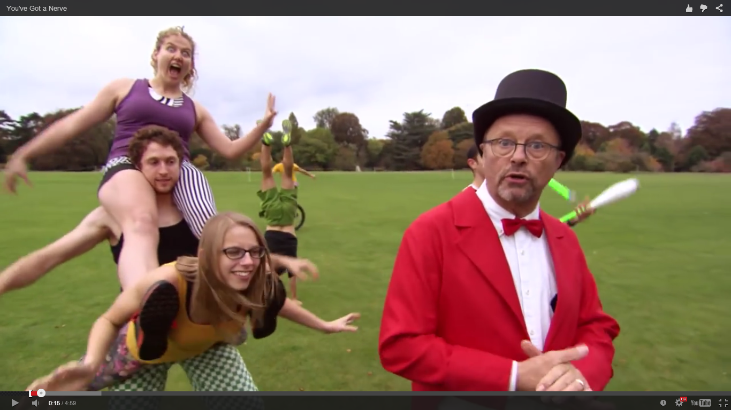

**Learning Outcomes**

* Students follow a simple method and collect data.
* Students analyse data and describe what it shows.
* Students use knowledge about the nervous system to explain reasons for the results.

**Each student will need**

* 1 copy of the pupil worksheet
* Stop clock

**Note: before carrying out the practical activity make sure you carry out a full risk assessment.**

**Possible Lesson Activities**

1. **Starter activity**
   * Ask the students to stand up and show them the video ‘You've got a nerve' to the class.
   * Discuss with them that standing actually requires their muscles to contract to hold their bodies in place. Muscles get tired so this is the reason why it starts to hurt if you stand for a while.
2. **Class activity: Initial discussion of science**
   * Ask the students to sit down and read through the sections *You are a balancing expert!* and *What have the ears got to do with balance?* on the pupil worksheet.

* Watch the section of the video from 0:36 - 2:55 again which recaps the science.
* Make sure they understand the key concepts: signals from sense organs travel along sensory neurons to the CNS (central nervous system) which consists of the brain and spinal cord. Signals then travel along motor neurones from the CNS to muscles. Some pathways are reflex actions which are automatic and do not involve the brain. Many of the actions involved in standing are due to reflexes. You could show the class the animated information from the web link below at this point.

1. **Paired activity: Balance investigation**

* Students work in pairs and follow the instructions on the pupil worksheet to carry out the investigation.
* Discuss with the students what variables they will need to control in order to collect reliable results e.g. height the leg is held above the ground, make sure they compare results from the same person.
* Depending on the class, you could choose to not hand out the right-hand side of the pupil worksheet and ask them to plan the investigation themselves. Ask pairs to discuss what variables affect how well we can balance. Elicit that visual information from the eyes, movement detection from the ears and pressure from the feet provide stimuli that the CNS uses to coordinate balance. They then plan how to investigate how depriving the body of one or more of these affects balance.
* You may wish to provide some classes with pre-drawn results tables and discuss how many times they should repeat. Some students may need help in calculating means.
* Students only need to lift one foot a few centimetres off the floor. Make sure that when students are balancing with their eyes closed, their partner stands near to them in case they become unstable. When students remove footwear make sure there are no hazards e.g. broken glass on the floor. You may wish to provide towels or pieces of thick cardboard for students to stand on.

1. **Individual activity: Analysis and conclusion**

* Students analyse the results and describe what they show. They should discover that with eyes closed they balanced for the shortest time and they balanced for longest with bare feet.
* Students then write a scientific conclusion to explain the results. With eyes open, they had signals travelling from their eyes to the CNS. This information helps the brain to coordinate muscle contraction for balance. With bare feet, pressure sensors on the feet send signals to the CNS.

1. **Plenary**

* Discuss results and conclusions with the class.
* Ask them why, if you have an ear infection, you might feel dizzy and unable to balance.
* Ask students to discuss in pairs a way that they could investigate how a disruption to movement sensors in the ear affect how well you can balance on one leg. A suitable idea might be to spin a person round a set number of times and then time how long they can balance. You could increase the number of spins each time to see how this affects balance.

**Web links**

<http://www.bbc.co.uk/schools/gcsebitesize/science/aqa/nervesandhormones/thenervoussystemact.shtml>

Animated information on the nervous system.