Career Case Study – Mark Wijnbergen PhD Student in Biomechanics

Script for video clip entitled “MW_Career”

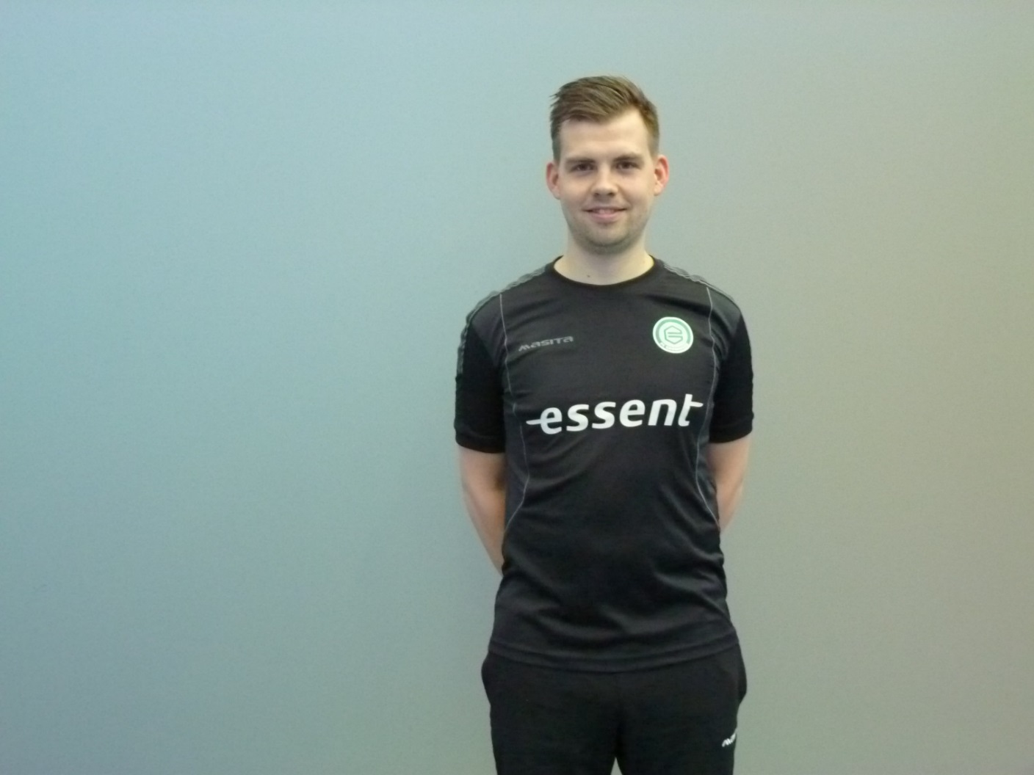“My name is Mark Wijnbergen. I am currently a PhD student at Teesside University which means that I am conducting research all day long. However, when I was younger I never imagined that I would be a scientist or a researcher because I thought that science would be boring, being at a desk just staring at a computer or conducting strange experiments. Although my dream as a young child was to become a professional footballer, I knew I was unlikely to achieve this but I still wanted to work in a professional football organisation. So that’s why I decided to study a Bachelors Degree in Human Movement Sciences and then for a Masters Degree in Sports Sciences in the Netherlands which is where I am originally from. When I was studying I found doing research pretty interesting - I enjoyed working with different athletes. I went to work for a professional football organisation for two years which was great. But when I was there I realised that I wanted to find out more about different topics and decided that it would be better for me to become a researcher. As a researcher you collect and use information to increase the amount of knowledge worldwide. I hope to have made you interested in becoming a researcher in applied or pure science.