Session 6: Eating Cress
Science curriculum area (2P): |  | Plants (2P)  i. observe and describe how seeds and bulbs grow into mature plants  ii. find out and describe how plants need water, light and a suitable temperature to grow and stay healthy
Working Scientifically (KS1 WS) |  | Working Scientifically (KS1 WS)  i) asking simple questions and recognising that they can be answered in different ways  ii) observing closely, using simple equipment  iii) performing simple tests  iv) identifying and classifying  v) using their observations and ideas to suggest answers to questions  vi) gathering and recording data to help in answering questions
Teaching Objectives |  | - To examine and discuss the cress, including facts about the plant and differences between results from the two growing locations.  - To attempt to explain differences.  - To be able to talk about what the seed has produced and how the cress plant grew.  - To make egg and cress sandwiches.
Key Vocabulary: seed, bean, water, warmth, nutrients, leaves, stem, roots, predict
Resources  Fully grown cress seeds, boiled eggs, mayonnaise, butter, bread, knives for spreading and cutting, plates, bowl, magnifying glasses, sketch book and pencils, clean kitchen scissors |  |  | Weblinks  http://www.healwithfood.org/grow-indoors/garden-cress.php - Teacher information about growing cress, including the nutritional value (rich in vitamin C); http://www.misssueflay.com/how-to-make-the-perfect-egg-cress-sandwich/ - How to make egg cress sandwiches; http://www.food.com/recipe/egg-and-cress-sandwiches-139693 - How to make egg cress sandwiches.
Before the session: Invite parents or another class in to eat the cress sandwiches with you. Ask the class to explain their learning to the visitors and to show them the different plants they have grown and the models they have made over the block of sessions. Check class records for any dairy, egg and gluten allergies and intolerances.
Whole class: Ask the chn to look carefully at their cress heads. Encourage them to look through the magnifying glasses and to talk to each other about what they can see. Ask: Is it different to what you expected? What can you see through the magnifying glass that you can't see with the naked eye? What shapes can you see? Can you draw what you can see, in your sketchbooks? Give them time to do this and then ask them to label the different parts of the cress that they can see (stem, roots, leaves). Ask them to turn to their partners and explain what each of those plant parts do to help the plant grow (roots collect nutrients, stem takes the nutrients to the leaves, leaves turn sunlight into food). Ask them to fill in the final part of their cress record, before you show them the cress grown in the cupboard. Ask them: Has this turned out like you expected? Is this what you predicted? Is it similar or really different to what you expected? What has happened? Why has this happened? Then explain that the healthy cress is actually ready to eat and that they are going to make sandwiches to put their cress into.
Activities: Split the chn into sandwich making teams or have tables with butter and bread, another for egg chopping, another for egg and mayonnaise mixing, etc. Ask an adult to supervise boiling eggs (unless you bring them in already boiled) and then have teams of chn chopping the boiled eggs and mixing with mayonnaise in a bowl. When the mayonnaise and chopped egg is roughly mixed, ask the chn to cut a handful of cress, using clean kitchen scissors. The cress should be put in the bowl to be thoroughly mixed with the egg and mayonnaise. There are instructions on the websites in the weblinks section. The egg cress filling is now ready to be put in the sandwiches. Invite parents or another class in to sample the egg cress sandwiches. Set up the tables with tablecloths and flowers and ask the chn to wait on their guests, always being polite and considerate.
Plenary | Sit the chn down and congratulate them on their manners and behaviour with the visitors. Explain that their cress will actually grow back again, if they keep it watered and at the right temperature. It should be cut and grow back several more times. Ask them to take the cress home and to take photos of any egg cress sandwiches they make at home with their families.
Outcomes | Children will  - Observe the cress growth and comment on their observations  - Be able to talk about what the seed has produced and how the cress plant grew  - Understand the differences between the cress in the classroom and that left in the cupboard  - Boil eggs and butter sandwiches and make egg and cress sandwiches

Hamilton’s Science Scheme:
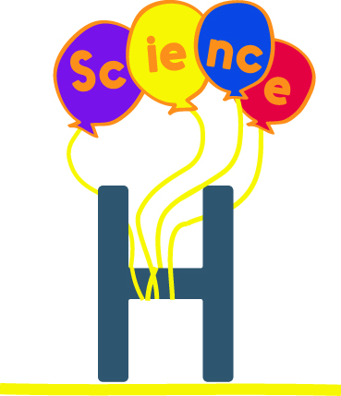
- Covers all statutory National Curriculum Science content
- Arranged in blocks of six sessions for half-termly teaching
- Differentiation within each year’s objectives
- Supportive teacher information
- Assessment activities & ideas
- Comprehensive resources
- Checked by experts
- Mixed year Science planning – NEW in 2017
And best of all, it’s all FREE!
Find out more at www.hamilton-trust.org.uk/stem

