Key Stage 3 – Electric Avenue
Notes for teachers
At a glance
Being more energy efficient helps the environment, as well as our bank balances. But this is only part of the bigger issue surrounding electricity consumption. The everyday choices we make in our homes about which electrical appliances to use and when to use them have consequences for the rest of the population, as they impact on electricity supply. In this lesson, which is suitable for extending the more able, students compete in a game as they try and help a family make wise choices in order to save on their electricity bill. It assumes that students have prior knowledge of how to calculate kWh and the cost of electricity.
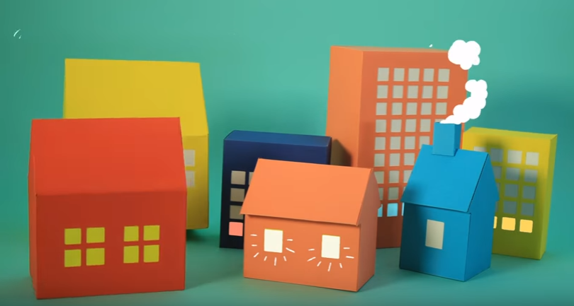
Learning Outcomes
- Students can calculate kWh and the cost of electricity
- Students can calculate percentage changes
- Students can explain how changes impact on the amount of electricity used.
Each student will need
- Copy of page 1 of the pupil worksheet
- Access to the spreadsheet 'electric avenue spreadsheet' OR
- Copies of the family tables from the spreadsheet (if you do not have access to computers)
- Calculators (if students do not use the spreadsheet)

You will also need
- One set of 'family cards' cut from page 2 of the pupil worksheet
- Three sets of 'changes cards' cut from page 3 of the pupil worksheet

Possible Lesson Activities
- Starter activity
  - Ask the class 'Are you told to use less electricity at home?' Ask them to share some ways they are told to do this e.g. turn off the lights when leaving a room, take shorter showers. Discuss the reasons why this is - saving money is a big incentive but there are also environmental reasons as generating electricity produces air pollution. A video such as the one in the weblinks below can be used to engage students.
  - Check prior knowledge of calculating electricity costs by setting the class simple problems: You use a heater with a power rating of 3kW for 2 hours. What is your electricity usage in kWh?
(3kW x 2 hours = 6 kWh).
Remind students that a kWh is a unit of electricity and this is what you pay for. Ask them: How much would using the heater cost if one kWh costs 10p? (6 kWh x 10p = 60p).

- Main activity: Playing the game
  - Show the class the animation 'Power People'.
  - Give each student a copy of the pupil worksheet and ask them to read through the information on the first page.
  - Ask them to use these two sources of information to write down the answer to the question 'what problems might we face with electricity demands in the future and why?' Discuss the students' answers.
  - Organise the class into 7 groups. Give each group a 'family card' (cut from page 2 of the pupil worksheet).
  - Explain the rules of the game:
They will be helping this family to use less electricity and save money on their electricity bill.
First, they need to calculate how much they currently use on a typical day. This information is found on the spreadsheet 'electric avenue spreadsheet'. Groups will need access to this. The spreadsheet contains a sheet for each family which shows the appliances they used and for how long. They can input formulae to calculate the total number of kWh (units) used for each device and then the cost of running each one (every family is currently on an electricity tariff which charges 10p a unit). They then can calculate total number of units used and total cost. You may wish to demonstrate how to do this before the groups start. If you do not have class access to the spreadsheet then print out the tables for each group.
  - Now, tell the groups that they will be able to use changes in order to reduce the amount they spend on electricity. Assign a time to carry out this activity (around 20 minutes). Print 3 copies of page 3 of the pupil worksheet and cut out the 'changes cards'. Place these face down on a desk at the front of the classroom. Students from each group can choose one card and return to their group. They should use the information to make changes to their electricity usage and recalculate the cost of the day's electricity. These changes should be made in additional columns so the starting figures are not altered. This makes comparisons possible.
  - Some of the cards ask them to calculate reductions based on percentages. You may want to go through with the class how this is done before they start. For example, if the heating costs of 30p is reduced by 15% you do this calculation: 30p x (15/100) = 4.5p
30p - 4.5p = 25.5p
  - Some of the changes may not help a family reduce their bill e.g. swapping a desktop computer for a laptop, so groups may choose not to use this. Groups can use as many cards as they want in the time allowed.
  - At the end of this activity they will have a reduced electricity bill. They should calculate the percentage reduction in their bill. This is done by the calculation: ((old total - new total) / old total) x 100.
  - Ask groups to reveal their percentage reduction and the changes they made. The group with the highest percentage reduction is the winner.

- Plenary
- Show the class a graph which shows electricity demand throughout the day (see weblink below).
- Ask them to interpret the graph and describe what it shows.
- Discuss how the changes they made to their family's electricity usage will help reduce demand at peak times and why it is important that families do this.
Weblinks
https://www.youtube.com/watch?v=CRor6cgQXTY
An advertisement from the "Save Money, Save Energy" campaign, which shows simple ways to save electricity in the home.

http://news.bbc.co.uk/1/hi/sci/tech/7268832.stm
News story which contains a graph to show electricity demand throughout the day.

http://www.energy-use.org/
Website of the METER project being carried out at The University of Oxford. This contains a video explaining the project as well as information on why the research is important.
Teachers and student's families can sign up to be part of the project and contribute real data about energy usage.

