Key Stage 3
Energy survey
Pupil worksheet
What were you doing last Monday at 6pm? Maybe you were helping to cook the dinner or watching TV. Were you playing on a games console or doing the ironing? (probably not!)
If you were using electricity, researchers at The University of Oxford are interested in knowing all about it. Read on to find out why...
Using electricity
Electricity to power our appliances is generated in a variety of ways such as large, polluting coal-fired power stations, wind turbines and controversial nuclear power stations.
There is a constant balancing act going on behind the scenes, one of supply and demand. If more electricity is in demand than can be supplied then the electricity supply to our homes will stop.
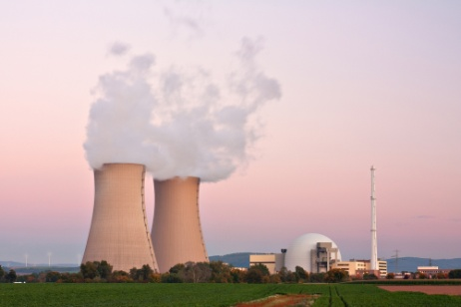
Peak demand
Dr Philipp Grünewald at the University of Oxford is collecting data about what electrical appliances households are using and when. He will be able to find out when people use the most electricity (peak demand) and if persuading people to change the way they use certain appliances will help avoid possible power cuts in the future.
Your task
You are going to take part in an energy survey.
- Take the survey home and complete it yourself. Ask an adult to complete it as well. You need to record what electrical appliances you used between 4 pm and midnight one evening of the week. The adult can continue to fill their's in once you’ve gone to bed.

- Input the data into the spreadsheet and draw a graph to show how total power used (in Watts) changes across the evening.

- What times is your electricity usage highest (peak times) and lowest?

- Describe how you could change how you use appliances to reduce usage at peak times. Why is this important?

Key Stage 3
Energy survey
Survey
My name:
Time | Main appliance used | Other appliance used
16:00-16:30
16:30-17:00
17:00-17:30
17:30-18:00
18:00-18:30
18:30-19:00
19:00-19:30
19:30-20:00
20:00-20:30
20:30-21:00
21:00-21:30
21:30-22:00
22:00-22:30
22:30-23:00
23:00-23:30
23:30-00:00

My adult's name:
Time | Main appliance used | Other appliance used
16:00-16:30
16:30-17:00
17:00-17:30
17:30-18:00
18:00-18:30
18:30-19:00
19:00-19:30
19:30-20:00
20:00-20:30
20:30-21:00
21:00-21:30
21:30-22:00
22:00-22:30
22:30-23:00
23:00-23:30
23:30-00:00

