Key Stage 3 – Energy survey
Notes for teachers
At a glance
For the vast majority of people modern life is dependent on electricity. Researchers at the University of Oxford are looking into what we use electricity for and when, in order to ensure that in the future, supply meets demand at all times. In this activity students carry out their own research by filling in a survey at home into their energy usage across an evening. They will then analyse the data and come up with suggestions for how they could shift their energy usage away from times of peak demand.
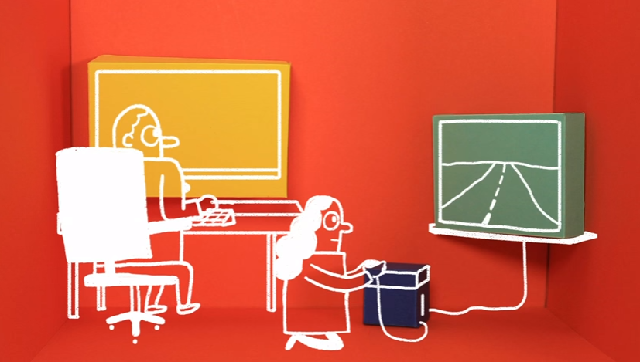
Learning Outcomes
- Students can describe why electricity usage changes throughout the day
- Students can analyse data and draw a line graph
- Students can evaluate a method
Each student will need
- Copy of the pupil worksheet
- Access to the spreadsheet 'energy survey spreadsheet' and the internet

You may also need (optional)
- Graph paper
- Watt meter
- Variety of electrical appliances e.g. hairdryer, lamp, mobile phone charger

Possible Lesson Activities
Before this lesson give the students copies of the pupil worksheet as a homework activity. Play the video from Dr Philipp Grünewald at the University of Oxford where he asks for help in completing an energy survey (see weblinks below). Explain that they will find out more next lesson. At home they should read through the information and complete the energy survey. They should record their usage of electrical appliances for one evening (4 pm until midnight) and ask one adult at home to do the same. If they have a choice of adults, then pick the one that is at home for the most amount of time that evening.

- Starter activity
  - Ask the class to list five ways they have used electricity so far that day. Discuss our dependence on electrical appliances in modern life.
  - Ask students to find the label on a range of electrical appliances and record the power of each in kilowatts. An optional activity is to plug a variety of electrical appliances e.g. hairdryer, lamp, mobile phone charger, into a watt meter and record the power rating of each appliance. Compare the power of each appliance. Remind students that when you pay for electricity you are paying for how much energy you have used. The higher the power rating of an appliance, the more energy it uses per second.
  - Show the class the animation 'Power People'. Ask them 'Why does our electricity consumption change throughout the day?'; 'Why could this be a problem?'

- Main activity: Energy survey data input
  - Ask the class to retrieve the pupil worksheets that they started for homework.
  - Tell them that in this lesson they will be analysing the data they collected in their energy survey. Give each student access to a computer and the spreadsheet 'energy survey spreadsheet'. Demonstrate how to use the spreadsheet to input the information from their survey.
  - They should start using the sheet called 'person 1'. This is where they should input their energy usage from the evening. They use the dropdown menus to select the appliance type then appliance for the main appliance used.
If the appliance they used isn't available, they should select 'other' and input the power rating by carrying out an internet search to find an approximate value.
If only one or no appliances are being used in a time-slot they need to select 'other' and leave the power as 0.
The time-slots are for half an hour. If an appliance is used for less than this, e.g. a hairdryer for 5 minutes, you can discuss with the class how to solve this by proportionally reducing the power for this appliance.
They then continue to input the data for their adult - 'person 2'.
- If you are unable to use the spreadsheet with the class then print out the table of appliances and their power rating from the 'data' sheet. Ask students to use this information to work out the total amount of power used for each time-slot. You may wish to supply them with another table to input the data into.

- Main activity 2: Data analysis
- If the sheet is filled in correctly, the 'totals' sheet will contain the total power used during each time slot.
- Ask students to plot a line graph to show how power used changes throughout the day. They can use the spreadsheet to do this or plot the data by hand on graph paper. For some students you may choose to demonstrate how to do this.
- Ask students to analyse their graph and answer question 3 on the pupil worksheet. This asks them to look at where their electricity usage was highest and lowest during the evening.
- Ask students to feedback their answers to the class and see if everyone has the same pattern of usage. Compare theirs to national usage (a suitable graph can be found in the weblinks below).
- Students then answer question 4 which asks them to consider how they could reduce usage during peak times. Some suggestions could be to put the dishwasher on just before bed rather than straight after dinner or read a book rather than watch TV in the evening.
- Ask students to share their suggestions and see which ones students would consider, and which they wouldn't.

- Plenary
- Show the class the video explaining Dr Grünewald's research project, METER from the weblink below. Ask them to evaluate the methods he is using compared to their survey - why will this project get more accurate data? Some possible answers are:
- Their survey only used two people in the household, the METER research will ask all members of a household over the age of 8 to fill in a survey.
- The METER survey will look at energy consumption over a whole day, not just the evening.
- The METER survey will also measure the electricity consumption using a meter connected to the mains supply rather than just rely on peoples’ information.
Weblinks
https://youtu.be/GNsNumNrAio
Phil Grünewald invites students to help with energy research. Play this video in the lesson before as an introduction to the energy survey homework task.

http://www.energy-use.org/
Website of the METER project. This contains a video explaining the project as well as information on why the research is important.
Teachers and student's families can sign up to be part of the project and contribute real data about energy usage.

http://news.bbc.co.uk/1/hi/sci/tech/7268832.stm
News story which contains a graph to show electricity demand throughout the day.

