Key Stage 3
Hip-Stars
Pupil worksheet
Skeletons are far from frightening - they're amazing!
Your skeleton supports and protects your body, helps you to move and even makes new blood cells.
Joints and bones
Two different places where the bony bump can form
Joints are the places where bones meet.
Most of your joints can move. One example of a joint is the hip. This is where the upper leg bone (the femur) meets the pelvis. When you walk, kick a football, squat or dance you are using your hip joints.
The hip is a kind of joint called a ball and socket - you can see why from the diagram.
Hip with FAI
Cartilage is a smooth substance that reduces friction between the ends of the bones.
Ligaments (not shown) hold the bones together. They are stretchy to allow movement.

Wear and tear
Because hip joints get used all the time, it is no wonder that as we age they can become damaged.
One common problem is called oesteoarthritis (OA). This is where the cartilage becomes worn away. The bones start to rub together, which is very painful.
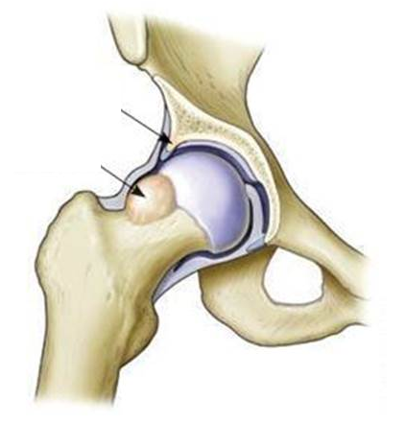
What causes OA?
Scientists at the University of Oxford are researching this. One condition they are investigating is called FAI. This is a small bump of bone that can develop in the hip joint and can increase the risk of developing OA. The next step is to work out how to stop FAI forming. This could help us to stop OA developing and prevent people from having years of painful movement.
Your task
Be a hip-star and create your own working model of the hip.
Evaluate how well it shows how the hip joint works.
Then, use it to suggest how FAI can cause OA.
Key Stage 3
Hip-Stars
Planning sheet
My design

Key things to think about:
What material will you use for the main part of the bones? The socket and ball?
How are you going to make sure the model hip is able to rotate completely and smoothly?
How can you make sure that the joint can move but the ball isn’t at risk of separating from the cup socket?
How my model represents the hip joint

Limitations of my model (what parts are not very good at representing the hip joint and why?)

