Key Stage 3 – Hip Stars
Notes for teachers
At a glance
Scientists at the University of Oxford are investigating the link between sporting activity in young people and the development of osteoarthritis. In very active people, bony lesions can form on the hip joint which increases their risk of developing the condition.
In this activity students apply what they know about the structure of joints to build a working model of the hip joint from a range of different materials. After evaluating their model, they go on to use it to suggest why the bony lesions can lead to osteoarthritis.
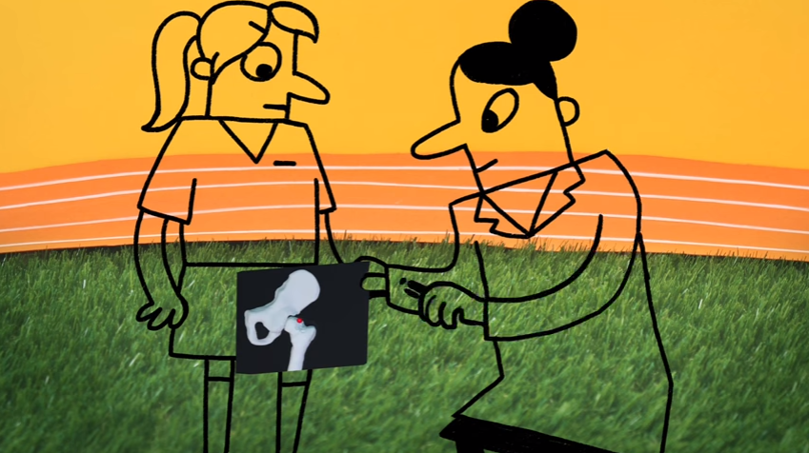
Learning Outcomes
- Students can describe the role of joints, cartilage and ligaments
- Students can design, build and evaluate a model
- Students can use a model of the hips to suggest how bony lesions on the hip (FAI - femoroacetabular impingement) can cause osteoarthritis
Each student will need
- Copy of the pupil worksheet
- Equipment to build the model (rulers, thick cardboard, aluminium foil, string, elastic bands, sticky tape, scissors, balls of various sizes e.g. table tennis, tennis)

Possible Lesson Activities
- Starter activity
  - Show the class the animation 'Hip hip hooray'.
  - Ask each student to summarise the information in one sentence. Choose volunteers to share these with the rest of the class. Record key terms that are mentioned e.g. osteoarthritis, hips, sport, FAI. Inform the class that they will be using these terms throughout the lesson.

- Main activity: Building the model
  - Give each student a copy of the pupil worksheet and ask them to read through the information on the first page.
  - Show the students the equipment that they have to build their model hips (rulers, thick cardboard, aluminium foil, string, elastic bands, sticky tape, scissors, balls of various sizes e.g. table tennis, tennis).
  - It may be useful to show the class a video or animation which shows the 3D structure of the hip - some suitable ones are shown in the weblinks below.
  - Students then plan their designs using page 2 of the pupil worksheet. Key things they need to think about are:
  - What material will you use for the main part of the bones? The socket and ball?
Rulers are good for the main parts of the bone as they are strong and able to support the weight of the rest of the structure. Cardboard can be used to create the socket. A ball can be used to model the end of the femur. It is best to use an actual ball rather than a ball of scrunched up paper or foil as this will have a more even shape.
  - How are you going to make sure the model hip is able to rotate completely and smoothly?
The socket needs to be made so the ball can rotate inside. The size and shape of the ball must match the socket so it is not too big or too small. Students may also consider covering the touching surfaces in a smooth material like sticky tape or aluminium foil.
  - How can you make sure that the joint can move but the ball isn’t at risk of separating from the cup socket?
The elastic bands can be used to hold the socket and ball together. They are stretchy to allow movement - just like the ligaments in the real hip joint.
  - Students can work in pairs or as individuals.
  - If you have enough time, you may wish them to make an initial prototype and then refine this to make a final model.
  - Students should then present their model to another student, showing how it works and explaining what each part represents.
  - After getting feedback, students can evaluate their model by writing down why it was a good model of the hip and any limitations it may have.

- Plenary
  - The students modify their model to show a hip with FAI. The easiest way to do this would be to add a small piece of scrunched up foil or cardboard to either the ball or the socket to represent the bony lump. On moving the hip joint this should make the motion less smooth.
  - Now, they should explain how FAI could lead to osteoarthritis and reduced movement. They can use the key terms that were gathered in the starter activity. Ask some students to share their answer with the class.
The rubbing of the bony lump against the cartilage of the ball or socket in the hip will wear away the smooth cartilage. This increases the friction between the ball and socket which reduces the movement of the hip.
Note: you may wish to end the lesson with a short discussion on why this information should not stop students playing sport - the risk of FAI is very low compared to the risks to health of not exercising enough.

Weblinks
https://www.youtube.com/watch?v=qlCvKEOZtpo
The first 1:30 of this animation can be used to show how the hip joint works in 3D.

http://www.arthritisresearchuk.org/arthritis-information/conditions/osteoarthritis.aspx
Information about osteoarthritis from Arthritis Research.

