Key Stage 3 – Social Media Plot
Notes for teachers
At a glance
Scientists from the University of Oxford are studying how information and misinformation can spread across social media platforms. Mathematical models can be used to help predict how information might spread.
In this activity pupils plot a series of graphs and use them to interpret, predict or describe the spread of information.
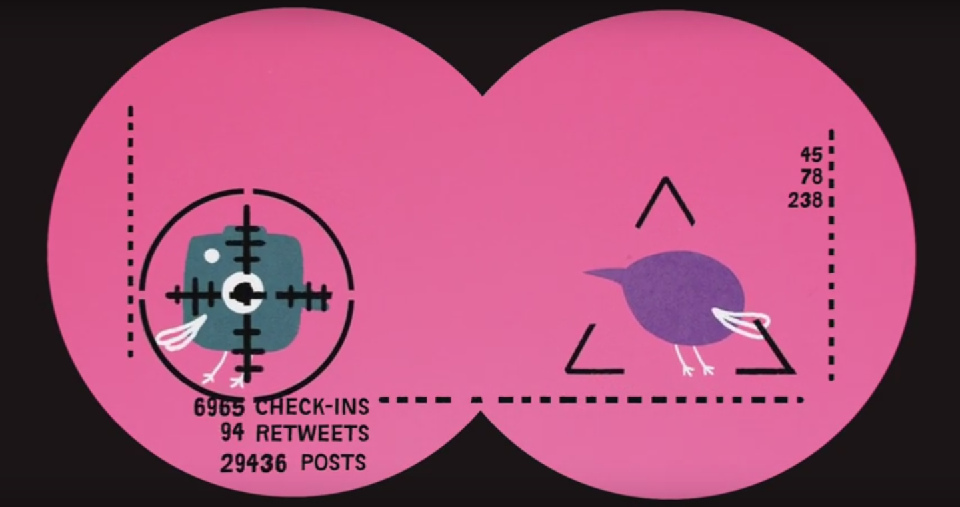
Learning Outcomes
- Students can successfully plot graphs
- Students can use graphs to estimate values
Each student will need
- Student worksheet
- Pens/pencils
Possible Lesson Activities
- Starter activity
  - Show ‘Keeping Social Media Social’ video
  - Ask the students to discuss in pairs if they have ever received/read an email or social media post that has asked them to share a post with ‘5 of their best friends’ or something similar. When/if they do, how often do they then share the post? Select a few students to share some of their discussion/ideas
  - Explain that you are going to show the students a model of how a message like that might spread
  - Ask all the students to stand up and select a volunteer to start ‘sharing’ a post by tapping two people on the shoulder. Those two people need to each tap two people who are standing up on the shoulder and then sit back down to show they have received the ‘post’. The people who have been tapped on the shoulder then each tap two more standing people on the shoulder and so on. Very quickly everyone in the room will be sitting down showing they have ‘seen’ the post
  - Ask the students what would happen if some of them refused to share the post. Would it spread as quickly? Would it stop it altogether? Why might they actively choose not to share something?

- Main activity: Social Media Plot
- Hand out the student worksheets and graph paper
- Ask the students to plot the graphs and answer the questions
- Answers to graph questions:

- i) 200 views at about 10:30-10:40am
ii) 2000 at about 2:40-2:50pm

- a) It is a quadratic graph b) At about 45mins after it was posted

- b) Approximately 100
c) This is a classic ‘S’ shaped graph. The growth starts slowly as relatively few people have seen/retweeted the graph, then starts to accelerate rapidly as the post becomes more popular and is retweeted more and more often but then slows down as most people who are likely to see/retweet the post have already done so.

- Plenary
- Go through the answers to the graphing exercise
- Ask half the students to think of ways that sharing information on the internet would be a good thing and the other half to think of ways that it would be a bad thing
- Select students from both sides to share some of their ideas
Weblinks
- Digital wildfires Educational Resources
https://www.tes.com/teaching-resource/digital-wildfire-e-safety-and-social-media-resource-pack-ks3-11313658
- Oxford Sparks: Keeping Social Media Social Animation - http://www.oxfordsparks.ox.ac.uk/content/keeping-social-media-social

