Key Stage 3
Flavour saver
Pupil worksheet
Playing a starring role in ice-cream, custard, cakes and biscuits; vanilla is the world's favourite flavouring.
Natural vanilla
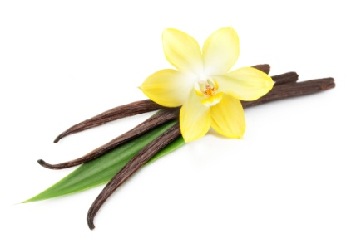
Vanilla comes from the seed pods of a type of orchid plant. It originated in Mexico, but is now also grown in other warm climates throughout the world.
It is the second most expensive spice after saffron because its production requires a lot of work. Making 1 kg of vanillin requires approximately 500 kg of vanilla pods, from around 40,000 flowers.
Vanilla contains a mixture of different chemicals but the one that gives it its distinctive aroma and flavour is called vanillin.
Natural vs artificial
Not all of the vanilla you eat comes from the vanilla plant. Only about 0.25% of vanillin sold originates from vanilla pods, while most of the remainder is made from other raw materials using chemical reactions. These include wood and even crude oil.
Artificially produced vanillin can be produced for as low as £12 per kg, compared to prices of around £1500 per kg for natural vanillin.
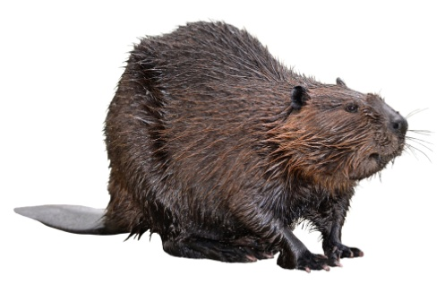
A more unusual source of vanilla flavouring
Castoreum is a chemical compound that beavers use to mark their territory. It mostly comes from sacs located at the base of the tail. Castoreum has a musky, vanilla scent, so it is sometimes used as a vanilla flavouring. It may be listed on food labels as 'natural flavouring' (and not beaver-bum goo) so you wouldn't know you were eating it! But, as it is not easy to extract, production is very low. So the odds are that it won't be in any food you eat (probably).
Your task
1. Explain why most of the vanilla flavouring we eat is made artificially.
2. Work in a group of 3. Each person is going to investigate one way of making artificial vanillin and evaluate it.
3. In your group, discuss your evaluations and decide on the best way of making artificial vanillin.

Key Stage 3
Flavour saver
Using crude oil to make vanillin
Vanillin can be made using compounds found in crude oil.
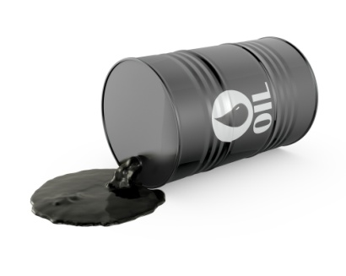
Crude oil is a non-renewable resource. It is a type of fossil fuel, which was made millions of years ago from organisms that lived in the sea. Many other useful products are made from crude oil including petrol and plastics.
To make vanillin from crude oil many processes need to take place. First, the crude oil is transported from where it is extracted and refined to turn it into useful products. Then one product, called benzene, undergoes many chemical reactions. This is called a pathway. The final product is vanillin:
Benzene phenol catechol guaiacol vanillin
Many of the products in the middle of the pathway are harmful.
For example, phenol is highly corrosive and can damage the lungs if it is breathed in. It can be absorbed into the body by contact and high levels cause liver damage.
Catalysts are used in each reaction to speed them up. Phosphoric acid is used in the reaction to make phenol. It is very corrosive, and so its disposal can be a problem.

The conditions needed for the reactions to take place are temperatures of up to 260°C and a pressure of up to 40 atmospheres (40 times normal air pressure). Creating these requires a lot of energy.
The cost of vanillin produced in this way is about £12 per kilogram.
Evaluate the process
How much does it cost?
Are the raw materials renewable?
Is pollution produced?
How safe is the process?
How much energy is needed?

The advantages of this process are:

The disadvantages of this process are:

My evaluation of this process is:

Key Stage 3
Flavour saver
Using wood to make vanillin
Lignin is a long biological molecule (polymer) found in wood. This makes it one of the most common organic polymers on the planet. Old books tend to smell pleasant because the lignin in paper breaks down into vanillin.
Trees are grown, cut down and transported to a processing plant where the wood is cut up and mixed with water to form a pulp.
The pulp is mixed with sodium hydroxide and sodium sulfide. This chemical is strongly alkaline and highly corrosive. The by-products of the process have to be neutralised with strong acids.
Other approaches use chemicals called solvents but these are highly flammable and toxic.
One tonne of wood produces about 4 kg of vanillin. The cost of vanillin produced in this way is about £150 per kilogram.

Evaluate the process
How much does it cost?
Are the raw materials renewable?
Is pollution produced?
How safe is the process?
How much energy is needed?

The advantages of this process are:
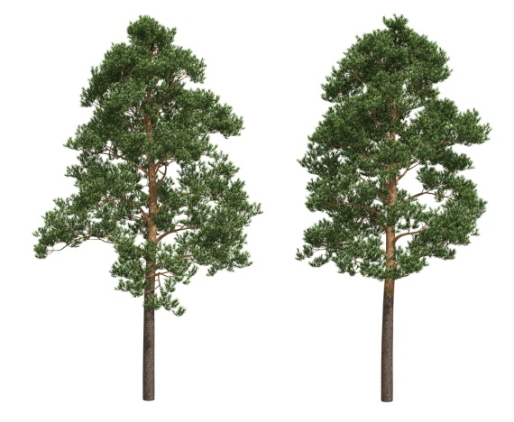
The disadvantages of this process are:

My evaluation of this process is:

Key Stage 3
Flavour saver
Using enzymes to make vanillin
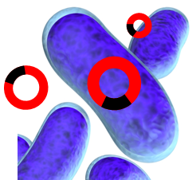
Enzymes are proteins found inside living cells. They are catalysts and speed up reactions.
Many enzymes can be used in industrial processes, including making vanillin. Using living organisms to make useful products in this way is called biotechnology.
One way is to use genetically modified bacteria. These bacteria have been altered so they have a gene to make an enzyme which can turn glucose into vanillin.
a new gene is added into the bacteria
The bacteria are added into a large container called a fermenter along with water and glucose. Glucose is a sugar that is extracted from plants. The fermenter is kept at a temperature of 37°C.
The vanillin the bacteria make is extracted from the water. At the moment, this process can only be used on a small scale. The vanillin produced costs around £150 per kilogram.
Some people are against the use of genetically modified organisms to make food. They are concerned that the modified genes may enter the food and damage humans when it is eaten. However, there is no scientific evidence to support this.
Evaluate the process
How much does it cost?
Are the raw materials renewable?
Is pollution produced?
How safe is the process?
How much energy is needed?

The advantages of this process are:

The disadvantages of this process are:

My evaluation of this process is:

