Key Stage 3 – Flavour saver
Notes for teachers
At a glance
Many of the chemicals we use as drugs, flavourings and perfumes originate from natural sources but often the most economical way of obtaining them is to produce them artificially on an industrial scale. Scientists at the University of Oxford are researching into how to use enzymes to make these processes as efficient and sustainable as possible.
In this activity students find out about the chemical that gives vanilla its popular flavour - vanillin. They evaluate three different ways of producing vanillin artificially and learn about how to use Earth's resources sustainably.
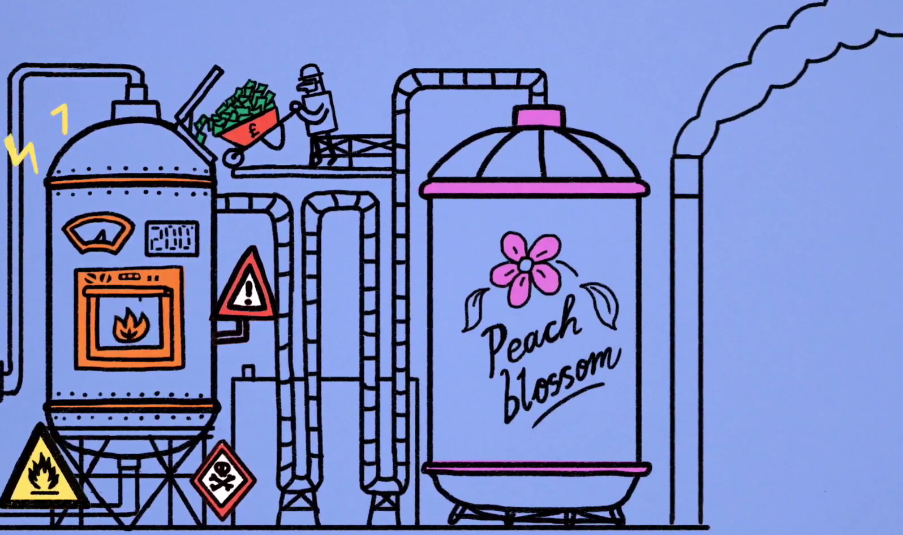
Learning Outcomes
- Students learn that many chemicals that originate from natural sources can be produced artificially.
- Students are introduced to the conditions used in industrial processes.
- Students evaluate industrial processes in terms of sustainability, safety and damage to the environment.
Each student will need
- Copy of student worksheet page 1
- Copy of student worksheet page 2, 3 or 4

You will also need
- Bottles of real vanilla extract and artificial vanilla essence. Labels should be covered. (Optional)
- Cups of vanilla milkshake. Make this by mixing around 100 cm³ of milk with 1 teaspoon of icing sugar and a few drops of vanilla. Make some labelled A, which contain real vanilla extract and some labelled B, which contain artificial vanilla essence. (Optional).

Possible Lesson Activities
- Starter activity
  - Ask students to vote for their favourite ice-cream flavour by raising their hands: chocolate, strawberry or vanilla. Tell the vanilla-lovers that this is their lucky day as this lesson is all about vanilla.
  - Ask students if they know where vanilla comes from. After hearing their ideas, ask them to read through the information on page 1 of the student worksheet and answer question 1.
  - Discuss the answer to the question. Most of the vanilla flavouring we eat is artificial because to extract real vanilla from the beans is a labour intensive and costly process.
  - Ask students to do a blind comparison and smell a sample of real vanilla extract and artificial vanilla flavouring to see if they can tell the difference. If it is safe and appropriate to do so, allow the students to taste test each as well. Mix each flavouring into some milk with a small amount of sugar to make a vanilla milkshake. Ask the students which they preferred before revealing the results.

- Main activity: Evaluating vanillin manufacture
  - Show the students the animation 'What can chemists learn from nature?'. This discusses why chemists aim to replicate natural chemicals, like vanillin, on an industrial scale and how they approach this.
  - Discuss the issues raised in the animation about why we need to work towards making industrial processes more sustainable (you may need to describe what this means if students have not come across this term before), cheaper and safer. Start by considering the type of raw material used (is it renewable? Does its extraction cause damage to the environment?). Ask students to work alone to think up some other factors that might need to be considered and invite volunteers to share these with the class. Some suitable examples are: How much energy the process requires, if it creates any pollution, how safe the chemicals are that are used and how much waste is produced.
  - Divide the class up into groups of three. Students in each group will investigate and evaluate one method of artificial vanillin production: using crude oil, wood and enzymes.
  - Give the students the corresponding page from the student worksheet (2-4). They should read through the information and use the table to think about the advantages and disadvantages of the process before writing a final evaluation.

- Plenary
  - Ask the groups to form again and each student should quickly describe the process they investigated before reading out their evaluation.
  - Groups should then decide on which process they think is best and justify it. An alternative approach, which initiates a more heated discussion, is to ask each student to defend their method.
  - Ask each group to feedback their thoughts and see if groups agreed with each other's decision.

Weblinks
http://sitn.hms.harvard.edu/flash/2015/the-flavor-rundown-natural-vs-artificial-flavors/
Background information on creating artificial flavourings, including vanillin

Get Curious with the University of Oxford
This animation was made to support the University of Oxford’s Curiosity Carnival: European Researchers Night. Sept 29 2017 will be a chance to find out what research is really all about, meet researchers, ask questions and discover how research affects and changes all our lives.
The night is a huge festival of curiosity – a city-wide programme of activities across the University of Oxford’s museums, libraries, gardens and woods. There will be a wide range of activities for all ages and interests – live experiments, games, stalls, busking, debates, music, dance and a pub-style quiz – most of which are free of charge.
To find out what’s on, how you and your students can get involved visit: www.curiositycarnival.org
Oxford’s Curiosity Carnival 2017 will join hundreds of other European cities in celebrating European Researchers’ Night on 29 September.
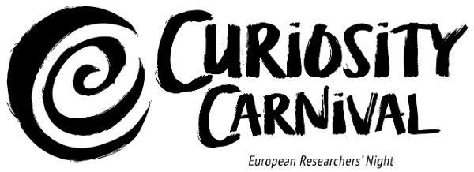
This European Researchers' Night project is funded by the European Commission under the Marie Skłodowska-Curie actions.

