Student worksheet
How to design a cable tidy.
- What is a revolve? Can you give examples of something that might revolve?

- List the steps needed to model a simple revolve e.g. a donut shape.

- Student Challenge
Using Fusion 360 Model a cable tidy similar to the sizes below. Export your file as an STL and then slice it in CURA ready for 3D printing.
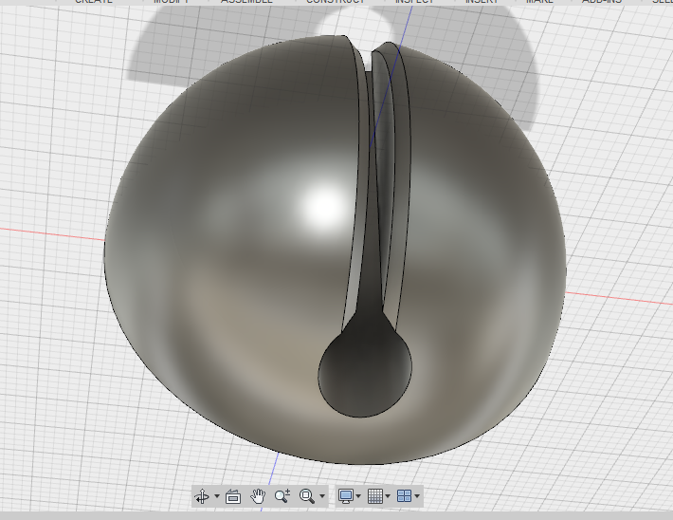

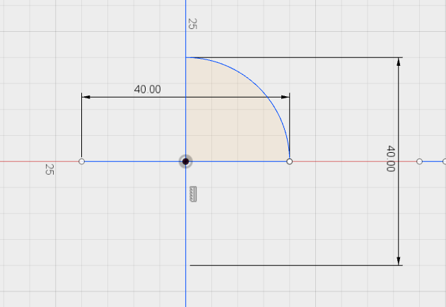
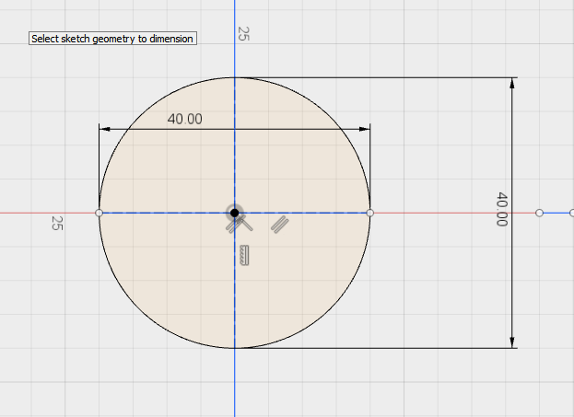

Plenary – What have you learnt today?
Can you describe what a revolve is?

How is a revolve different to an extrude? Explain.

