Student worksheet
How to design an iphone keyring stand
- Using the trim feature, draw these shapes, trim them down and then extrude.

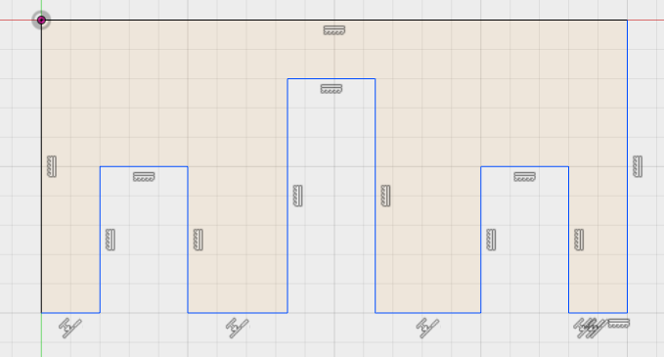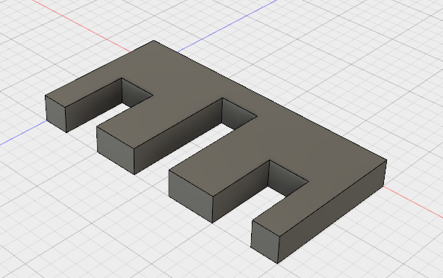

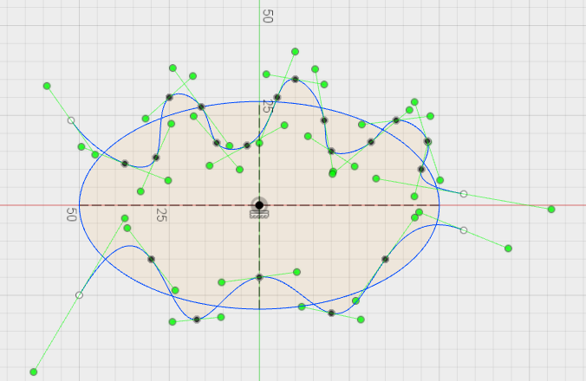

- Measure the thickness of your phone? Record it down below.

- Design your own iphone min keyring stand. Use these sizes as an outline guide. Can your design fit inside this measurement?

Plenary – What have you learnt today?
Explain the function of the trim feature and why you would use it?

