How to design an iphone stand keyring
Teacher notes
Resources:
- Teacher powerpoint
- Example STL file
- Fusion 360
- Smart phone e.g. iphone or android phone.
- Ruler

Pre-preparation
- Print out the student worksheets – These are to be used throughout the lesson
- Ensure you have access to Fusion 360
- Print out the example STL file, make a few copies for the class to look at. Depending on the quality of plastic and the thickness of the phone you might have to rescale the model. The current version works on an iphone 6.

Objectives
- How to use the trim feature in fusion 360.
- To design an iphone keyring stand.

Starter task 5 minutes
- Students are to log onto Fusion 360 and start a new sketch.

Objective 1 – How to use the trim feature in fusion 360.

Task 1 – How to trim a sketch (10 minutes)
Demonstrate to the class how to use the trim feature to trim a sketch. Draw the sketch below and then trim the sketch down.

The trim feature looks like this (it’s under fillet on sketch drop down).

Draw a square, then draw another square inside, as shown below. Then use the trim button and trim the top edge of the square. This will trim the shape to the one shown below.
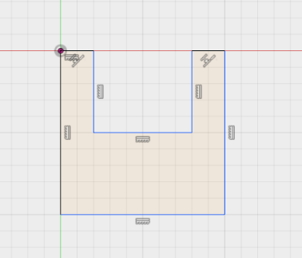
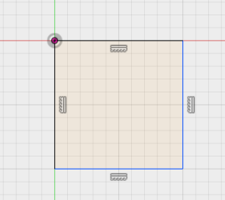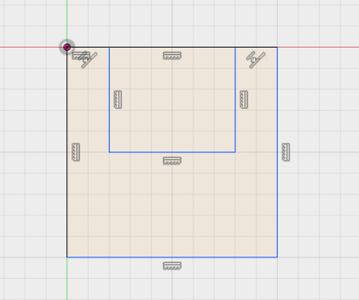

Students are to refer to task 1 on the student worksheet to practice using the trim tool. They need to practice sketching the shapes and then extruding them.

Objective 2 – To design an iphone keyring stand

Teacher needs to complete a run through demonstration of how to design a basic iphone keyring stand. Refer to the teaching powerpoint. (10 mins approximately)

Main student task (25 minutes)

Students need to use a ruler and measure the thickness of their smart phone. They are to record the thickness on task two on the worksheet.

They are then to design an iphone/smartphone keyring stand within the given measurements using the sketch features, trim feature, extrude and hole feature.

They are to use the example sizes as a guide on the worksheet.

Insist that students use the tools learnt in task one e.g. spline tools, trim etc, to change the shape of the keyring stand.

Can the students re-design the example to reduce the amount of material used to an absolute minimum whilst maintaining structural integrity.

5 minute Plenary
- Explain the function of the trim feature and why you would use it?

