**Student worksheet**

**How to slice a model**

1. Thinking back to the earlier lessons what are the three main parts to the 3D printing process? List them below.
2. Explain how these two models differ below;

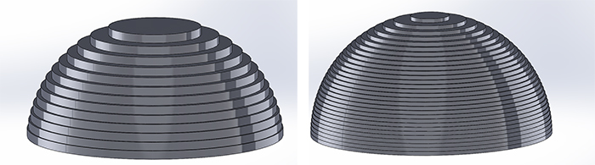

https://support.3dverkstan.se/article/30-getting-better-prints

1. Student Challenge

Using your 3D printers slicing software, slice your models to these settings so they are ready to be 3D printed.

Experiment with setting quality and complete the table below, an example has been done for you. Try to use the least amount of material possible.

|  |  |  |  |  |  |
| --- | --- | --- | --- | --- | --- |
| STL file Name | Layer height | Density | Raft – yes/No | Support – Yes/No | Print time/material cost/weight |
| e.g. Model 1 | 0.2 | 20% | no | no | 38 mins, 6.5 grams |
|  |  |  |  |  |  |
|  |  |  |  |  |  |
|  |  |  |  |  |  |
|  |  |  |  |  |  |
|  |  |  |  |  |  |
|  |  |  |  |  |  |

1. What does this tell you about slicing settings when 3D printing?
2. What does ‘Generate support’ mean and why is it important?

**Plenary – What have you learnt today?**

**What’s the critical angle that a model will need support?**

**How does the layer height effect the time of a print?**