Mechanisms work in the same way as an electrical system.  Levers and linkages  OUTPUT  INPUT  PROCESS  The change in  ---------------------------------------------------------------  E.g.  The ------------------- parts react to the  --------------------------------------------------  E.g. |  |  | What do mechanisms do?  They make jobs ----------- to do, ----------------------------------------------------------------------------------
Levers
The input ------------- the system.

E.g.

A lever is the simplest kind of mechanism, it --------------------------------------------------
Common use of a lever is to -----------------------------------------------------------------------
Load | The------ is the -------- you are trying to---------------------
Fulcrum | The ------------ is the point that ------------ from its spot.
Effort | The -------- is the point where ---------------------------. Usually it's where someone will push or pull on the lever.
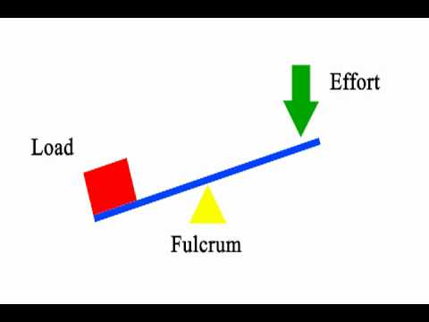
Classes of levers
Class  1 | A class 1 lever has the ---------and the --------on opposite sides of the --------------, like a seesaw.
Class  2 | A Class 2 lever has the -------- between the ---------- and the ----------
Class  3 | A class 3 lever has the ------------------------------------------------- the load and the fulcrum.
I will remember this by:

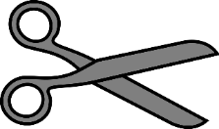
Examples of class 1 products

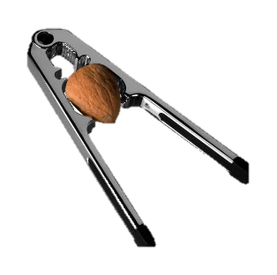
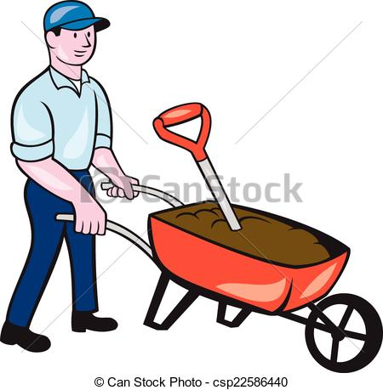
Examples of class 2 products

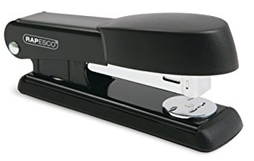
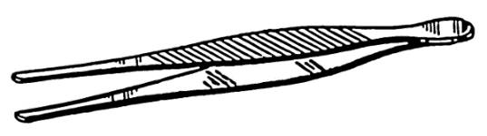
Examples of class 3 products

A linkage is a ----------------------------------------------------------------------------------.
Name ----------------  As the ----- rod moves to the ---- the ---------rod moves to the -------The bars move in  ---------------------- | Linkages are used to :  If the fixed point was not central
Cams  A cam is a shaped piece of metal or plastic ----------------------------- -------------. When the cam --------, the follower --------------  Cams are used to ---------------------------------------------------------------------- | An ………………. cam is a disc with its …………………………………… positioned ………………  To alter the speed  of the follower:
Label the parts to the cam mechanism. (wrong way around to fit it on page!)

