Term  Social, cultural and economic responsibilities in designing and making products. | Meaning | Examples
Social responsibility  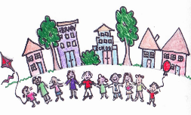 | Designers have a responsibility to create products that ------------------------------- | The “ soccket”
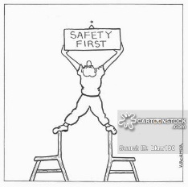  Moral responsibility | Designers/manufacturers have a responsibility do what is right to an individual or group of people ------------------------------------------------------------ | Stone washing denim
Economic responsibility | Designers have a responsibility to ensure that poor workers and communities ------------------------------------------------------ | Fair trade  Example
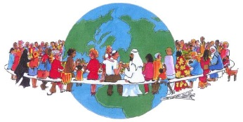  Cultural responsibility | Designers have a responsibility to respect different cultures ------------------------------------------------------------------------ | Examples of considerations
Key terms “Kinetic energy” “Generating energy” “Silicon and sand” “Developing countries” “Cultural norms”

