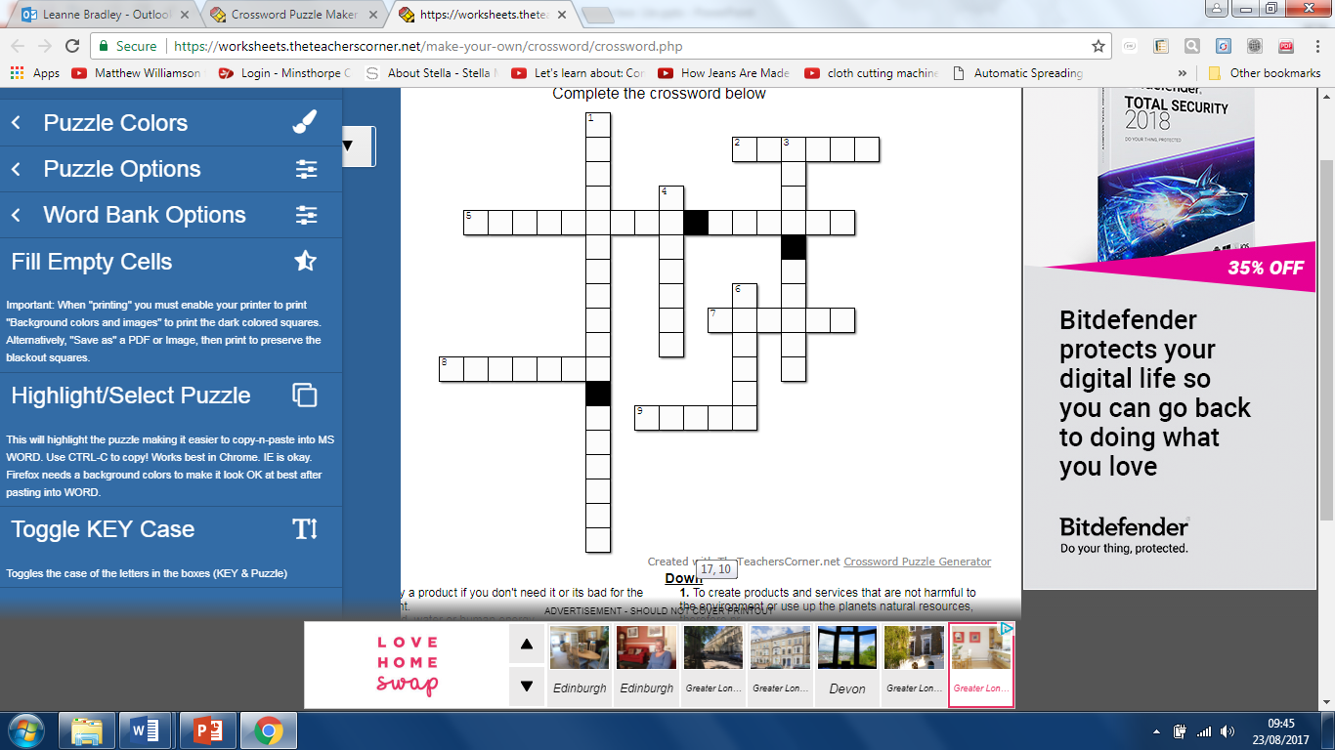**Sustainability**

Complete the crossword below

Reduce

Sustainable design

Recycle

Renewable energy

Reuse

Refuse

Fairtrade

Rethink

Repair

**Across**

**2.** Don't buy a product if you don't need it or it’s bad for the environment.

**5.** Sun, wind, water or human energy.

**7.** When a product breaks down or does not work try to fix it.

**8.** Reprocess a material or product and make something else.

**9.** Use a product to make something else with all or parts of

**Down**

**1.** To create products and services that are not harmful to the environment or use up the planets natural resources,

**3.** Ensuring that the people that make products are paid a fair price and have decent working conditions.

**4.** Design in a way that considers people and the environment.

**6.** Cut down on the amount of materials and energy used.