Gears
Gears are ------------- with -------- on the outer edge.
They are designed to fit into the teeth of other gears, so that they ----------- or ---------------------- together.
Gears are used to ---------------- or ----------- the  ---------- or ------------ of rotary motion.  Label the direction the gears above turn. | An ------------------ is a --------- wheel that is ----------- between two or more other --------- wheels  Label the direction the gears above turn.
Bevel gears  Bevel gears, change the ---------------------- through  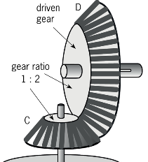  ---------  The teeth mesh at ------------ to each other.  For a hand whisk, the ----------------- of the handle is ------------------to the whisk by gears | Pulleys  A pulley is a ----------- with a --------- or ---------- that goes around it.  The --------- has a ----------- in it to prevent the belt or rope from slipping off.  If the amount of pulleys  are increased :  -------------------------------  -------------------------------  -------------------------------  Pulleys are used to ----------- the amount of ---------- needed to ---------------or to change the --------------------------------------------------.
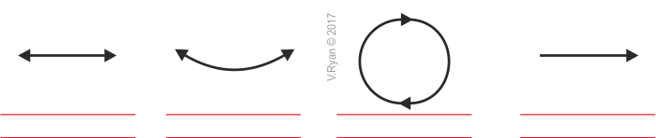
Types of motion- Label and give an example of a product that uses this motion.

