Worksheet- Modern Materials
Kevlar  Name 2 products Kevlar is used for.  Cables in civil engineering bullet proof vests  Cut resistant gloves.  How much stronger than steel is Kevlar?  5x stronger  Name 2 properties of Kevlar  Very strong and durable.  5x stronger than steel  Can withstand high temperatures.  Resist chemicals | Carbon fibres  Why are Carbon fibres used to make racing cars?  Flame proof.  4x stronger than steel with ¼ weight  Circle the correct properties of Carbon fibre  Absorbent rigid flexible  strong flameproof Flammable  Name 2 other products often made from Carbon fibres.  Helmets  Aircraft frames  High performance sport equipment. | GRP (Glass reinforced plastics)  What is GRP?  Is a composite material made of plastic reinforced by fine fibres of glass.  What is GRP resistant to?  Water and corrosion  Name 3 products often made from GRP  Wind turbine blades  Boat hulls  Bath tubs  Swimming pools/water slides  Sport cars  Canoe  Surf boards  Aeroplanes
Phase changing materials  What are Phase changing materials?  Material that absorb, store and releases heat to maintain body temperature.  Name 3 products often made from these materials.  Bedding  Wheel chair cushions  Footwear  Ski wear  Outwear  Sleeping bags | Nomex  What is Nomex?  Flame-resistant material  What properties make it suitable for racing car driver’s clothes?  Heat resistant  Flame resistant  Spark resistant  Durable  Light weight | Geotextiles  What does the term “civil engineering” mean?  Industry term used for the construction of roads, bridges, canals, dams, and buildings)  What is geotextiles used for  They can also be used to protect and strengthen river embankments from erosion.  Name a property that makes it suitable for this?  Absorbent, can separate, filter, reinforce, protect and drain

LCD (Liquid crystal display)  Fill the blanks.  LCD’s can block or allow light to pass through, depending on the amount of electricity  applied.  Why is LCD better for portable electronic appliances?  Allow displays to be much thinner and  consume less power | Rhovyl as an antibacterial fibre.  What is Rhovyl?  The antibacterial substance is added in the heart of the fibre and prevents the development of bacteria that form during any bodily activity.  What products is it used for?  Bedding  Underwear  Socks  Child care (clothing) | Breathable materials  What does “breathable” material mean?  Let’s sweat (perspiration) out but not rain in, thus allowing the fabric to “breath”  What do breathable materials do with sweat?  Absorbs & releases sweat quickly  Give an example of a breathable material  Gortex
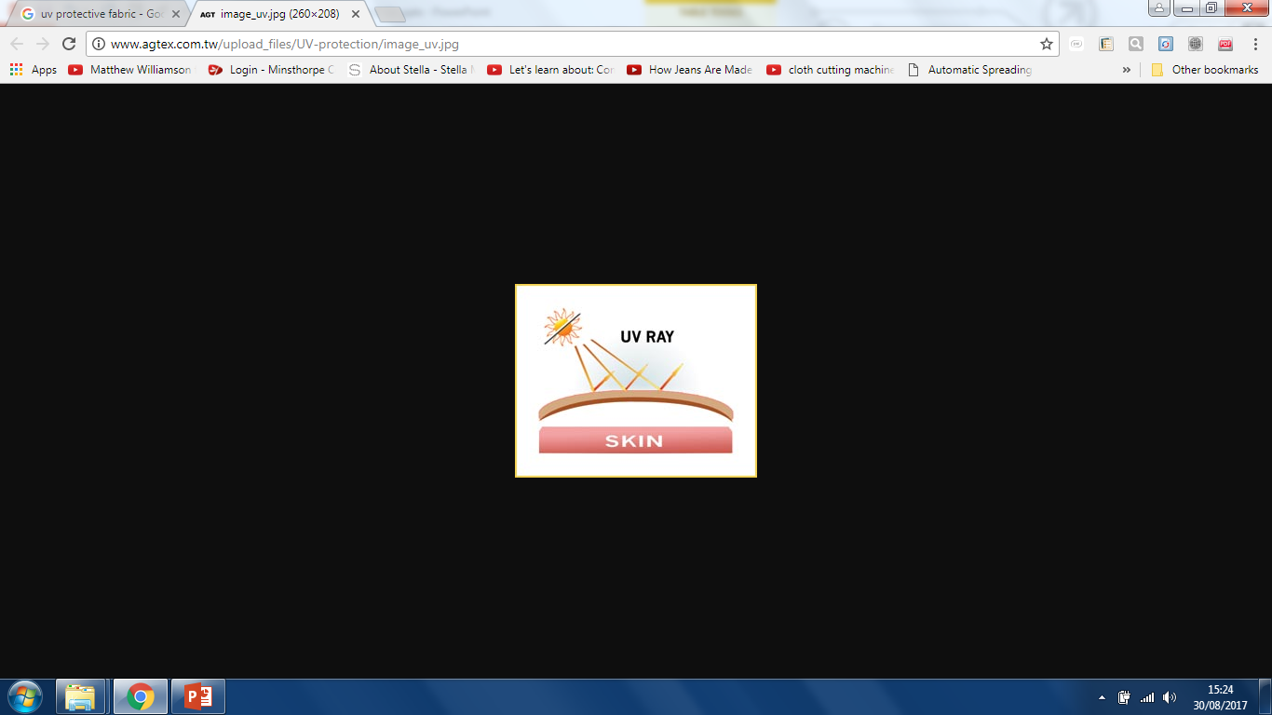  UV protective clothing  Fill in the blanks  Pre-treated with uv preventing ingredients during manufacture to enhance their effectiveness. (titanium dioxide)  What products is it used for?  Hats  beach wear –especially for children  UV beach tents | 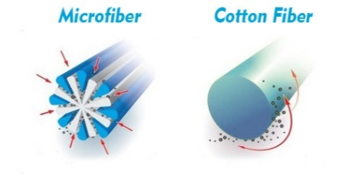  Microfibres  What is the technical definition of a microfibre?  Less than one denier thick  Ultra fine  Soft  High strength  Comfortable  Breathable  Quick drying  Absorbent but dries very fast.  Name 3 properties  What are they commonly used for?  Underwear, active sportswear, cleaning products |   Why does the structure of Kevlar make it so strong?  Molecules can pack closely together  Why might GRP be used in a product, rather than carbon fibre?  Less expensive and less stiff and brittle  What happens when your body temperature increases and cools, when wearing phase changing materials?  The material absorbs the heat and stores it. When body temperature comes down, the stored heat is released back to the body.

