Viscose (Re-generated)  Used for  It is used for shirts dresses and linings.  Properties  Is soft to touch and drapes well.  It creases easy and is not durable | 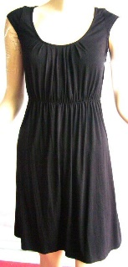  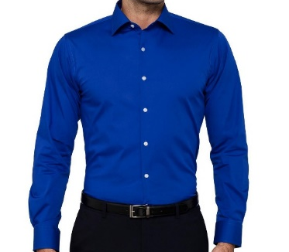  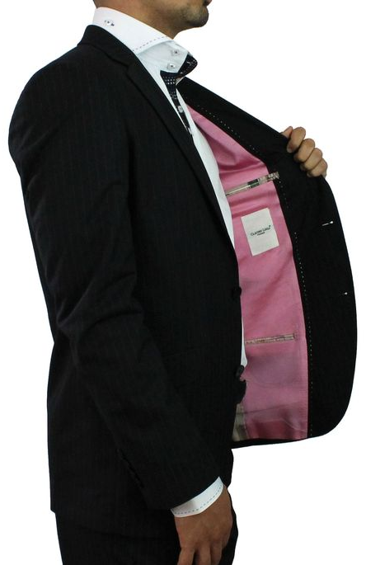
Rubber (re-generated)  Used for  Rubber gloves, car tires, soles of a shoe  Properties  Water repellent  Stretchy and malleable  Electrical insulator.  Strong | 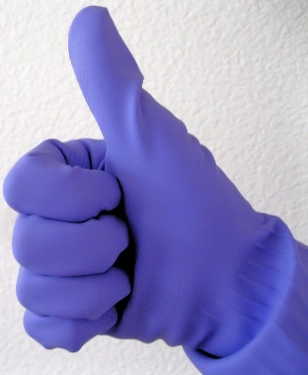  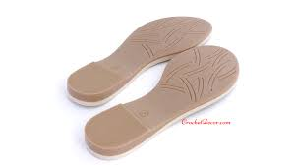
Nylon (Synthetic)  Used for  Active sportswear, carpets, swimwear, seatbelts.  Properties  Water resistant  Resistant to abrasion & chemicals  Creases drop  Polyester (synthetic)  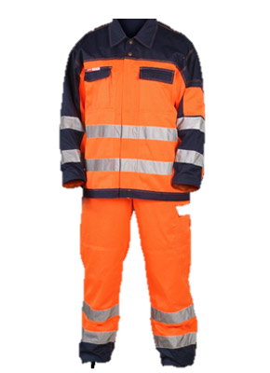  Used for  Wide range of uses- often blended with cotton for shirts, suits and bedsheets. On its own, anything from working clothes to carpets.  Properties  Crease resistant  Non- absorbent- dries quickly  Very durable  Easy to care | 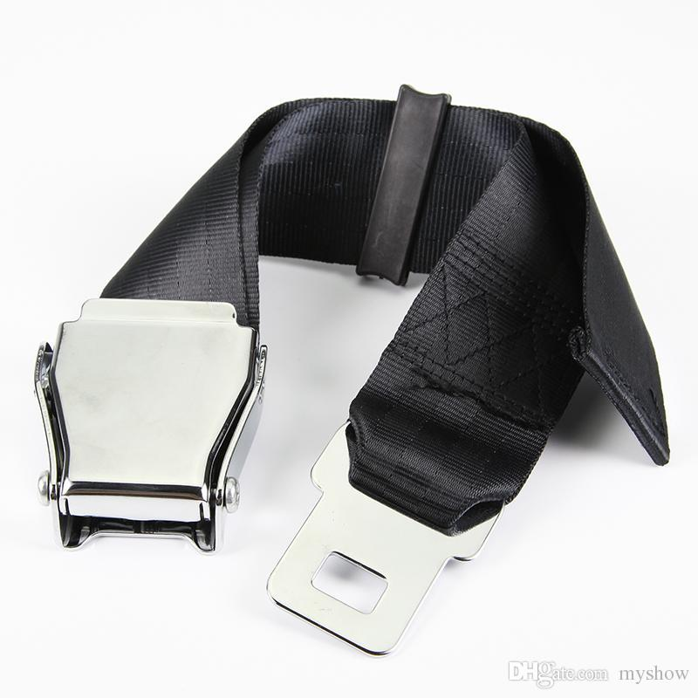
Cotton (natural/plant)
Used for

Jeans, towels, summer clothing.

Properties
Absorbent
Cool to wear
Creases badly
Comfortable
Linen (natural/plant)  Used for  Used for summer clothing, tea towels and tablecloths  Properties  - cool to wear  - Very absorbent/dries quickly  - Good drape  - Durable  - Creases | 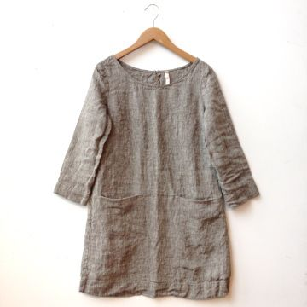  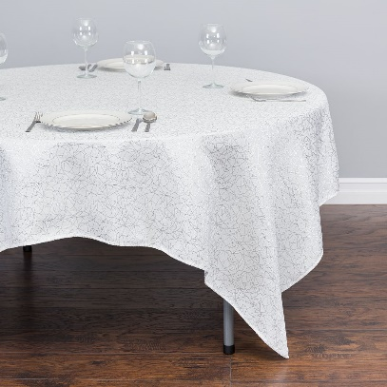
Wool (natural/animal)  Used for  jumpers, suits and blankets  Properties  - Warm to wear  - Absorbent  - Soft or coarse to handle  - Creases drop out | 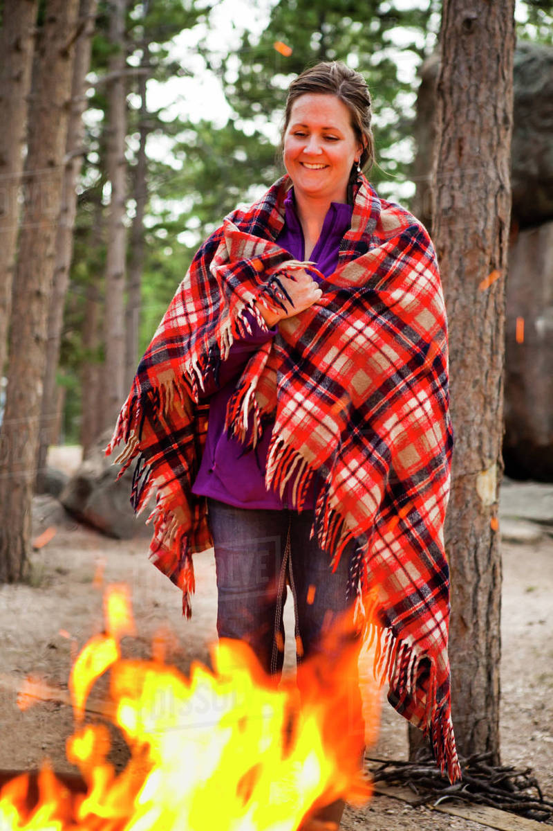
Silk (natural/animal)  Used for  Evening wear, ties,  Properties  - Soft to handle  - Good lustre and drape  - Durable  - Creases drop out  - Dry clean | 