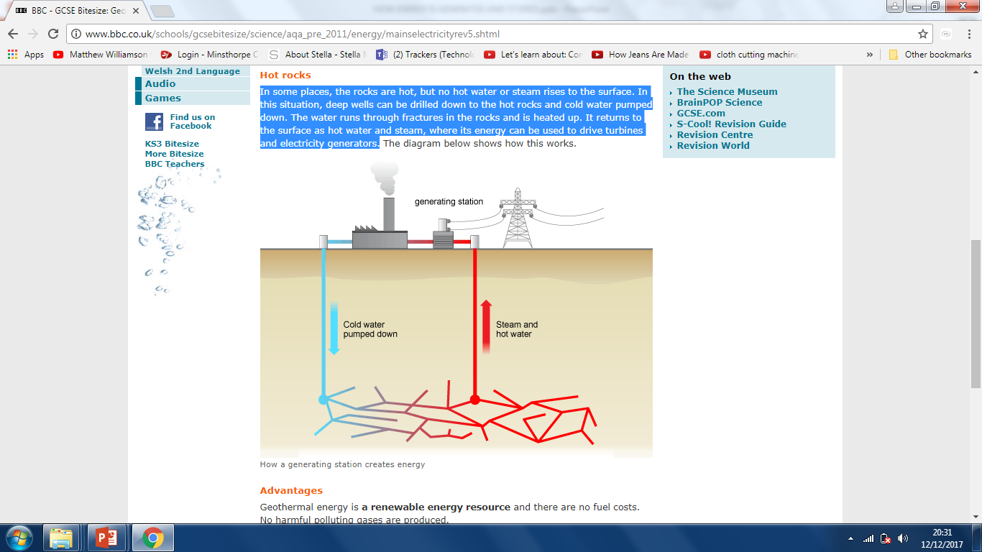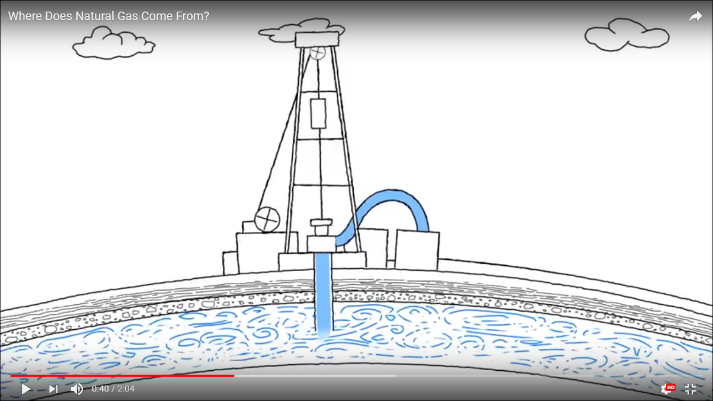

**GEOTHERMAL**

3) The captured steam spins a------------------- which is connected to a ------------------- that produces ---------------------------------

**GAS**

3) Pipes are sunk into the ground to---------------------the -----------

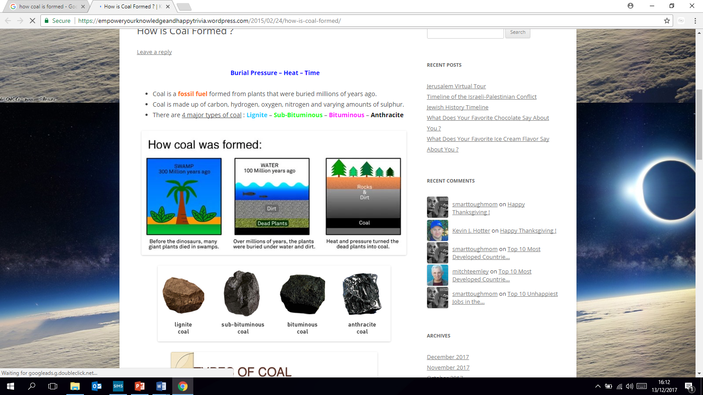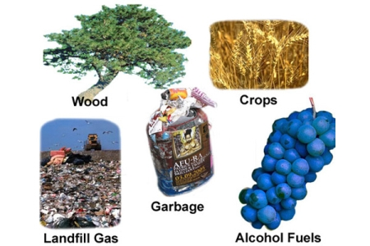

1) Remains of decayed ----------------- & -------------------deep underground.

2) Pressure and ------------ turn them into natural ----------------------

3)------- and -----------------turned the dead plants into coal.

1) Millions of years ago giant ------------------ died

in ----------------forests.

2) Small amounts of heat can be

------------------------ by ----------------------

1. Earth’s crust has hot-----------------------------------

**BIOMASS**

2) Over millions of years, the plants were --------------- under----------- and dirt.

**COAL**

1. Burn waste
2. Heats water
3. Creates steam
4. Turns turbine
5. Powers generator
6. Creates electricity.

|  |
| --- |
| 1. Millions of years ago, ----------------------------------------------------------- lived in the water. |
| 1. They died and fell to the ----------------------------------- |
| 1. Sand and rocks ----------------------------------------------------- |
| 1. With ---------------------------------------------- they turned into rocks |
| 1. ---------------- from earth caused dead plants/animals to --------------------------------------------------- |

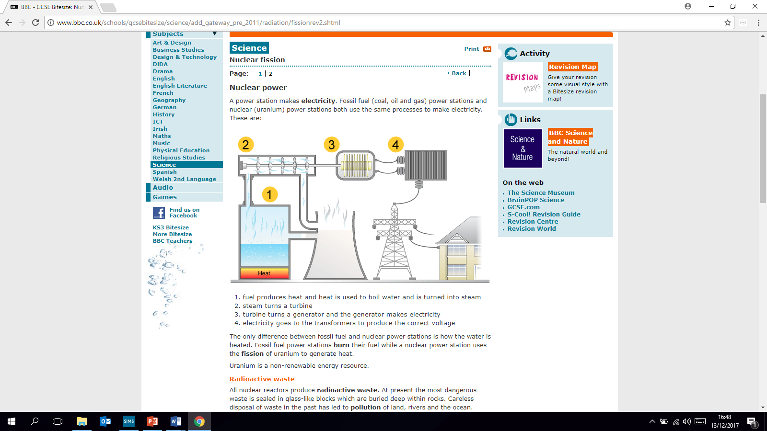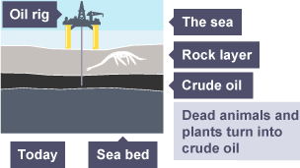

A power station makes electricity from fossil fuels (coal, gas, oil) or nuclear (uranium)

1. Fuel produces ---------- and heat is used to boil water and is turned into ------------
2. Steam turns the ---------------
3. Turbine turns a ------------------------- and the generator makes

--------------------------------

There is only one difference between using fossil fuels and nuclear (uranium) to generate electricity.

Fossil fuels are burnt

Uranium is heated. (Uranium is a heavy metal)

**Power stations-nuclear.**

**OIL**

4) The gearbox is connected to a --------------------------- that converts the-------------------- energy to

electricity.

1) ---------- force makes the ------------------------ rotate.

1) Solar panel ----------------------- sunlight to

d--------------------- c---------------------------- (DC)

**WIND**

**SOLAR**

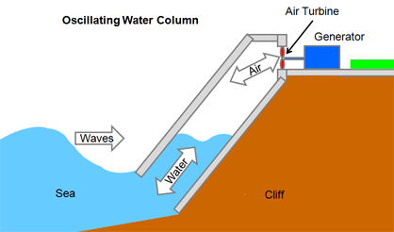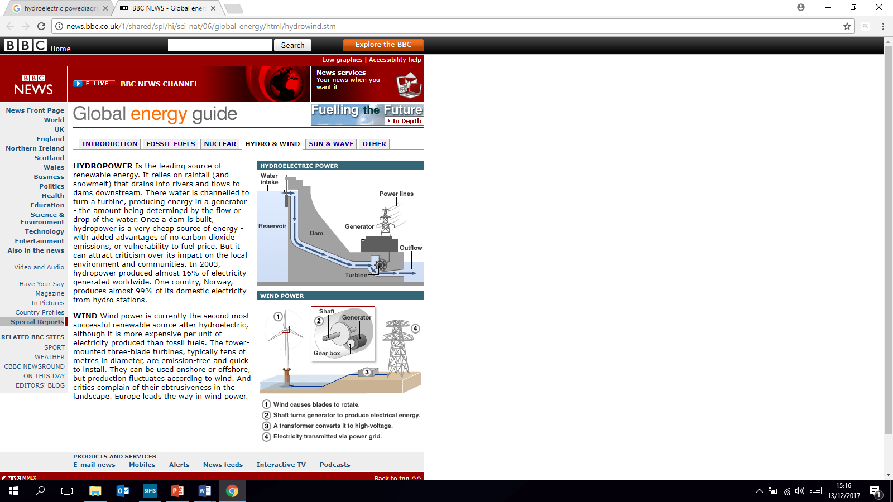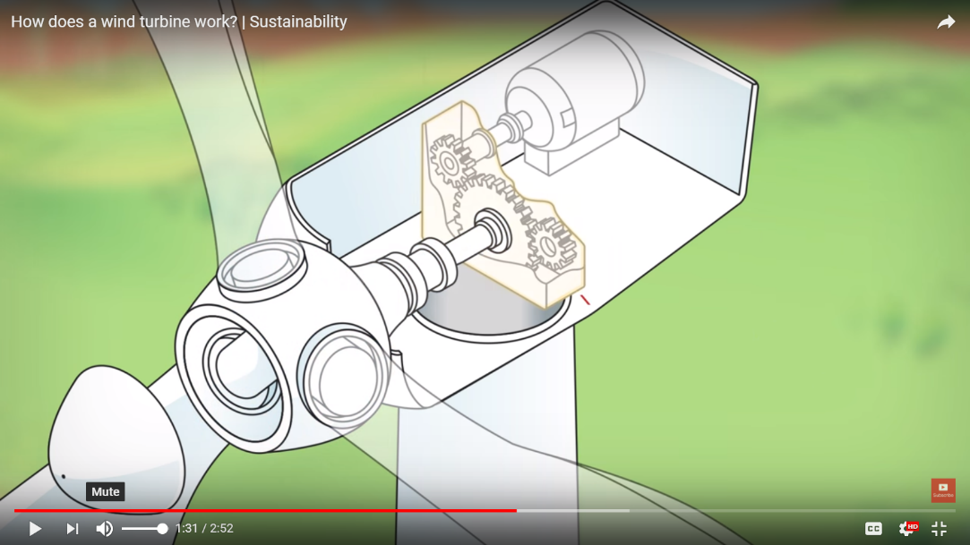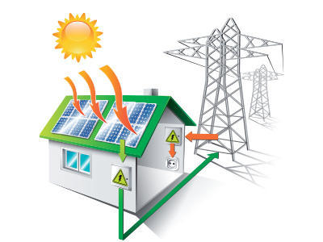

**Hydroelectric**

2) Turbine blades are connected to the --------------which rotate.

2) This --------------------------------- drives the turbine.

3) Air flow drives the turbine to spin

4) The generator converts this energy to electricity.

4) Extra electricity is sent to grid so

----------------------------------------------------

3) Shaft is connected to -------------------

which--------------- speed.

3) Takes ------------------------ to your home

2) Inverter converts electricity DC to a-------------------------

c------------------------------

1) Enclosed chamber is built in the sea.

3) Turbine is connected to

------------------------------

1. Water from a --------- level rushes -----------------------

**Wave**

2) Air is forced through an opening.

(waves rising and falling cause this)

Renewable energy